

PATIENT INFORMATION MANAGEMENT SYSTEM (ON-PREMISES TO CLOUD MIGRATION

AIT 735 Case Studies in Database management Systems



MARCH 27, 2021

TOWSON UNIVERSITY

Ashwini Madhuranally Prakash

Contents

Table of Contents

1. INTRODUCTION 2

2. Analysis 6

2.1 Server architecture: Current and future state 7

2.2 Cost benefit analysis 10

3. Requirement Specification 13

4. Design 22

4.1 Conceptual Design 22

4.2 Logical Design 25

4.3 Physical Design 30

4.4 Database Architecture Design Details 36

6. Implementation 43

7. Migration 76

7.1 Validation of the requirements implementation 99

8. Conclusion 136

9. References 136

**Abstract**

The project is related to the migration of Patient Information Management System Database (PIMSD) from on-premises to cloud database. On-premises database refers to provision of infrastructure and resources to manage their databases in data centers that are located within the physical confines of the organization. The challenges in on-premises databases are high capital expenditure, a risk of data loss, limited scalability, and additional expenditure involved for industry compliance adherence.

When people visit hospitals for medical assistance, their data will be saved in the hospital database as patients’ data (e.g., name, phone no, etc.), which is very crucial for a hospital management system. This information will be used by the medical care providers to provide better service to the customers/patients. The hospital in this case study currently uses on-premises database to create, store and manage all the patient and doctors’ information.

The purpose of this case study is mainly designed for the efficient maintenance and retrieval of patients’ Information. Additionally, to address the aforementioned challenges, the case study will look into solutions to improve resource scalability using the auto-scaling feature of Microsoft Azure and improve data availability (against situations like downtime, natural disaster) by making use of the Geo-replication feature in Microsoft Azure.

To do so, Microsoft Azure will be configured for PIMSD as an efficient combination of Infrastructure as a service (Iaas) and Platform as a service (Paas), reliable security features, best-in-class data monitoring services, cost-efficiency, high availability, and ease of use.

**Patient Information Management System-on premises to cloud migration**

# 1. INTRODUCTION

Patients’ data/information has been playing a critical role in a healthcare database. Like any other industry, patient’s data is growing in volume and value. Patient’s data management is a process of making use of this data to the benefit of healthcare practitioners to enable them to provide meticulous health service to the patient and for the well-being and benefit of the patient. A reputed health care system currently manages its patient’s information using an on-premises database. Multiple issues are being experienced in terms of records availability, data backup, and disaster recovery, scalability issues as the volume increases, data theft and security related issues.

Microsoft Azure cloud Database helps the organization to address data availability, back up, disaster recovery and database resiliency issues through the Geo-replication feature. Scalability issues will be resolved by using the auto-scaling feature of Microsoft Azure. In addition to this cloud Microsoft Azure also offers advanced security features to protect data against data theft [1]. Hence, I am using Microsoft Azure for my case study.

To address cost management, security and scalability, backup, disaster recovery issues, the hospital plans to develop a patient information system database and host it in the cloud that can handle the patient registration process. The advantages are:

* Cost-efficiency: Cloud database provides a consumption-based pricing mode. Cloud-based database will corroborate efficient usage of the cost associated with infrastructure and reduce the excessive expenses correlated with infrastructure maintenance and this cost saving can be in turn utilized to manage other expenses [2].
* Scalability: The resources can be increased and decreased efficiently based on the demand or workload [2]. Cloud computing supports both vertical and horizontal scaling based on our needs.
* Reliability: Since the patient information plays a pivotal role, the management needs to be confident that the data is always going to be there. Cloud service providers offer data backup, disaster recovery, and data replication services to make sure your data is always safe [1]. In order to achieve fault tolerance, redundancy is often built into cloud services architecture so if one component fails, a backup component takes its place. and it makes sure that the customers are not impacted when a disaster occurs.
* Availability sets and availability zone feature of cloud ensure that the data is always available.

**Scope of the Project**

In-Scope: The project will conduct architecture development, database design, the schema with tables, working code for database migration and deployment to Azure through build pipelines. The architecture will utilize the benefits of cloud such as Azure availability, geo-replication and scalability and data security

Out Scope: The design and development of the front end of patient registration system website is not considered.

**Objectives of the project**

The main objectives of the case study from the technical perspective is to learn to write a working code for migrating patient information management system from MS SQL DB to Microsoft Azure and to use Microsoft Azure cloud database for patient information management system. During implementation it will be ensured that the database is fault tolerant, highly available in case of data center failure by making use of the geo-replication feature of Microsoft Azure cloud Database and efficiently scalable as per the demand fluctuations.

From the knowledge perspective, the case study helps me understand the features available in Microsoft Azure and how to make the best use of them. In the process of developing a proof of concept for database migration, I will understand the risks associated with it. This case study project will help me develop necessary skills related to cloud-technology and how to leverage cloud resources.

**Milestones of the Project**

1. **Project Planning**

This phase involves the system proposal, identification of business needs, business value, high-level functionality and project schedule.

1. **Requirement Analysis & Design**

This stage involves the documentation of Functional requirements, Non-Functional requirements, and Data requirements.

1. **Database Design**

This stage involves a

1. Logical database model deliverable: ERD diagram
2. Physical database model: A physical diagram which includes tables, table constraints and will also include the primary keys and foreign keys.
3. **Implementation**

A prototype is created based on the functional requirements.

1. **Data Migration**

Patients’ Information is migrated and loaded in the Cloud database

1. **Testing and Deployment**

The testing phase involves testing if the database works as the functional requirements specified. Testing is done against the specified functional requirements to ensure the database meets all functional requirements.

1. **Documentation**

The case study will be documented as a report on completion of all above milestones.

***Figure 1: Workflow diagram***

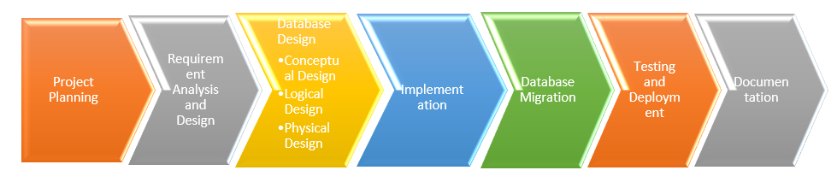

1. **Deliverables**

* Project Charter
* Cost Benefit Analysis
* Business Requirement Documentation
* Database Design
* Prototype & Screenshots
* Migration Strategy Document
* Test cases
* Project Case Study report.

This case study is basically migrating the database which is already existing on-premises to cloud where every information related to a patient can be inserted, updated, and deleted conveniently. Through the case study, the broad view on an organizational database’s efficiency will be discussed in terms of cost, scalability, availability, data recovery, fault tolerance and security by making appropriate decisions. Additionally, practical aspects of the organizational DBMS such as database as a service, requirements during migration, how to leverage the benefits of cloud service will be investigated.

In terms of the project implementation, I will conduct the literature review on cloud features, services it offers, benefit of selecting one service over the other, etc. After identifying key requirements, I will design and implement a solution which is cost efficient that reduces the capex investment and infrastructure maintenance. The project will focus on database availability and resiliency which needs in depth grasp of availability sets, availability zones and Azure regions.

The project will give overall knowledge of redesigning the existing database to be efficiently migrated to cloud without data loss. This case study will give me hands-on experience in terms of designing a database, writing migration code, analyzing, and making decisions on efficient usage of the benefits offered by the cloud service provider to the best of an organization. I will gain extensive understanding of the different stages involved in the database migration process.

# 2. Analysis

A reputed health care system currently manages its patient’s information using an on-premises database. Various issues are being experienced in terms of records availability, data backup, and disaster recovery, scalability issues as the volume increases, data theft and security related issues.

Patient Information System includes patient information, doctor visited, treatment and medication details. As a result of the extending popularity of the health care system the patients’ data is growing in volume. This enormous increase in the volume leads to performance issues. The current IT resources are not sufficient to handle the increasing volume. This in turn is resulting in scalability issues. The healthcare system is looking for an effective method for migrating on-premises database to a cloud database.

**Major Use Cases**

|  |  |
| --- | --- |
| **Use Case** | **Description** |
| *1. Patient, Doctor and authorized admins should be able to access the patient information efficiently at their convenience.* | Recognize the challenges in the existing on-premises database system. Understand how data is being accessed, what are the major issues the organization is facing and Design the new architecture in order to address these challenges/issues without affecting the actual data. |
| *2. Database admin should be able to enable the fault tolerance feature of Microsoft Azure database through geo-replication*. | Determine availability zones within the region for high availability and to continue access data in case of data Centre failure.  Determine availability zone across the region for disaster recovery. |
| *3. Database admin should be able to enable the scalability feature of the Microsoft Azure to allow the application to respond to the fluctuating workload.* | Determine the applicable vertical scaling options.  Determine the horizontal scaling options to the benefit of the organization.  Scaling can be done either automatically or manually based on the specific triggers such as number of requests and the resources can be allocated and deallocated in minutes.  Analyze and choose the scaling option that best fits the organization requirement. |
| *4. As a database developer, work with database architect regarding Database monitoring feature that should be configured and enabled for efficient maintenance after database migration* | Understand the monitor features available in cloud such as Azure service health and Azure monitor.  Analyze and configure how these features can be best used to monitor the hospital’s database. |
| *5. As a database developer, work with database designer regarding the security feature that needs to be configured as the system includes crucial and personal data* | Understand the security needs of the existing database system.  Understand various security features of cloud database system like inbuilt authentication and authorization feature, secure connection strings, advanced data security, auditing, data masking, encryption, etc. and configure as per the database requirement. |
| *6. As a database developer I should be able deploy the code to production through an automated build pipeline Through CI/CD.* | Develop a build pipeline code with Azure from code repository.  Enable DACPAC deployment integrated with builds  Integrate integration builds along with DACPAC deployment builds and to make sure existing functionality is not affected. Perform testing to ensure the new Database is working as per the expectations |

**Technology Stack**

The Database software that will be used in the case study is Microsoft SQL server 2019 Express. and the interface used to connect is SQL Server Management Studio. The reason behind choosing the MS SQL Server 2019 Express is as mentioned by Microsoft it is a free edition of SQL Server, ideal for development and production for desktop, web, and small server applications.

* Operating System: Windows 10
* Database: MS SQL Server 2019 Express
* Cloud Provider: Microsoft Azure
* Cloud Database: Microsoft Azure SQL Database
* Development Environment: ASP.NET, Web API

## 2.1 Server architecture: Current and future state

In the on-premises database, the hospital database is set up and deployed within the confines of the organization. Database stays within the private network. The full responsibility of managing the software and the infrastructure will be on the hospital. In the case study the database that is being used is Microsoft SQL Server 2019 Express. MS SQL Server is a client-server architecture where the client connects to the server using TCP/IP Protocol, sends the request and the server accepts the request, processes it and sends a response. In the current on-premises database, the database server is located behind the firewall and the access is restricted only to the authorized applications in the same network. As a result of this, hospital face challenge regarding the usage of cloud-based applications to access on-premises data. The data can be made available outside premises, but it may include considerable investment in terms of infrastructure and operational maintenance compared to cloud-database. This is because after the database migration the data can be accessed directly from Microsoft Azure cloud database without compromising the data security [3]. The diagram below depicts the status of the on-premises database. The data in the on-premises Microsoft SQL Server will be migrated to the Microsoft Azure SQL Database by creating BACPAC files and using import/export methods using SQL Server Management studio interface [4].

***Figure 2: Current Status of the Database server infrastructure***

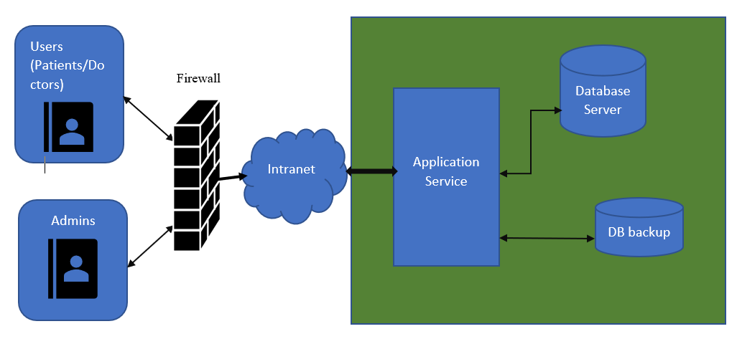

Once the hospital decides to go for database migration, there are two major steps that need to be followed. The first and the foremost step during the migration is to assess the on-premises database to identify the compatibility issues, partially supported or unsupported features and challenges that could arise during the migration process. Then to redesign the database to organize the patient information that needs to be migrated.

Second step is to discover the features in the target Microsoft Azure database platform that our organization’s database can benefit from after migration. Here we need to consider various categories like cost, availability, performance, security, scalability, and data recovery. When Geo replication feature is configured in Azure Database it allows us to create readable secondary databases of individual databases on a server in the different data center (region) [1].

***Figure 3: Database features that are available in Microsoft Azure***

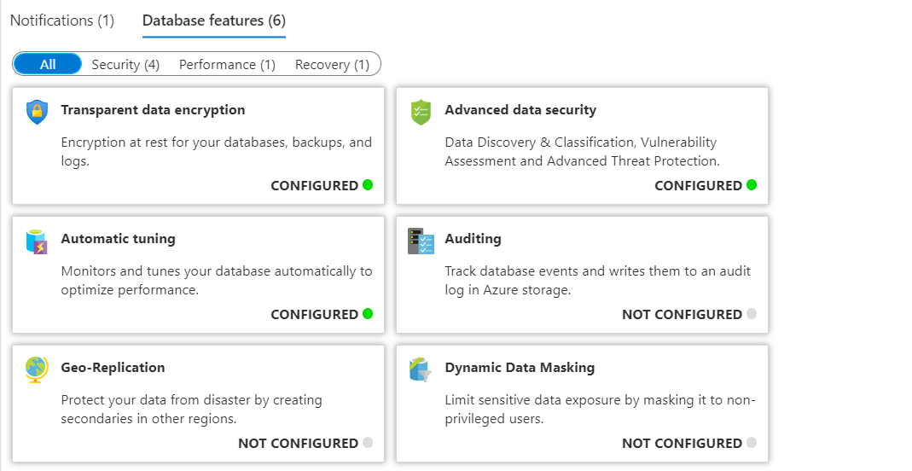

After the on-premises database is migrated to the Microsoft Azure cloud database, firewall rules will be configured to allow on-premises connections to the cloud server. In addition to this, Microsoft Azure uses Azure Service Bus Relay to access on-premises services without having to use the firewall port. This feature is beneficial for the cloud-based applications. Service Bus Relay allows cloud-based applications to access the services in the organization’s network without opening a port on the firewall or making any changes to the company’s network infrastructure. Hybrid connections is a feature of Azure Service Bus Relay that allows the client application to send request and receive responses over HTTP protocol. Hybrid Connection supports services hosted using TCP Port [3]. The diagram below depicts the architecture of the migrated database.

***Figure 4: Future State of the Database server infrastructure***

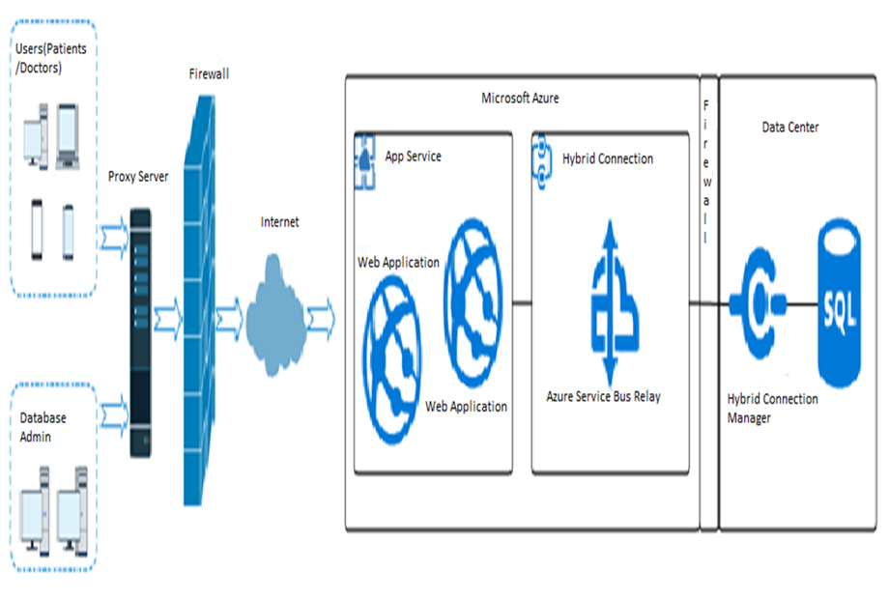

## 2.2 Cost benefit analysis

Before migrating from on-premises database to the cloud database, it is important to analyze the benefits of migration in terms of cost and various considerable factors.

With on-premises, the hospital uses on-premises dedicated servers. A considerable upfront investment is involved in purchasing software licenses, servers. After investing in the infrastructure, the hospital needs to recruit a team for maintenance. Additionally, on-premises infrastructure is very adaptable in terms of scaling resources. Sometime the volume will be less, and resources will be more that results in the increase of operation cost. At times volume will be more and the resources will be less which results in performance hinderance. On-premises involves the resources that are physically located in the premises of the hospital, and this results in the requirements of the expert staff to configuring and maintaining servers. Having efficient staff for infrastructure maintenance is very costly. The cost of on-premises database includes, data center investments and operations, hardware investments and operations, software investments and operations, Database investments and operations, storage expansion, backup, service-desk, and security [5]. Most of the times the data center admins will have to work overtime to keep the lights on. In case of any incidents or systems failure, they may take more time fix the issue and make the system up and running. There are also instances where the admins cannot find the cause or solution for the issue and in such instances, they may need to consult external technical consultants. In such scenario the business suffers from downtime and substandard user experience and this may also result in additional cost for the hospital. The time taken by the on-premises database to be operational is high relative to cloud database because the product has to be built first as per the specification provided, then it needs to be provisioned, network needs to be configured, licenses need to be registered, backup plan need to be configured, and monitoring methods should be decided and planned accordingly and also the database needs to time to time software upgrades.

Cloud Database has very less or almost no capital investment relative to on-premises database. The infrastructure belongs to the provider and the Microsoft Azure has pay-as-you-go subscription model. In this model the hospital pays for using the devices and this payment could on a monthly or annual basis. Using cloud database, the hospital pays for the units consumed and only for the time used [1]. In cloud database the provider takes care of maintenance, software upgrades, etc. Hence, cloud database requires minimum technical expertise from the client. This will allow the hospital to focus on other business aspects. A cloud service provider delivers a SLA uptime guarantee and will compensate financially if they fail to deliver specified SLA uptime. Hence, compared to on-premises database the level of assurance and support provided by the cloud database is immeasurable. The cloud provider provides highest level of data security. By evaluating existing licensing models, the cost can be considerably reduced when the hospital migrates to the cloud database. Cloud providers will have agreements with companies like google, Microsoft, etc,. because of which cloud providers allows the clients to use their existing software licenses. This will again result in additional savings. The hospital can use the existing windows licenses. When the hospital is aware of peak volume times, it can reserve cloud database instances which provides up to 72% discount compared to on-demand pricing. The cloud reserved instances aid in significant cost saving [1].

***Table 1: Comparison between on-premises and cloud database in terms of cost and various considerable factors.***

|  |  |  |
| --- | --- | --- |
| Criteria | On-Premises Database | Cloud Database |
| Cost | High | Low |
| Technical Involvement | Very High | Low |
| Scalability | Limited scalability | Unlimited options of both vertical and horizontal scaling |
| Data back up | Takes time | Automated, quicker, and Easier |
| Downtime | Medium | Very Low |
| Control | Full Control | No direct access to Database hardware |
| Security | Medium | High |
| Compliance | Responsibility of the hospital | Taken care by the cloud provider |
| Technical Maintenance | Very high | Low |
| Operational Efficiency | Medium | High |
| Subject to Facility problems | Yes | No |
| Built in Business Continuity | No | Yes |
| Required time to time investment | Yes | No |
| Complexity | High | Low |

# 3. Requirement Specification

**Major Business Needs**

* The database will save the patient’s personal information such as Name, Gender, phone number, address, e-mail address, doctor visited, Date of Birth, prescribed medications.
* The database will save the doctor details such as name, Employee ID, department, date of joining, phone number, email address, and address.
* The case study will facilitate the efficient retrieval of patient’s data with minimum downtime.
* Redesign the existing database to fit into the cloud database.
* Migration of data without compromising the confidentiality, authenticity, and integrity of the data.
* Enable geo-replication and scalability features of the Microsoft Azure to ensure high availability, auto scalability, data backup and recovery.

**Requirements**

|  |  |
| --- | --- |
| **Requirement #** | **Description** |
| Requirement 1 | The system will allow to add new user. |
| Requirement 2 | The System will allow to add new patients |
| Requirement 3 | The system will allow to add new doctors |
| Requirement 4 | The system will need the following details from the patient to create a new account.   * First Name. * Last Name * Phone number * Email ID * Address * Phone number * Date of Birth |
| Requirement 5 | The system will need the below details from the doctor to create a new account.   * Name * Phone Number * Email ID * Specialization * Date of Joining |
| Requirement 6 | The system will allow to allocate unique user ID for each patient. |
| Requirement 7 | The system will allow to allocate unique user ID for each doctor. |
| Requirement 8 | The system will allow users to login to their account credentials |
| Requirement 9 | The system will allow user to edit the following personal data   * Phone number * Address |
| Requirement 10 | The system will display appointment details that includes patient’s name, their doctor’s name, reason of visit information in the patient’s account. |
| Requirement 11 | The system will allow doctor to view the patient’s records. |
| Requirement 12 | The system will allow doctors to view the medications prescribed for the patients. |
| Requirement 13 | The system will allow doctors to create a record for each visit with the following details   * Date of visit * Reason of visit * Diagnosis * Amount_charged |
| Requirement 14 | The system will allocate unique system generated record id for each record. |
| Requirement 15 | The system will save the patient payments with the following details   * Amount * Payment type * Payment date * patient_id |
| Requirement 16 | The system will display the payment information in the patient’s account. |
| Requirement 17 | The system will reduce the amount from the patient’s account balance every time the payment is made. |
| Requirement 18 | The system will not allow the payments other than the valid payment types(Card, Cash and Check). |
| Requirement 19 | The system will not allow to schedule two appointments at the same time with the same Doctor. |
| Requirement 20 | The data is migrated from the on-premises database to the cloud database |
| Requirement 21 | The system will be able to scale in/out based on the need of service. |
| Requirement 22 | The cloud database will provide data back up on regular intervals. |
| Requirement 23 | The database will be geo replicated so that the data will be available in situations like natural disaster. |
| Requirement 24 | The migrated database will be provided with cloud monitoring option for maintenance and proactive support. |
| Requirement 25 | The database after migration will be tested for data integrity. |
| Requirement 26 | The migrated database will be notified ahead of time in case of service-related issues. |
| Requirement 27 | The cloud database will be protected against malicious offline activity. |
| Requirement 28 | The system will allow to monitor query performance to efficiently manage the resource consuming and long running queries. |
| Requirement 29 | The System will have 99.99% availability as per the cloud provider SLA. |
| Requirement 30 | The migrated database will be configured with advanced security features |

**Use Cases**

|  |  |
| --- | --- |
| **Name** | **Create a patient profile into the system** |
| **Identifier** | **UC1** |
| **Preconditions** | Patients requests an appointment |
| **Business Rule** | Administrator will enter the patient’s information into the system to generate user_id and the password. |
| **Actor** | System Administrator |
| **Scenario** | Administrator will use admin portal to create a patient’s profile.  R1 Admin captures the First name of the patient (Mandatory field)  R2 Admin captures the Last name of the patient (Mandatory field).  R3 Admin captures Gender info(Mandatory field).  R4 Admin captures Date_Of_Birth of the patient (Mandatory field).  R5 Admin captures Email_ID of the patient(Mandatory field).  R6 Admin captures phone number of the patient (Mandatory field).  R5 Admin must save all the gathered information into the system to generate unique patient ID  R5 Admin must generate user_ID and password for the patient’s profile |
| **Alternate Scenario** | Alternate Scenario A: Patient profile creation fails.  A1. The system returns an error if the required fields are not provided  A2. Error is logged  A3. The use case continues until the creation is successful |

|  |  |
| --- | --- |
| **Name** | **Create a Doctor into the system** |
| **Identifier** | **UC2** |
| **Preconditions** | Doctor will provide all the required information when they join the hospital. Relevant information is available for the Administrator of the current system. |
| **Business Rule** | Administrator will enter the doctor’s information into the system to generate user_id and the password. |
| **Actor** | System Administrator |
| **Scenario** | Administrator will use admin portal to create a doctor’s profile.  R1 Admin captures the name of the doctor (Mandatory field)  R2 Admin captures Email_ID of the doctor (Mandatory field).  R3 Admin captures phone number of the doctor (Mandatory field).  R4 Admin captures the Date_Of_Joining of the doctor  R5 Admin captures the specialization of the doctor (Mandatory field)  R6 Admin must save all the gathered information into the system to generate unique doctor ID  R6 Admin must generate user_ID and password for the doctor’s profile |
| **Alternate Scenario** | Alternate Scenario A: Doctor profile creation fails.  A1. The system returns an error if the required fields are not provided  A2. Error is logged  A3. The use case continues until the creation is successful |

|  |  |
| --- | --- |
| **Name** | **Create appointment into the system** |
| **Identifier** | **UC3** |
| **Preconditions** | Patients requests an appointment |
| **Business Rule** | Administrator will enter the patient’s information into the system to create an appointment |
| **Actor** | System Administrator |
| **Scenario** | Administrator will use admin portal to create an appointment.  R1 Admin captures the name of the Patient (Mandatory field)  R2 Admin captures the name of the doctor to be visited (Mandatory field).  R3 Admin captures User_ID of the patient (optional).  R4 Admin captures the reason_of _visit  R5 Unique appointment ID must be returned after successful completion |
| **Alternate Scenario** | Alternate Scenario A: Appointment creation fails.  A1. The system returns an error if the required fields are not provided  A2. Error is logged  A3. The use case continues until the creation is successful |

|  |  |
| --- | --- |
| **Name** | **Create record into the system** |
| **Identifier** | **UC4** |
| **Preconditions** | Patient will visit the doctor after scheduling an appointment. |
| **Business Rule** | Doctor will enter the visit details after examining the scheduled patient. |
| **Actor** | **Doctor** |
| **Scenario** | Doctor will create the record into the system.  R1 Doctor records the Date of visit.  R2 Doctor reports symptoms described by the patient  R3 Doctor reports the Diagnosis suggested by him  R4 Doctor reports the medications prescribed  R5 Doctor reports the Patient_ID of the patient.  R6 Doctor reports amount_charged for the visit  R7 Doctor reports his unique doctor_id.  R8 Unique record ID must be returned after successful completion |
| **Alternate Scenario** | Alternate Scenario A: Record creation fails.  A1. The system returns an error if the required fields are not provided  A2. Error is logged  A3. The use case continues until the creation is successful |

|  |  |
| --- | --- |
| **Name** | **Create medication into the system** |
| **Identifier** | **UC5** |
| **Preconditions** | Patient will visit the doctor after scheduling an appointment. |
| **Business Rule** | Doctor will enter the medication details after examining the scheduled patient. |
| **Actor** | Doctor |
| **Scenario** | Doctor will save medication details into the system.  R1 Doctor records his id  R2 Doctor records the Patient_ID of the patient.  R3 Doctor records the name of the medication  R4 Doctor records the prescribed dosage of the medication  R5 Unique medication ID must be returned after successful completion |
| **Alternate Scenario** | Alternate Scenario A: Medication creation fails.  A1. The system returns an error if the required fields are not provided  A2. Error is logged  A3. The use case continues until the creation is successful |

|  |  |
| --- | --- |
| **Name** | **Create payment into the system** |
| **Identifier** | **UC6** |
| **Preconditions** | Patient will make the payment after being examined by the doctor |
| **Business Rule** | Administrator will enter the payment information into the system |
| **Actor** | System Administrator |
| **Scenario** | Administrator will enter the payment information into the system  R1 Administrator captures the amount paid by the patient  R2 Administrator captures the patient id  R3 Administrator captures the payment type  R4 Administrator captures the payment date  R5 Unique payment ID must be returned after successful completion |
| **Alternate Scenario** | Alternate Scenario A: Payment creation fails.  A1. The system returns an error if the required fields are not provided  A2. Error is logged  A3. The use case continues until the creation is successful |

|  |  |
| --- | --- |
| **Name** | **The migrated database will have high availability** |
| **Identifier** | **UC7** |
| **Preconditions** | System is implemented and ready for deployment |
| **Business Rule** | Database administrator will replicate the database across multiple region |
| **Actor** | Database Administrator |
| **Scenario** | Geo-replication feature of Microsoft Azure SQL database allows replication of database across multiple regions which results in high availability |
| **Alternate Scenario** | **-** |

|  |  |
| --- | --- |
| **Name** | **Migrated Database must be scalable** |
| **Identifier** | **UC8** |
| **Preconditions** | System is implemented and ready for deployment |
| **Business Rule** | Database administrator will replicate the database across multiple region and change the capacity of the resource as required |
| **Actor** | Database Administrator |
| **Scenario** | As the demand increases performance remains intact due the scalability feature of the migrated database. |
| **Alternate Scenario** | **-** |

|  |  |
| --- | --- |
| **Name** | **Database developer works with database architect to configure monitoring tools for the efficient maintenance** |
| **Identifier** | **UC9** |
| **Preconditions** | System is implemented and ready for deployment |
| **Business Rule** | Monitoring of the migrated database must be facilitated |
| **Actor** | Database administrator |
| **Scenario** | Cloud monitoring features will be configured |
| **Alternate Scenario** | **-** |

|  |  |
| --- | --- |
| **Name** | **Migrated database must be highly secure** |
| **Identifier** | **UC10** |
| **Preconditions** | System is implemented and ready for deployment |
| **Business Rule** | Data should be secure and cannot be accessed by unauthorized users |
| **Actor** | Database administrator |
| **Scenario** | Advanced data security features, access control features, security monitoring features will be enabled |
| **Alternate Scenario** | **-** |

# 4. Design

## 4.1 Conceptual Design

**PIMS Entity-relationship Diagram**

The summary of entities and their relationships involved in the patient information system

* User_type entity: There will be two user types (doctor and patients).
* User_Account entity: Each account must belong to a user. One user_type may have only one account.
* Patient entity: Includes patient’s personal information
* Appointment entity: Patient requests an appointment, and each appointment is assigned to a doctor. Appointment entity includes appointment schedule details. One patient may have one to many appointments and one appointment may belong to only one patient. Appointment must belong to a patient.
* Doctor entity: Each appointment is assigned to a doctor. The doctor entity includes doctor’s personal information. A doctor may have one to many appointments and one appointment may belong to only one doctor. An appointment must belong to a doctor.
* Record entity: Includes patient visit details. Doctor generates a record after each appointment. A doctor may generate one to many records. A record must belong to a doctor.
* Specialization entity: Includes the type of specialization like pediatrician, Gynecologist etc. specialization may belong to one-to-many doctors. Doctor must have a specialization. A doctor can have only one specialization.
* Medication entity: Includes patient medication details. Doctor enters medication details. Each medication must belong to a doctor. Doctor may prescribe one to many medication
* Address entity: Includes user (patient/doctor) address. A address must belong to a user. User may have one to many addresses.
* Address_Type entity: Includes type of address (example: home and office address).
* Phone entity: Includes user (patient/doctor) phone number. A phone number must belong to a user. User may have one to many phone numbers.
* Phone_Type entity: Includes type of phone numbers (example: Daytime phone number, evening phone number and mobile number).
* Payment entity: Includes the details of the payment made by the patient. A payment must belong to a patient. One payment may belong to one patient. Patient can make one to many payments.
* Payment_Type entity: Includes type of payment (example credit card, debit card, and check)

***Figure 2: High-level ERD with entities and their relationship***

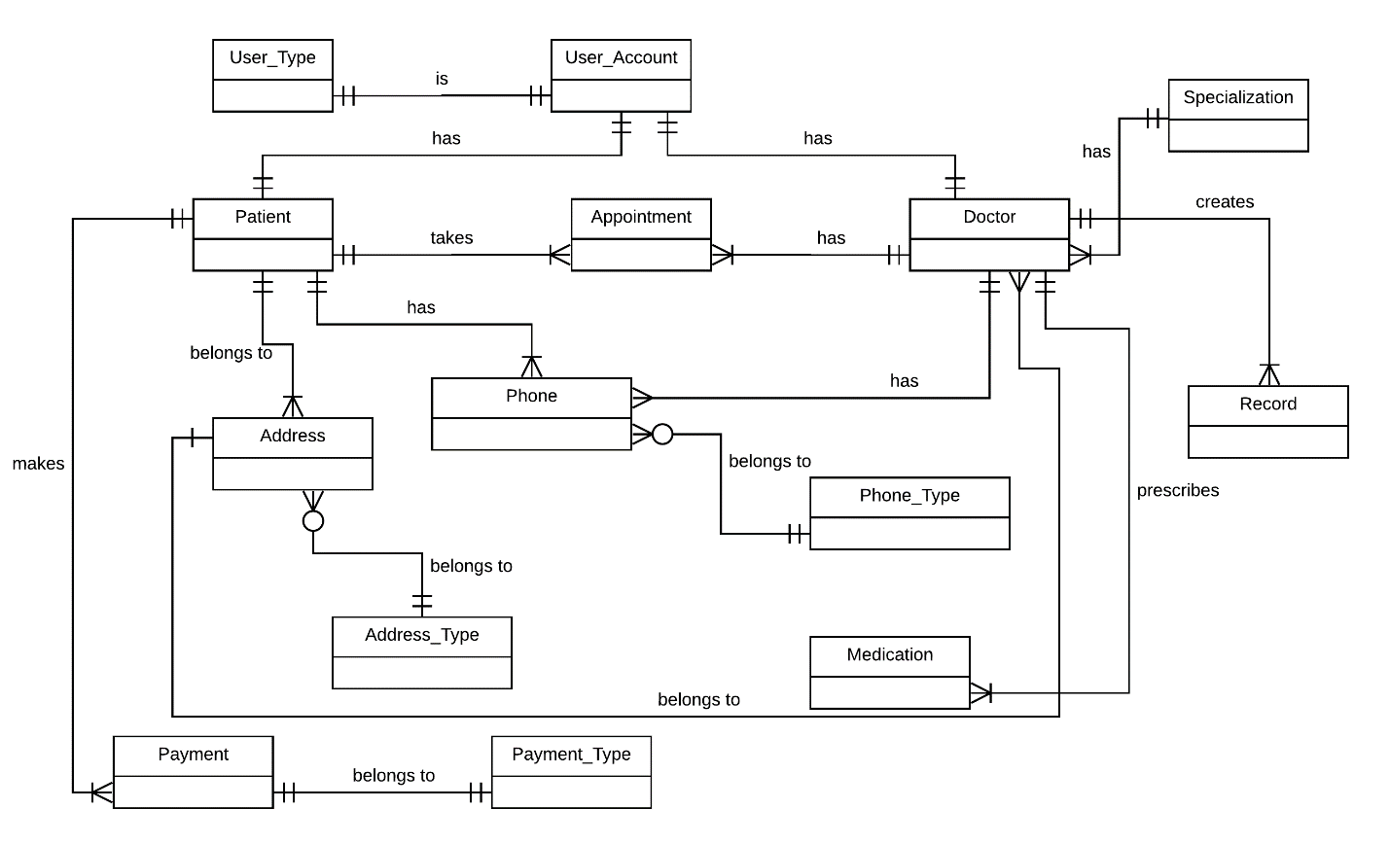

**Context data flow diagram**

Summary:

* The objective of the proposed PIMS migration from on-premises to cloud database is to improve the efficiency, scalability, and security of the hospital database.
* Admin manages the creation of users (patients and doctors) into the system and sends a confirmation email to the user.
* Admin manages appointment scheduling, and payment information in the system.
* A confirmation email will be sent to the patient when the appointment is scheduled and when the payment made by the patient is accepted and processed.
* Doctor manages the patient records and medication information in the system
* Patient may place a request for appointment by calling the hospital front desk

***Figure 3: Context data flow diagram***

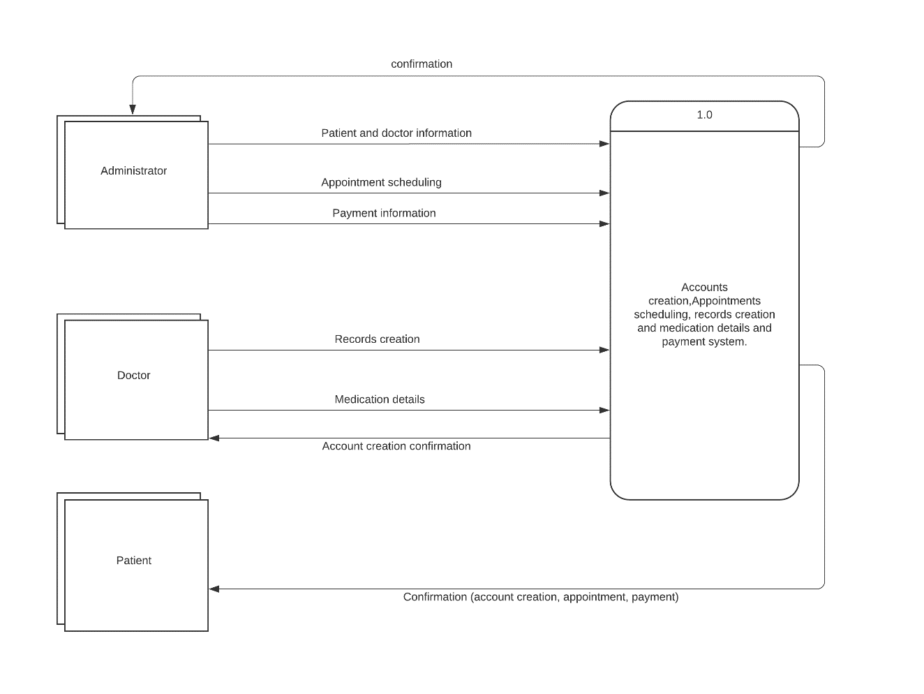

**DFD level 0 data flow diagram**

Summary:

* The patient information system in the hospital database comprises of patient and doctor profiles, appointment schedules, patient records, medication details and payments made.
* Patient Data store- contains patient information
* Doctor data store- contains doctor information
* Appointment Data store- contains appointment schedules with doctor association
* Record Data store- contains patient visit details with patient and doctor association
* Medication Data store- contains medication details with patient and doctor association
* Payment Data store- contains payment details with patient association

***Figure 4: DFD level 0 data flow diagram***

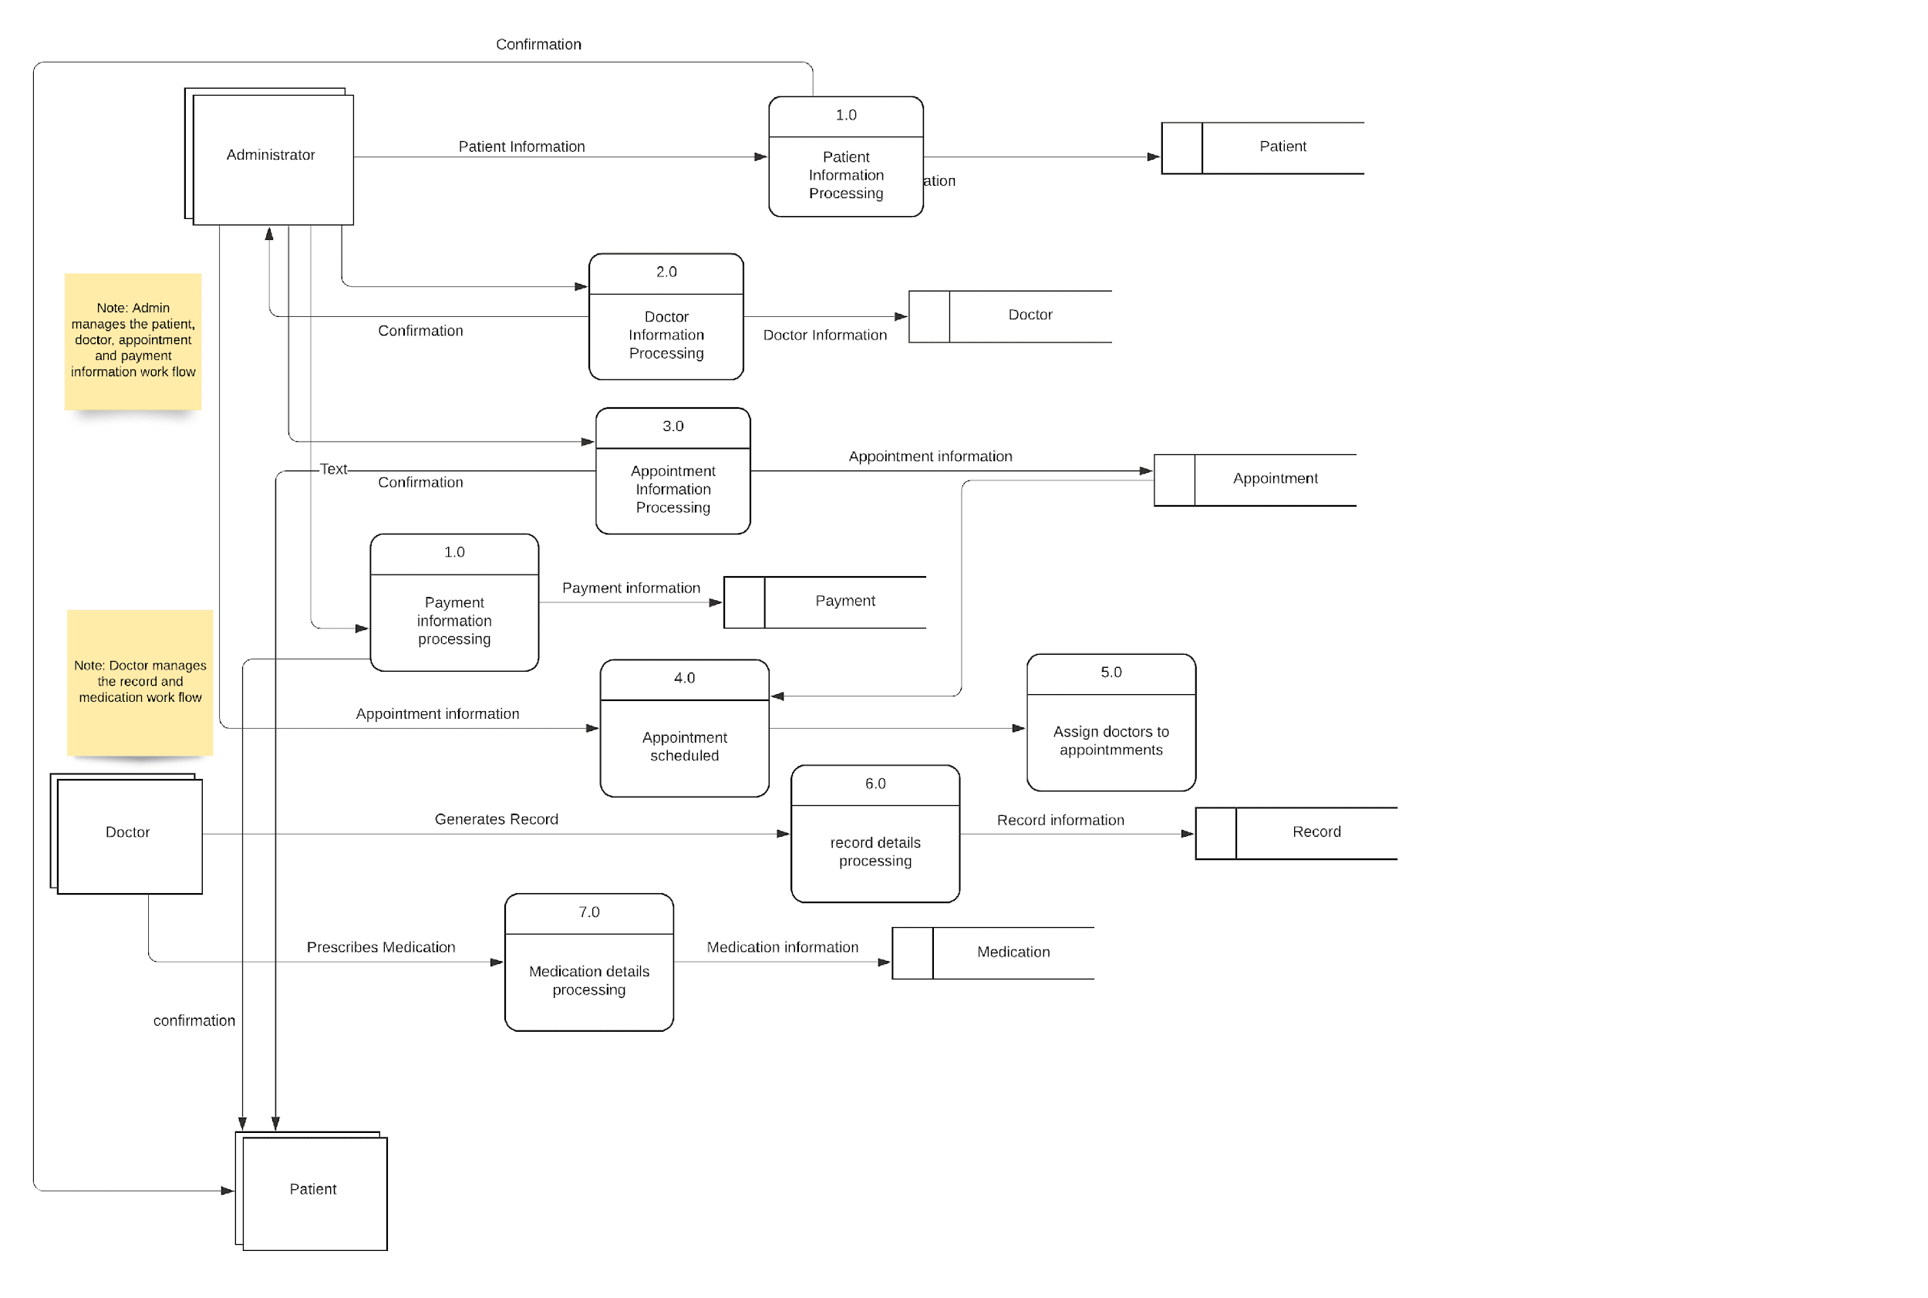

## 4.2 Logical Design

**Entity-Relationship Diagram**

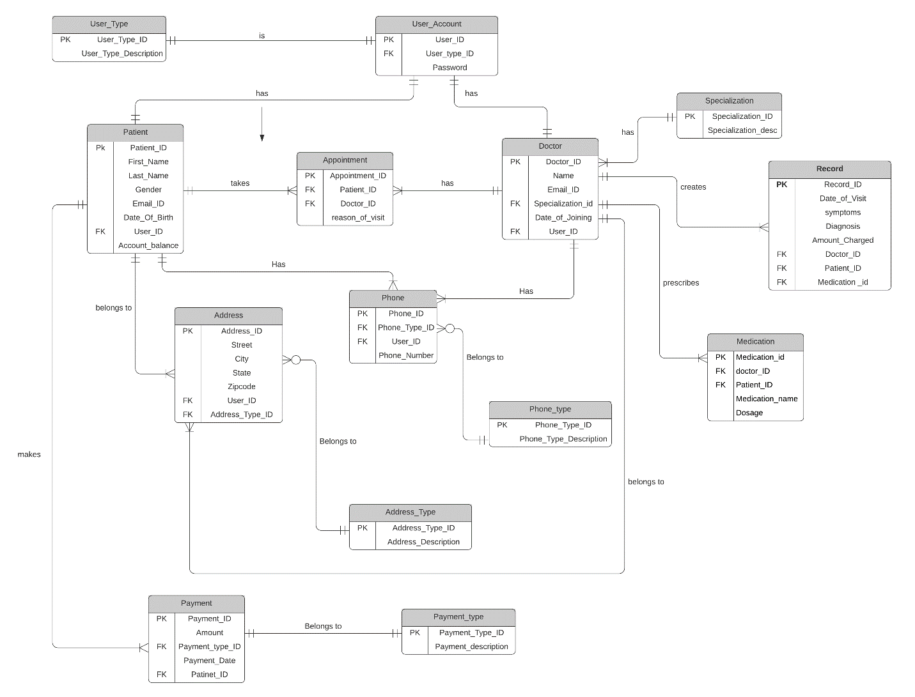

**Data Dictionary**

|  |  |  |  |  |  |  |
| --- | --- | --- | --- | --- | --- | --- |
| **Table Name** | **Column Name** | **Data Type** | **Primary key** | **Foreign key** | **Unique** | **Description** |
| **User Type** | User_Type_ID | int | yes |  | Yes | System generated unique ID |
| User_Type_Description | Varchar (20) |  |  |  | User description |
| **User_Account** | User_ID | Varchar  (10) | Yes |  | Yes | Unique ID that will be created for each user. |
| User_Type_ID | int |  | Yes |  |  |
| Password | Varchar (20) |  |  |  | Password created during account creation |
| **Patient** | Patient_ID | Int | Yes |  | Yes | System generated unique ID |
| First_Name | Varchar (20) |  |  |  | First name of the Patient |
| Last_Name | Varchar (20) |  |  |  | Last name of the Patient |
| Gender | Char (1) |  |  |  | Gender of the patient |
| Email_ID | Varchar (20) |  |  |  | Email address of the patient |
| Date_Of_Birth | date |  |  |  | Date of birth of the patient |
| User_ID | Int |  | yes |  |  |
| Account_balance | Numeric (5,2) |  |  |  | Amount to be paid by the patient |
| **Doctor** | Doctor_ID | Int | Yes |  | Yes | System generated unique ID |
| Name | Varchar (20) |  |  |  | Name of the Doctor |
| Email_ID | Varchar (20) |  |  |  | Email address of the doctor |
| Specialization_id | Varchar (20) |  | yes |  | Doctor specialty |
| Date_Of_Joining | date |  |  |  | Hired date of the doctor |
| User_ID | Int |  | yes |  |  |
| **Record** | Record_ID | Int | Yes |  | Yes | System generated unique ID |
| Date_Of_Visit | date |  |  |  | Date on which the patient visits the doctor |
| Diagnosis | Varchar (20) |  |  |  | Treatment  provided |
| Amount_Charged | Numeric (5,2) |  |  |  | Fee needs to be paid by the patient |
| Doctor_ID | Int |  | yes |  |  |
| Patient_ID | Int |  | yes |  |  |
| **Payment_Type** | Payment_Type_ ID | Int | Yes |  | Yes | System generated unique ID |
| Payment_description | Varchar (20) |  |  |  | Payment method like card, cash, check etc. |
| **Payment** | Payment_ID | Int | Yes |  | Yes | System generated unique ID |
| Amount | Numeric (5,2) |  |  |  | Amount paid by the patient |
| Payment_Type_ ID | Int |  | Yes |  |  |
| Payment_Date | Datetime |  |  |  | Date and time the payment is made by the patient |
| Patient_ID | Int |  | yes |  |  |
| **Phone_Type** | Phone_Type_ID | Int | Yes |  | Yes | System generated unique ID |
| Phone_Type_Description | Varchar (20) |  |  |  | Phone description like home, mobile etc. |
| **Phone** | Phone_ID | Int | Yes |  | Yes | System generated unique ID |
| Phone_Type_ID | Int |  | yes |  |  |
| User_ID | Int |  | yes |  |  |
| Phone_number | Varchar (15) |  |  |  | Phone number of the user with corresponding user ID |
| **Address_Type** | Address_Type_ID | Int | Yes |  | Yes | System generated unique ID |
| Address_Description | Varchar (30) |  |  |  | Address description like home, office etc. |
| **Address** | Address_ID | Int | Yes |  | Yes | System generated unique ID |
|  | Street | Varchar (20) |  |  |  | Street name of the address |
|  | City | Varchar (15) |  |  |  | City name of the address |
|  | Zipcode | Char (5) |  |  |  | Zipcode of the address |
|  | User_ID | Int |  | yes |  |  |
|  | Address_Type_ID | Int |  | yes |  |  |
| **Appointment** | Appointment_ID | Int | Yes |  | Yes | System generated unique ID |
| Patient_ID | Int |  | yes |  |  |
| Doctor_ID | Int |  | yes |  |  |
| Reason_of_visit | Varchar (25) |  |  |  | Reason mentioned by the patient for the visit |
| **Medication** | Medication_ID | Int | Yes |  | Yes | System generated unique ID |
| Patient_ID | Int |  | yes |  |  |
| Doctor_ID | Int |  | yes |  |  |
| Medication_Name | Varchar (20) |  |  |  | Name of the medicine prescribed by the doctor |
| Dosage | Varchar (15) |  |  |  | Dosage prescribed by the doctor for example 500mg, 5ml etc. |
| **Specialization** | Specialization_ID | Int | Yes |  | Yes | System generated unique ID |
| Specialization_desc | Varchar(20) |  |  |  | Description of the specialization, For example, gynecologist, pediatrician etc. |

## 4.3 Physical Design

DBMS Software: Microsoft SQL Server 2019 Express

Interface: Microsoft SQL Server Management Studio

**SQL statements for creating tables in the Database:**

|  |  |
| --- | --- |
| **Table Number & Name** | **SQL statement/code** |
| Table1: user_type | Create table user_type (user_type_id int not null primary key identity,  user_type_desc varchar (20) not null unique); |
| Table1: Constraints | Alter table user_type  add unique (user_type_desc), constraint user_type_desc check (user_type_desc in ('patient', 'doctor', 'admin')); |
| Table2: user_account | Create table user_account (user_id varchar(10) not null primary key,  user_type_id int not null,  Foreign key (user_type_id) references user_type(user_type_id),  Password varchar (20) not null); |
| Table 3: Patient | Create table patient (patient_id int not null primary key,  first_name varchar (20) not null,  last_name varchar (20) not null,  gender char (1) not null,  email_id varchar (20) not null,  date_of_birth date not null,  user_id varchar(10) not null,  account_balance numeric(5,2) not null,  foreign key (user_id) references user_account(user_id)); |

|  |  |
| --- | --- |
| Table 3: constraints | Alter table patient  add unique (email_id), constraint gender check (gender in ('M','F')); |
| Table 3: constraints | Alter table patient  add unique (email_id), constraint gender check (gender in ('M','F')); |
| Table 4: Specialization | Create table specialization (specialization_id int not null primary key identity,  Specialization_desc varchar (20) not null); |
| Table 4 constraints | Alter table specialization  add unique(specialization_desc), constraint specialization_desc check  (specialization_desc in ('Physician', 'Gynecologist ', 'Pediatrician', 'Allergist', 'Ophthalmologist')); |
| Table 5: Doctor | Create table doctor (doctor_id int not null primary key identity,  name varchar (20) not null,  email_id varchar (20) not null,  user_id varchar (10) not null,  specialization_id int not null,  foreign key (specialization_id) references specialization (specialization_id),  date_of_joining date not null,  foreign key (user_id) references user_account(user_id)); |
| Table 5: constraints | Alter table doctor  add unique (email_id); |
| Table 6: record | Create table record (record_id int not null primary key identity,  Date_of_visit date not null,  Diagnosis varchar (20) not null,  amount_charged numeric (5,2) not null,  doctor_id int not null,  patient_id int not null,  foreign key (doctor_id) references doctor(doctor_id),  foreign key (patient_id) references patient (patient_id)); |
| Table 6: constraint | Alter table record  add check (amount_charged > 0); |
| Table 7: payment_type | Create table payment_type (payment_type_id int not null primary key identity,  Payment_description varchar (20) not null); |
| Table 7: Constraints | Alter table payment_type  add unique (payment_description), constraint payment_description check(payment_description in ('Credit card', 'Debit card', 'check', 'cash')); |
| Table 8: payment | Create table payment (payment_id int not null primary key identity,  Amount numeric(5,2),  payment_type_id int not null,  patient_id int not null,  Foreign key (payment_type_id) references payment_type (payment_type_id),  Payment_date datetime not null,  Foreign key (patient_id) references patient (patient_id)); |
| Table 8: constraint | Alter table payment  add check(amount>0); |
| Table 9: phone_type | Create table phone_type (phone_type_id int not null primary key identity,  Phone_type_desc varchar(20) not null); |
| Table 9: constraints | alter table phone_type  add unique(phone_type_desc), constraint phone_type_desc check(phone_type_desc in('Daytime phone', 'Mobile', 'Evening phone')); |
| Table10: Phone | Create table phone (phone_id int not null primary key identity,  phone_type_id int not null,  user_id varchar(10) not null,  Foreign key (phone_type_id) references phone_type(phone_type_id),  Foreign key (user_id) references user_account(user_id),  Phone_number varchar(20) not null); |
| Table 11: address_type | Create table address_type (address_type_id int not null primary key identity,  address_type_desc varchar(30) not null); |
| Table 11: constraints | Alter table address_type  add unique (address_type_desc), constraint address_type_desc check(address_type_desc in(‘Mailing address’, ‘Permanent address’)); |
| Table 12: address | Create table address (address_id int not null primary key identity,  address_type_id int,  user_id varchar(10) not null,  Foreign key (address_type_id) references address_type(address_type_id),  Foreign key (user_id) references user_account(user_id),  street varchar (20) not null,  city varchar (15) not null,  zipcode char(5) not null); |
| Table 13: appointment | Create table appointment (appointment_id int not null primary key identity,  patient_id int not null,  doctor_id int, not null,  Foreign key (patient_id) references patient(patient_id),  Foreign key (doctor_id) references doctor(doctor_id),  Reason_of_visit varchar(25) not null);  Appointment_time datetime not null |
| Table 13: Constraint | Alter table appointment  Add Unique (appointment_time) |
| Table 14: medication | Create table medication (medication_id int not null primary key identity,  patient_id int not null,  doctor_id int not null,  Foreign key (patient_id) references patient(patient_id),  Foreign key (doctor_id) references doctor(doctor_id),  Medication_name varchar(20) not null,  Dosage varchar (15) not null); |

## 4.4 Database Architecture Design Details

Microsoft Azure SQL Database is a governed platform as a service (PaaS) database that handles most of the database management functions such as backups, patching, upgrading, and monitoring without the client’s involvement. Azure SQL Database is always administered on the newest version of the SQL Server database engine and patched OS with 99% availability. PaaS capabilities that are incorporated into the Cloud SQL Database enable the organization to focus on the database administration and optimization of activities that are crucial. This section of the document mainly focuses on the architecture and design requirements of the Microsoft Azure cloud database.

**Azure Cloud Services requirements for hosting the application in Microsoft Azure.**

* Iaas: Operating System- Windows Server
* Paas: Microsoft SQL Server
* Paas: Web Service
* Iaas: Microsoft Power BI

**Database Security**

The first and foremost concern when it comes to critical data is data security. Microsoft Azure SQL database provides multilevel security to the client’s data. The outer layer will be the network security layer where the firewalls will be used to prevent access to the data server. Access to the server will be granted only after verifying the IP address and Virtual private network origin. Microsoft Azure uses the network rules in which it will only accept the network traffic that is originated from selected virtual network subnets. After post subnet of the virtual network that is trying to connect is verified, access authorization will be investigated [1].

Microsoft Azure will provide user accounts to access the databases and servers. By assigning the specific role for each user account or group of user accounts, the database can be efficiently managed. This feature in Microsoft Azure is known as Azure role-based access control. During access management, the Microsoft Azure SQL database follows two steps. The first one is "Authentication" and the second is "Authorization". Microsoft Azure SQL database facilitates the following types of authentication.

* SQL authentication: in which the username and the password of the server admin will be verified before the admin connects to the Azure SQL database or SQL-managed instance. Once the admin logs in, additional user accounts can be created as per requirement. Each time a database user(doctor and patient) tries to access the data the username and password will be verified.
* Azure active directory authentication: Identities of all database users will be stored in the active directory. An admin in the hospital will be assigned the role of an active directory administrator and he can manage the identities and access permission of all database users.

**Authorization:** is a process of verifying whether the user has the permission to do the changes which he is trying to execute. Authorization can be efficiently managed by assigning roles to the database users and granting access permission based on their roles. Hence Microsoft Azure uses role-based access control for the efficient management of the authorized users and easy identification of the unauthorized users trying to do changes to the data. In the case study Database administrator will be authorized to perform database-level operations like, provisioning and de-provisioning cloud resources as and when required, changing the database user’s password, performing troubleshooting like rebooting the server, etc.

Microsoft Azure also supports row-level security. Here the admin can have control over what rows in a database table the user can view. Using this security feature hospital can differentiate between the data that should be made available to the patients and information that should be kept confidential.

Microsoft Azure database security also includes threat protection. It allows the client to analyze the activity logs, transaction logs to recognize any unfamiliar behavior. Microsoft Azure also creates an alert to inform the client if any such abnormalities are found. Microsoft Azure security center will have the alerts information along with the suggestion regarding the further actions that are supposed to be taken to deal with the threats. The cost of advanced threat protection depends on the number of database servers. Microsoft Azure information protection includes Transport Layer Security (TLS) to protect the data while in transit. This is achieved by data encryption. Microsoft Azure encrypts the data while in transit and while in rest. Encrypting data while in rest is important because it secures the data in the scenarios like data center theft, unauthorized access, etc. When the new Microsoft Azure SQL database is created, it will be encrypted by default. Microsoft Azure has an inbuilt server certificate to safeguard the encryption key. Microsoft Azure also provides an option to the client to manage the encryption key through Microsoft Azure Key Vault. If the hospital opts to manage the encryption keys on its own, it can select this option. Microsoft Azure SQL Database has a Dynamic Data masking feature. This automatically identifies the sensitive data like SSN, account number and recommends masking the fields. In addition to the data security feature, Microsoft Azure has multiple security 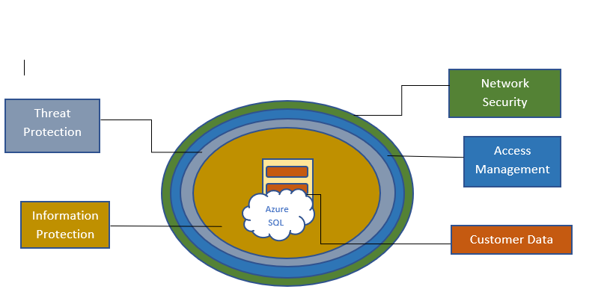compliance verification which the hospital can make use of for the efficient and secure data management [1].

**Data backup, Data recovery and Business continuity**

**Business Continuity**

Microsoft Azure SQL database offers multiple features to keep the business continuity at the optimum level. The main objective is to keep business intact due to infrastructure disruptions. The four major interferences in case of on-premises database are:

* Hardware/software failure
* Data corruption, Data theft or unintentional deletion
* Natural disaster which may cause data center outage
* Unexpected error that may occur during maintenance tasks like upgrades, patches, updates, etc.

Microsoft Azure SQL database offers the following features to overcome the about mentioned disruptions.

**High availability Architecture**

High availability means making sure that the database is up and running at the maximum time possible. The goal here is to minimize the downtime that could be caused due to hardware, software, network failures, maintenance issues like server updates, backups, windows upgrades, etc. Microsoft Azure takes care of all the server and database-related hardware, software, and network issues and maintenance-related issues [6]. Hence Microsoft Azure offers 99% uptime based on our subscription type. Microsoft Azure has an auto-backup feature, that makes sure that data is not lost if there is any software failure.

**Data Backup and recovery**

In the Microsoft Azure SQL database, database backups are executed by default. The first backup will occur soon after the creation of a new SQL Azure database. This auto backup is stored in the same Azure region which is known as availability sets which makes the recovery process quick and easy. After the first backup, the remaining backups are scheduled by Microsoft Azure based on the subscription level. Microsoft Full database backups occur weekly. Microsoft Azure databases use the Full Recovery Model, which enables us to restore the database to a point-in-time. The backup retention period in Microsoft Azure depends on the service-tier that we select. The basic service-tier provides a 7-day retention policy. Standard and Premium service-tiers offer 35-day retention policies. Long-term backup retention is possible by configuring Microsoft Azure SQL backups for the long-term using the “Recovery Service Vault” option [1].

Microsoft Azure cloud database is resilient and also recover efficiently from failures and continue to function with negligible downtime before recovery. Once recovered the database will run in a good state without any downtime [7]. Data recovery plays a vital role in terms of business continuity and causes huge loss if performed inefficiently. Microsoft Azure cloud database used MTTR (Mean Time to Recovery) and MTBF (Mean Time between Failure) to determine to add redundancy for the clients. Microsoft Azure cloud database establishes recovery metrics called RTO (Recovery time objective) which means maximum allowed time application can have downtime after any kind of service disruption incident. RTO is set based on our SLA selection. The organization has selected 99.9% SLA in which 10.1minutes of downtime is allowed during recovery [1].

Microsoft Azure also facilitates inbuilt data partitioning. In each module of the application data that is used often and instantly required will be made available by default and the remaining data will be made available on demand.

**Geo-replication**

When there is an on-premises database, if there is a data center outage, it causes business disruption. But when the hospital migrates from the on-premises database to the Microsoft Azure SQL database, even when there is a data center failure, the business will not be disrupted [8]. Microsoft Azure SQL database offers the geo-replication feature. Microsoft Azure has multiple availability regions across the globe. Each availability region will have two or more data centers. Based on the clients’ selection of the failover availability region, the database will be restored to another data center which is in another Microsoft Azure region. Microsoft provides the liberty to the client to select between automatic failover or manual failover. In the case study, the hospital will select the automatic failover option [1]. This process may take few seconds. Since the failover Microsoft region will be located in another location, business continuity will be maintained even during unexpected events like natural disasters. Microsoft Azure allows us to select the regions according to our requirements based on technical and regulatory considerations, service capabilities, data residency, compliance requirements, and latency. In the case study, we are selecting two regions. Microsoft Azure Central US will be used as our primary Microsoft azure region and Microsoft Azure East US will be used as the failover region.

* Microsoft Azure Central US
* Microsoft Azure East US (Used as the failover region)

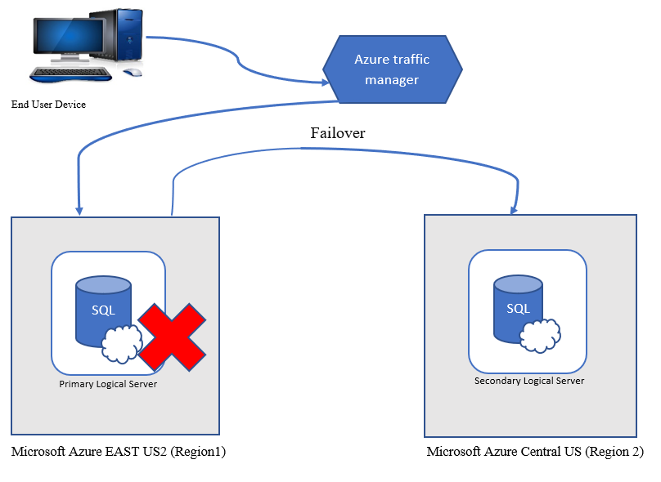

**Scalability**

Scalability is a feature in which the resources are added as per the requirements. Microsoft Azure offers two types of scalability options.

* Vertical scalability: In vertical scalability compute capacity of resources can be increased like CPU power, Memory, Storage [1].
* Horizontal scalability: In horizontal scalability secondary replica is created mainly for load balancing. This is also known as high-availability architecture. This high availability architecture is only available for the Hyperscale service tier. This service is not included in the Basic and Standard service tiers [1].

As the usage of the database application increases, performance decreases due to arriving workload. Adding more resources to the database aids in handling the workload. This process is call provisioning resources. The hospital can provision and de-provision resources as per the demand fluctuation. Microsoft Azure offers a pay-as-you-go pricing model. The dynamic scalability feature of the Microsoft Azure SQL database allows the hospital to change the resources as per requirements and pay only for the resources used [9]. In the case study, a manual dynamic scalability feature is used. Microsoft Azure also offers auto scalability. If the client is unaware of the demand fluctuation, they can select the auto scalability feature of Microsoft.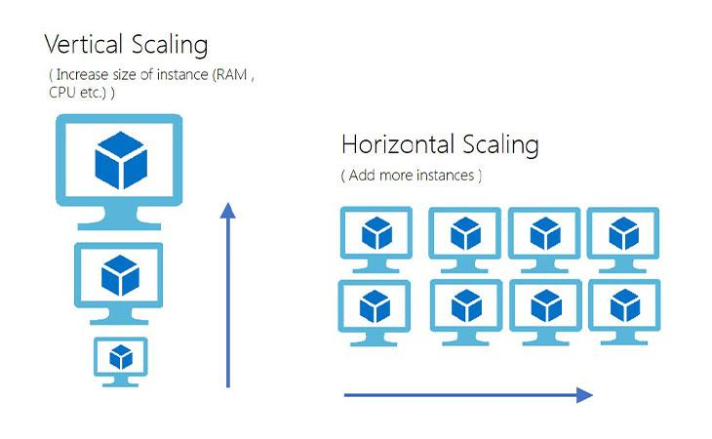

**Database Monitoring**

We need to consider ways to monitor the database performance after migration. Microsoft Azure facilitates monitoring via various monitoring tools. Microsoft Azure also provides an option to customize the reports and automate the process of reporting according to the application requirement [10].

Azure intelligent performance monitoring option provides an option to generate detailed reports on resource-consuming queries, long-running queries, which can be used for analysis and enhancement of database performance. Azure facilitates the development team to easily build the pipeline from development to deployment. This enables faster production deployment in an organization with minimal risk in end-moment fixes. An Azure resource is an instance of an Azure service, such as a web application, VMs, or SQL Database. Azure Resource Health helps to discover and get support for service problems that affect our Azure resources. It reports on the current and past health of the resources provisioned [1]. If any issues are found with a resource, resource health analyzes additional information to determine the source of the problem and it also describes the action Microsoft is taking to fix the problem and mentions things that we can do to address the issues.

**Cost-efficiency**

TCO Calculator in Azure will be used to estimate the cost savings the organization can achieve by migrating the database to Azure cloud database and the pricing calculator in Microsoft Azure will the hospital to predict the estimated monthly bill. This feature will help the organization to monitor the cost savings and utilize the saved cost on other beneficial features.

# 6. Implementation

**Database Implementation-Prototype**

**Database table creation:**

**Table1: (user_type)**

Create table user_type (user_type_id int not null primary key identity,

user_type_desc varchar (20) not null unique);

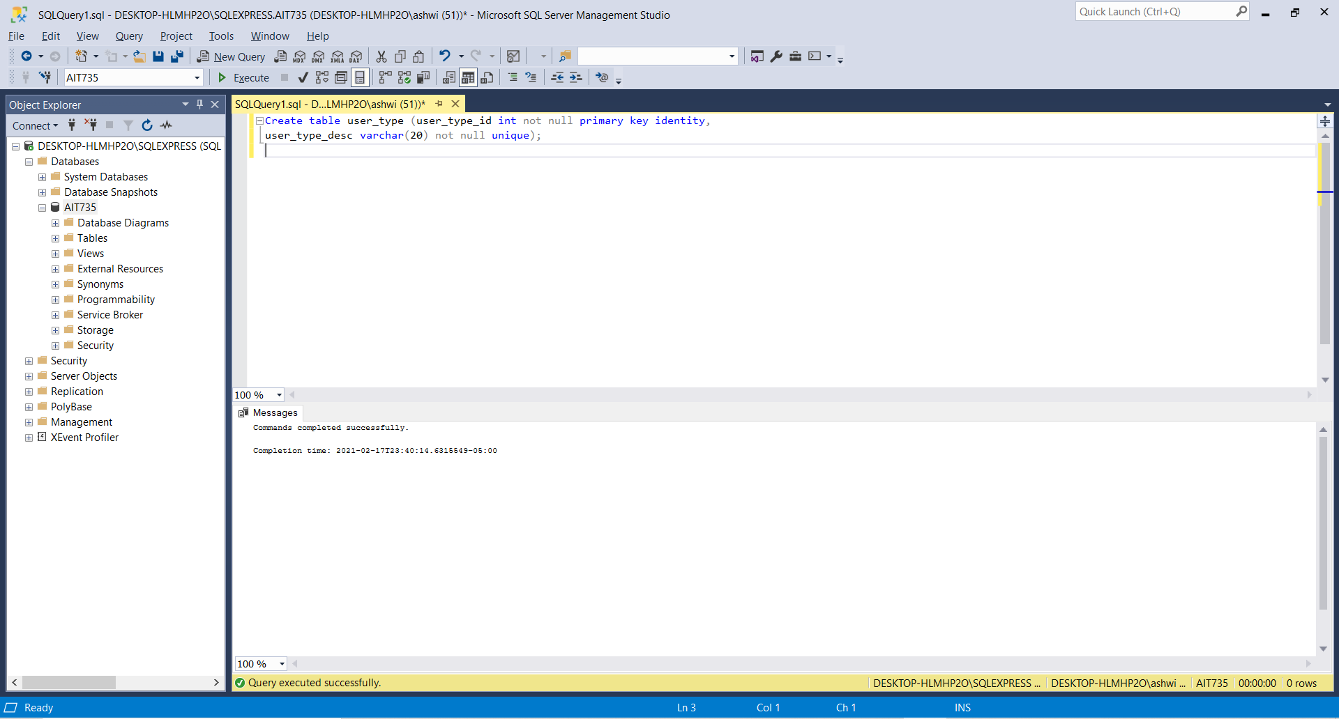

**Table 1: Constraints**

alter table user_type

add unique (user_type_desc), constraint user_type_desc check (user_type_desc in ('patient', 'doctor', 'admin'));

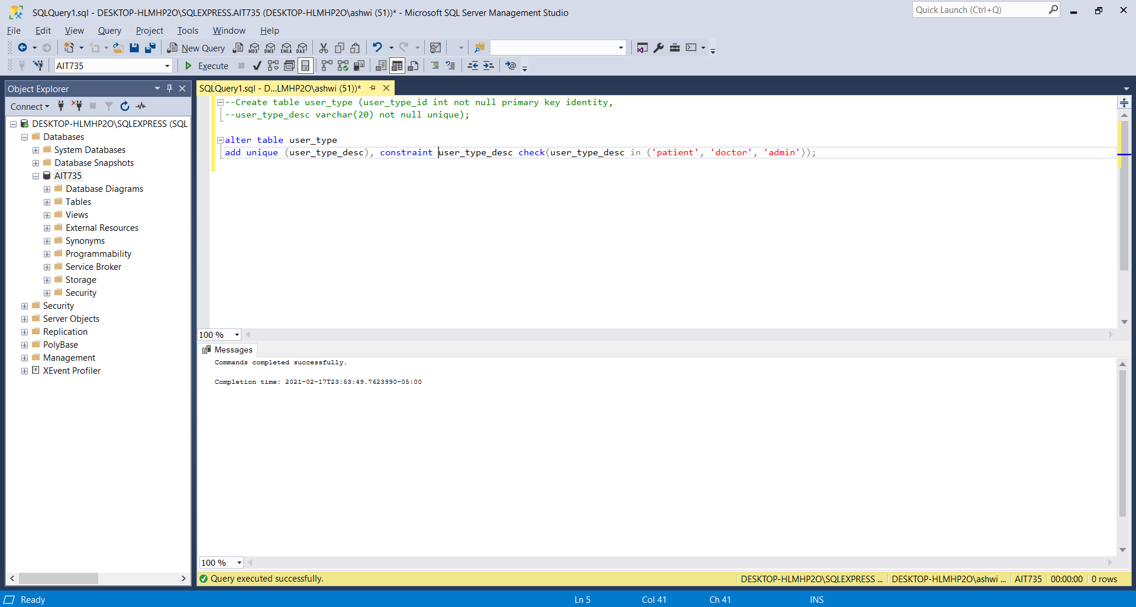

**Table 2: (user_account)**

Create table user_account (user_id varchar(10) not null primary key,

user_type_id int,

Foreign key (user_type_id) references user_type(user_type_id),

Password varchar (20) not null);

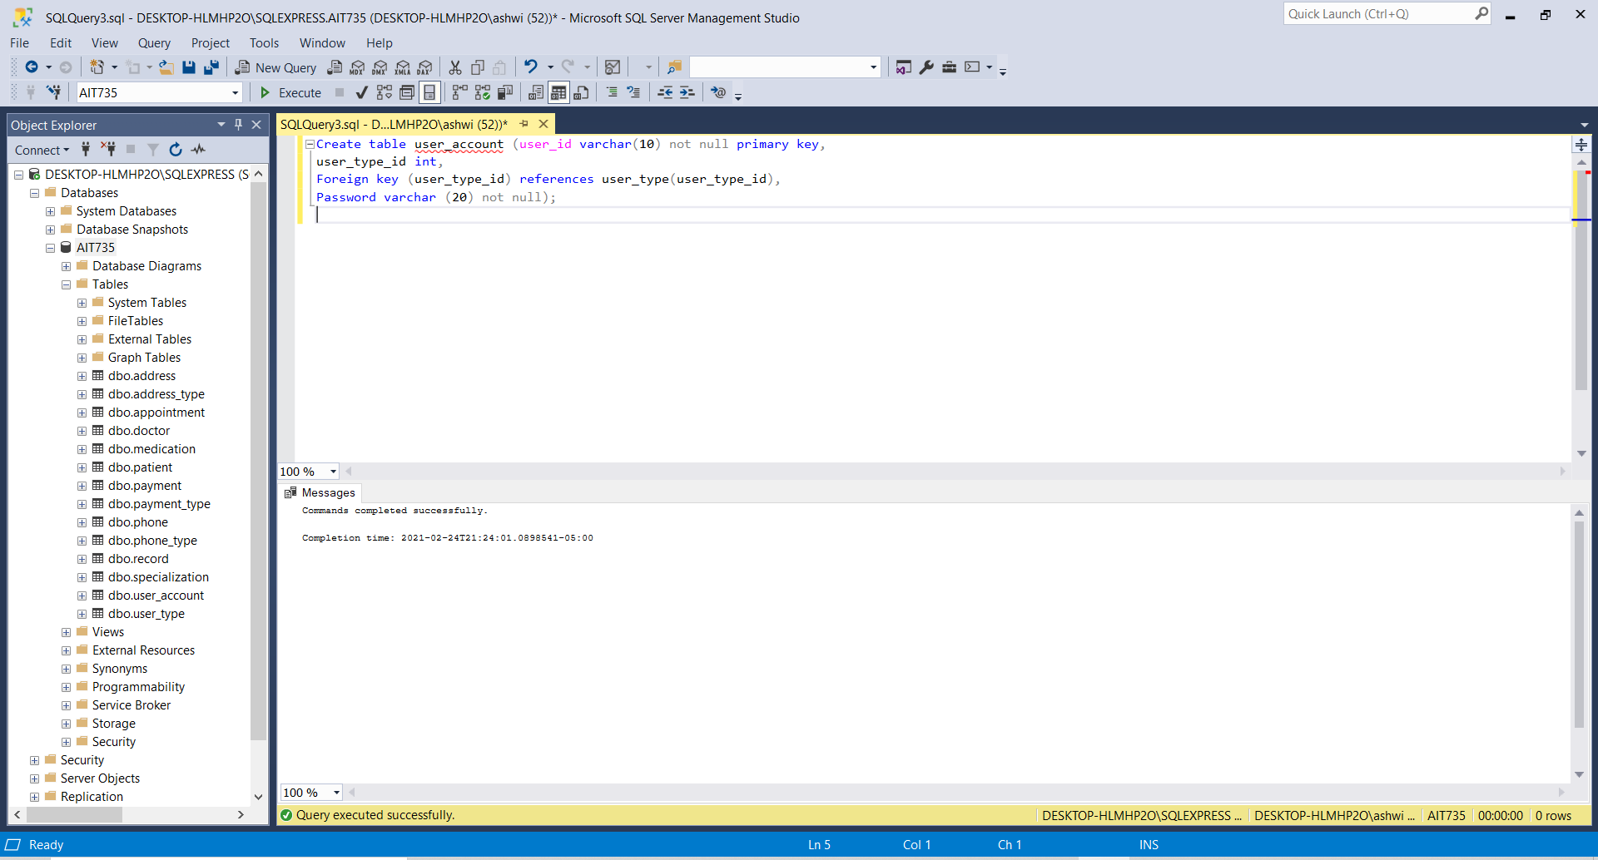

**Table 3: patient**

Create table patient (patient_id int not null primary key,

first_name varchar (20) not null,

last_name varchar (20) not null,

gender char (1) not null,

email_id varchar (20) not null,

date_of_birth date not null,

user_id varchar(10) not null,

account_balance int not null,

foreign key (user_id) references user_account(user_id));

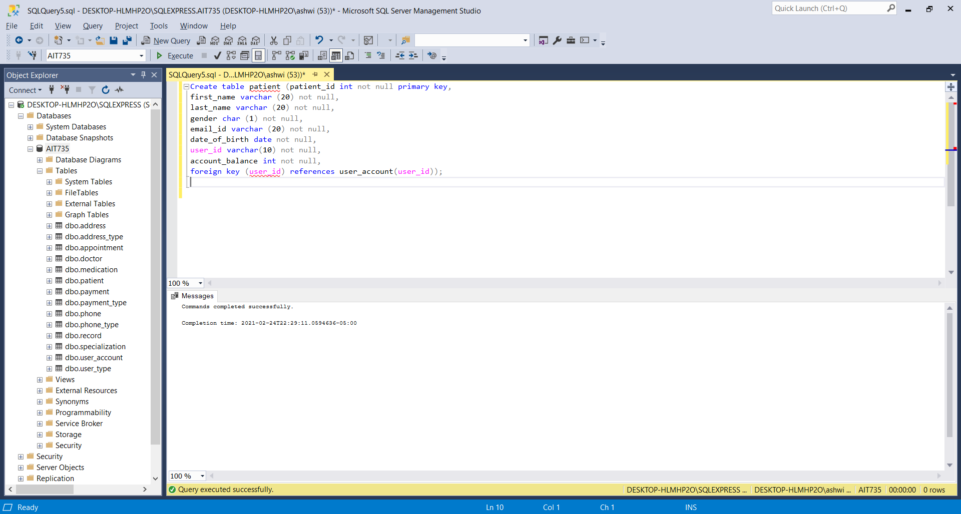

**Changed the data type of the column account_balance to numeric:**

alter table patient

alter column account_balance numeric(5,2);

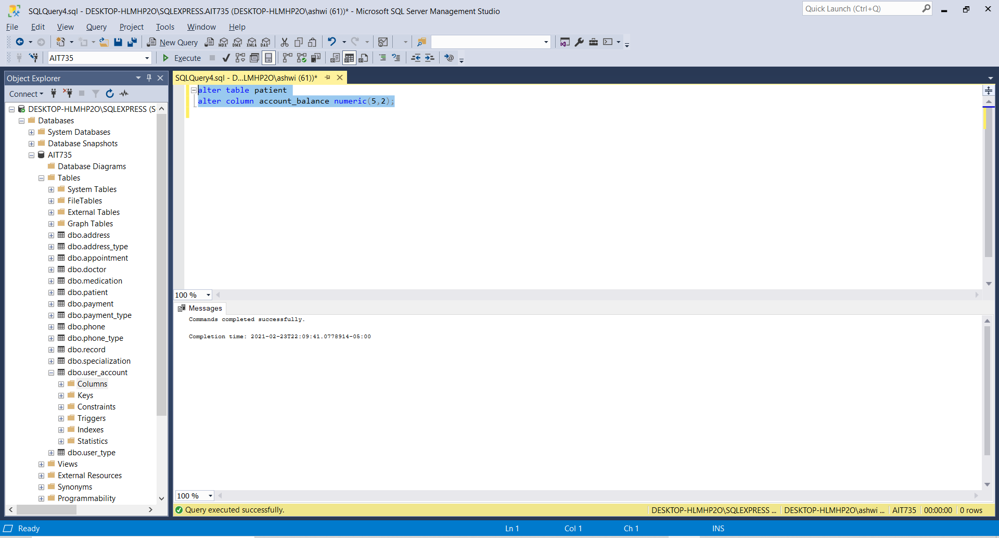

**Table 3: constraints**

alter table patient

add unique (email_id), constraint gender check (gender in ('M','F'));

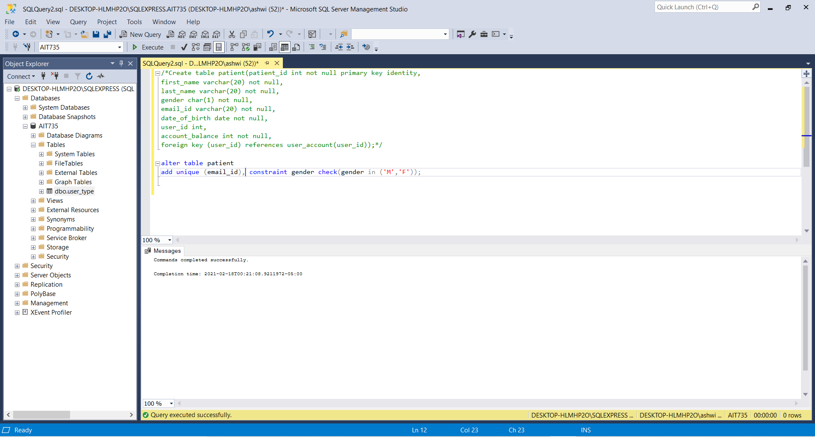

**Table 4: Specialization**

Create table specialization (specialization_id int not null primary key identity,

Specialization_desc varchar (20) not null);

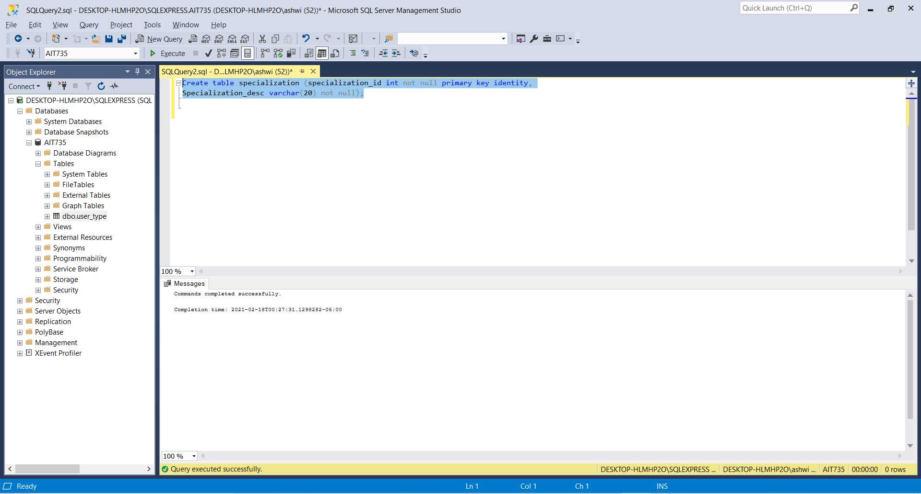

**Table 4 constraints:**

alter table specialization

add unique(specialization_desc), constraint specialization_desc check

(specialization_desc in ('Physician', 'Gynecologist ', 'Pediatrician', 'Allergist', 'Ophthalmologist'));

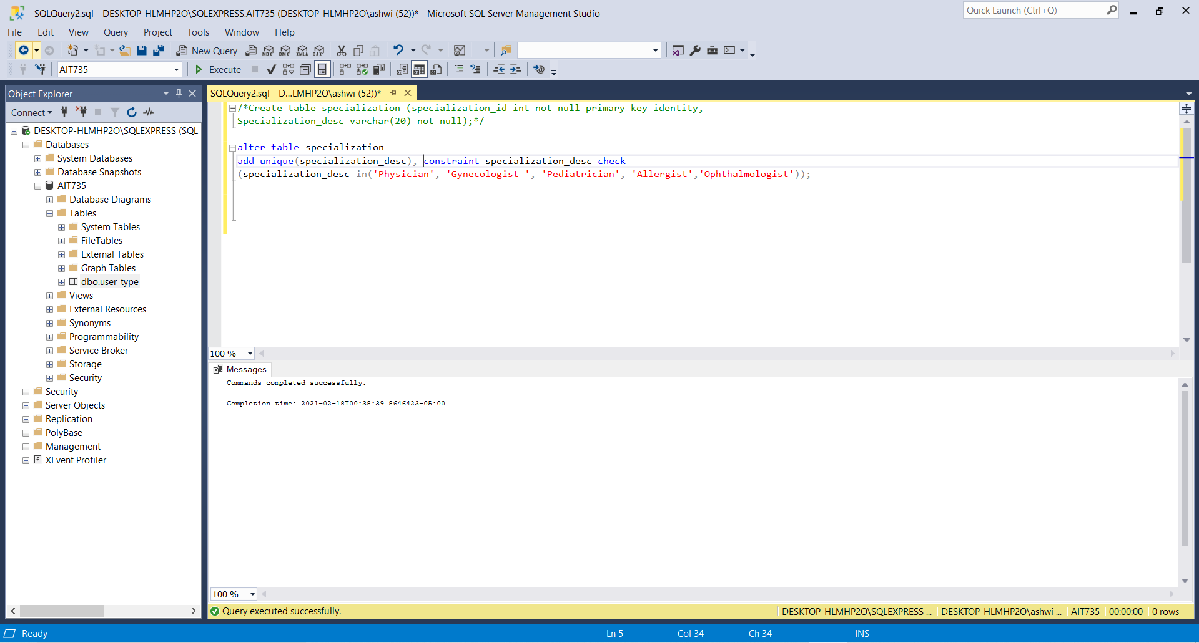

**Table 5: doctor**

Create table doctor (doctor_id int not null primary key identity,

name varchar (20) not null,

email_id varchar (20) not null,

user_id varchar (10) not null,

specialization_id int,

foreign key (specialization_id) references specialization (specialization_id),

date_of_joining date not null,

foreign key (user_id) references user_account(user_id));

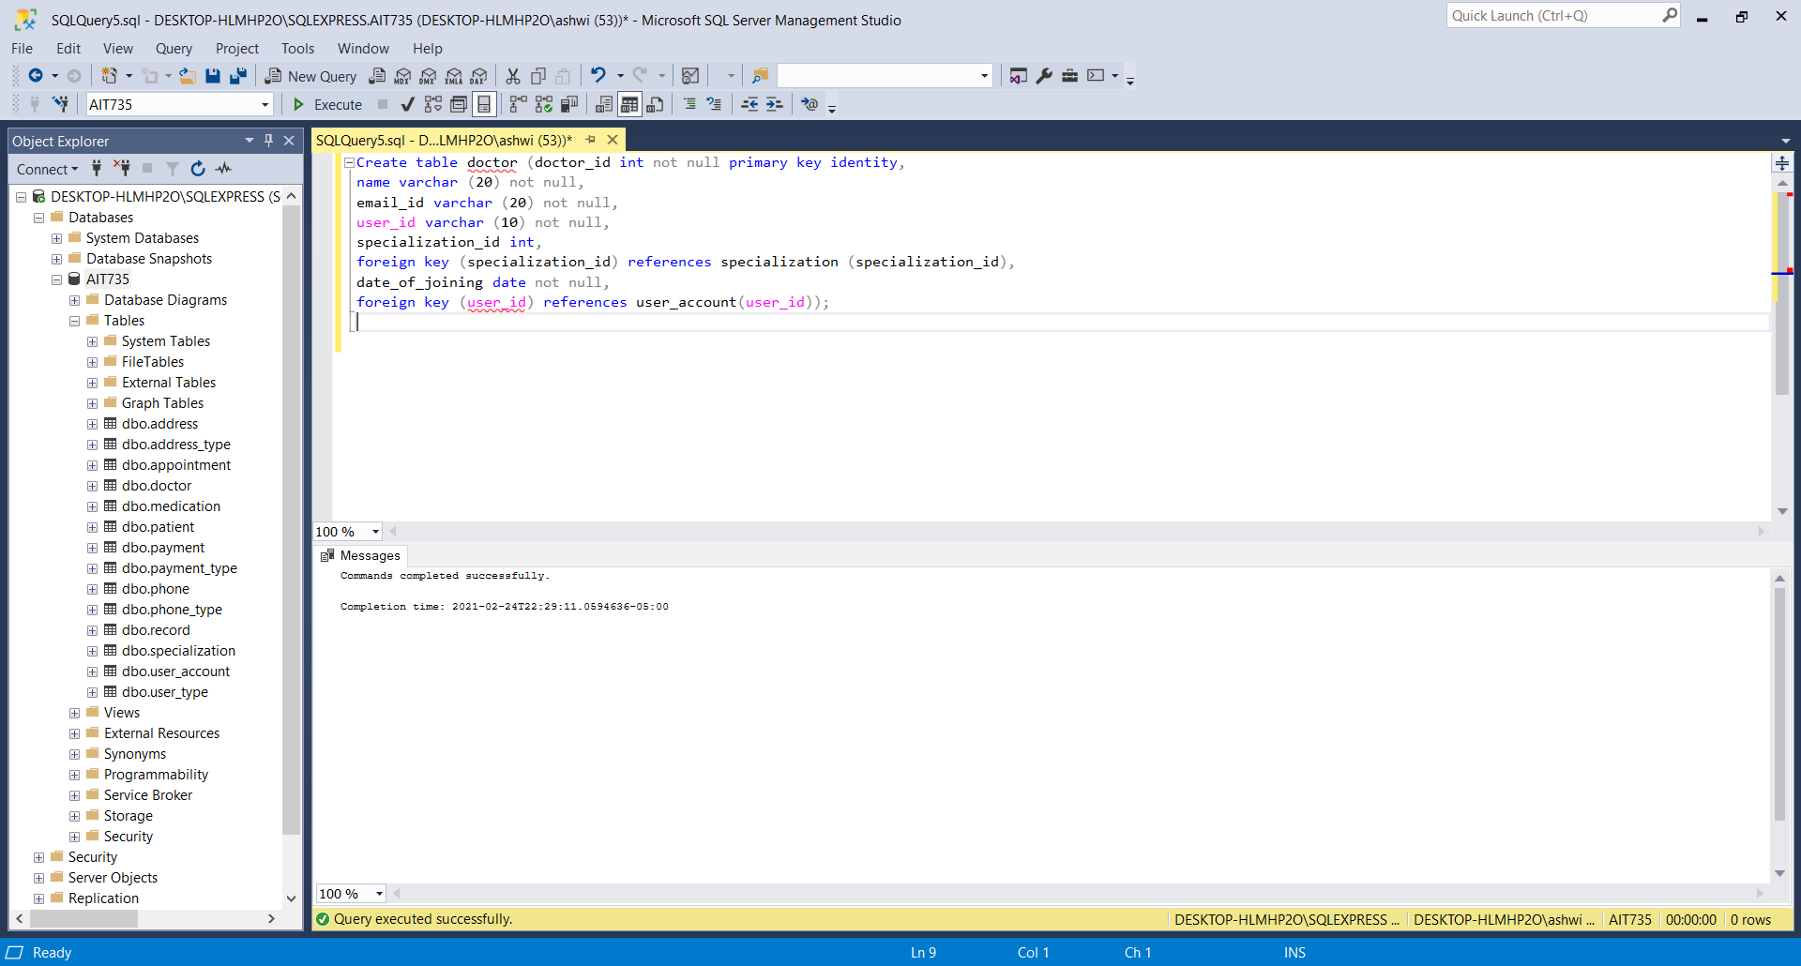

**Table 5: constraints**

alter table doctor

add unique (email_id);

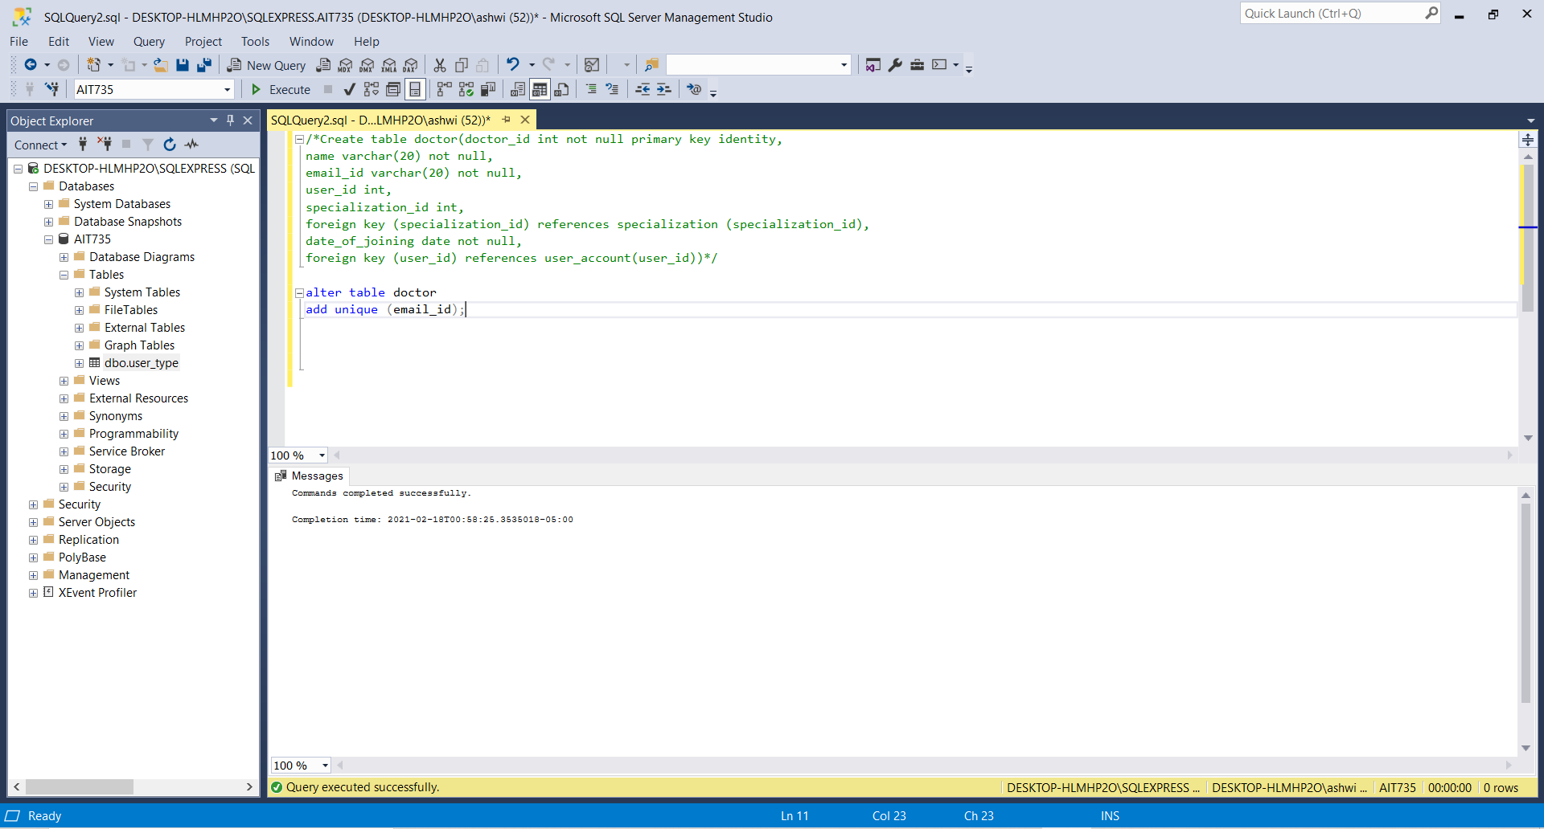

**Table 6: record**

Create table record (record_id int not null primary key identity,

Date_of_visit date not null,

Diagnosis varchar (20) not null,

amount_charged numeric (5,2) not null,

doctor_id int,

patient_id int,

foreign key (doctor_id) references doctor(doctor_id),

foreign key (patient_id) references patient (patient_id));

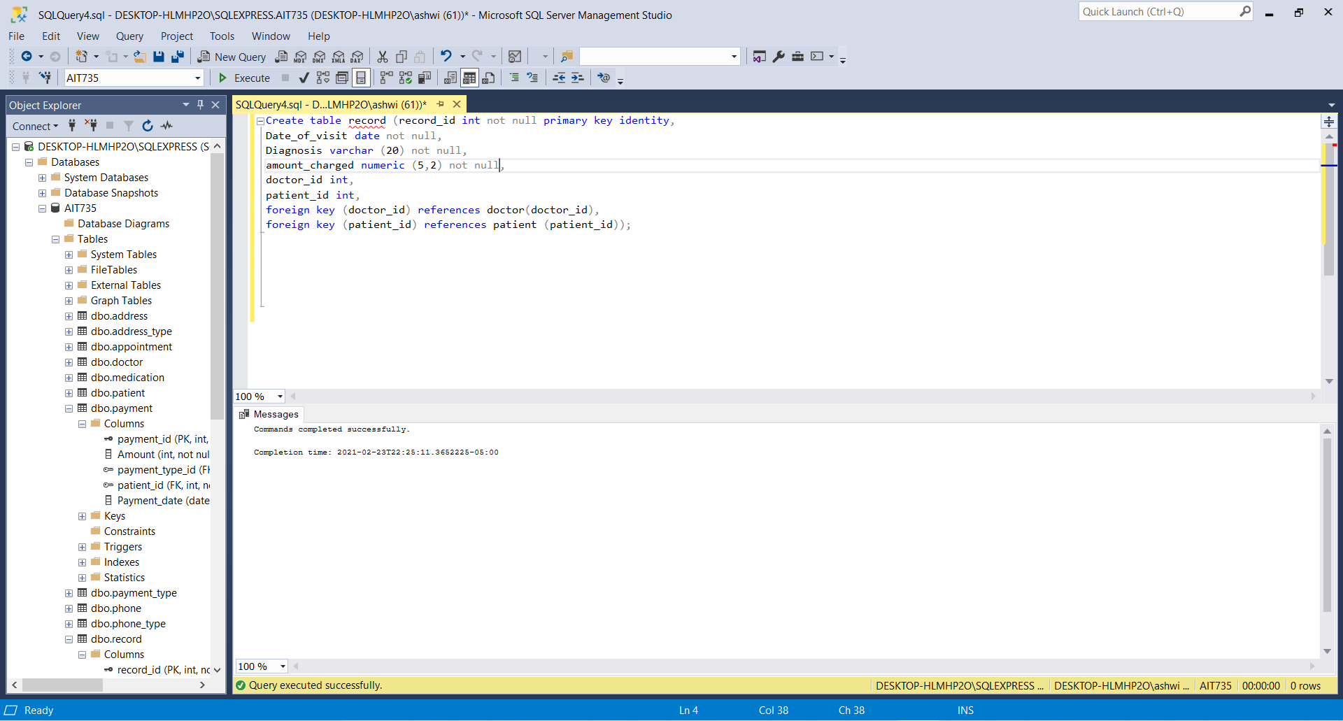

**Table 6: constraint**

alter table record

add check (amount_charged > 0);

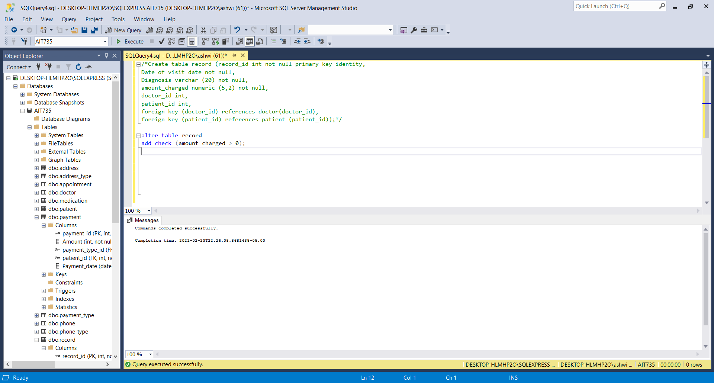

**Table 7: payment_type**

Create table payment_type (payment_type_id int not null primary key identity,

Payment_description varchar (20) not null);

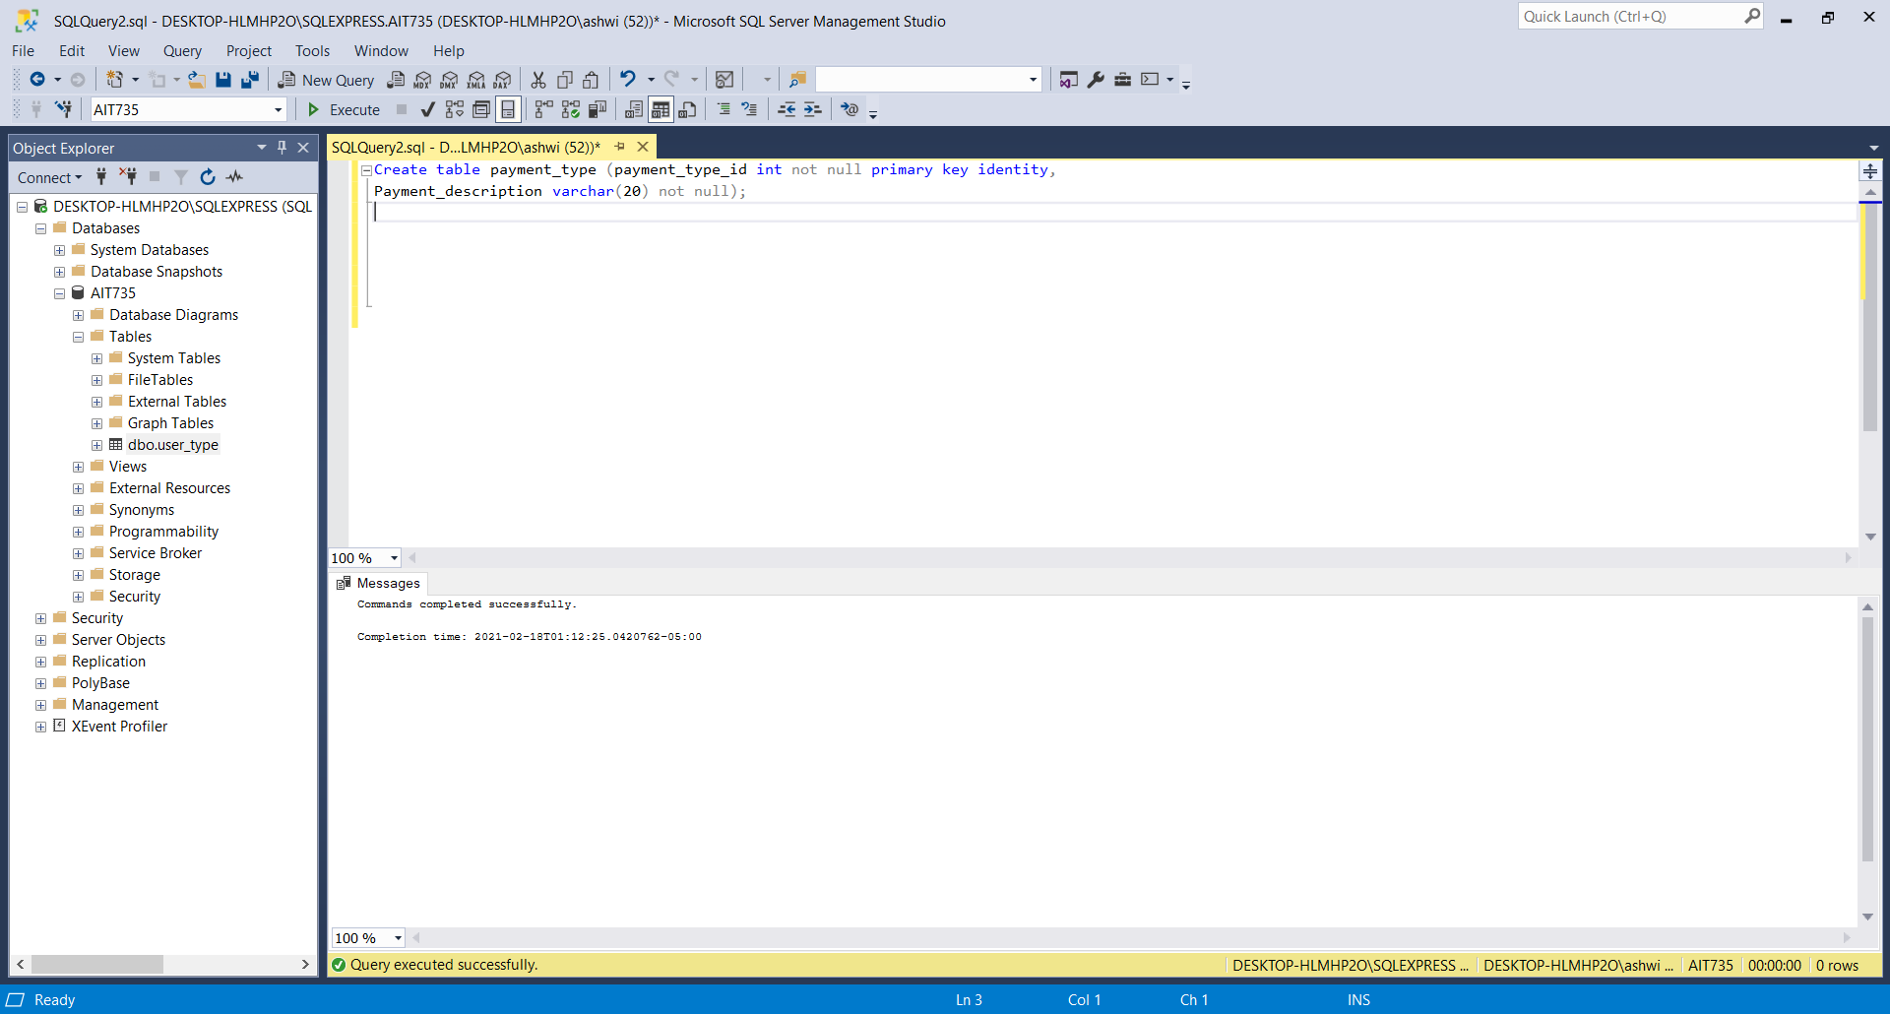

**Table 7: Constraints**

alter table payment_type

add unique (payment_description), constraint payment_description check(payment_description in ('Credit card', 'Debit card', 'check', 'cash'));

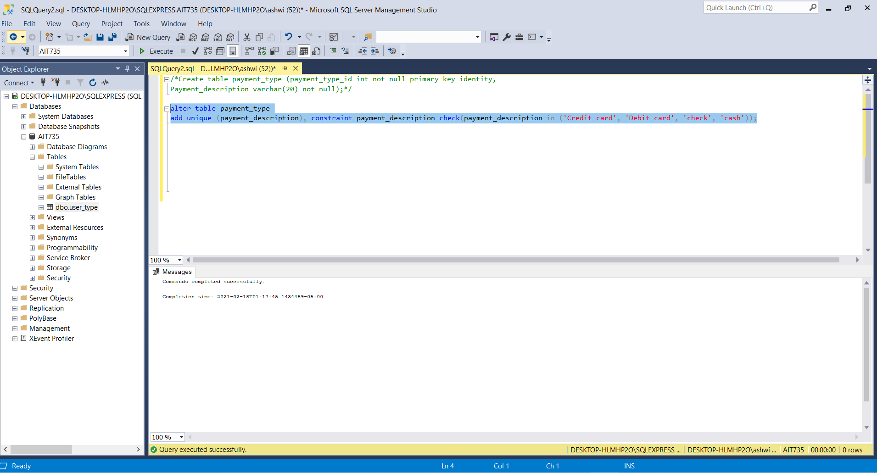

**Table 8: payment**

Create table payment (payment_id int not null primary key identity,

Amount numeric(5,2),

payment_type_id int not null,

patient_id int not null,

Foreign key (payment_type_id) references payment_type (payment_type_id),

Payment_date datetime not null,

Foreign key (patient_id) references patient (patient_id));

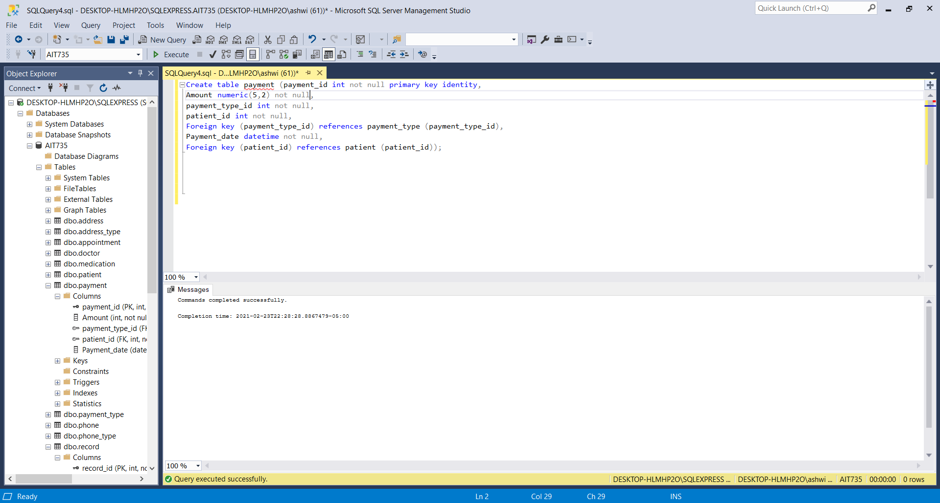

**Table 8: constraint**

alter table payment

add check(amount>0);

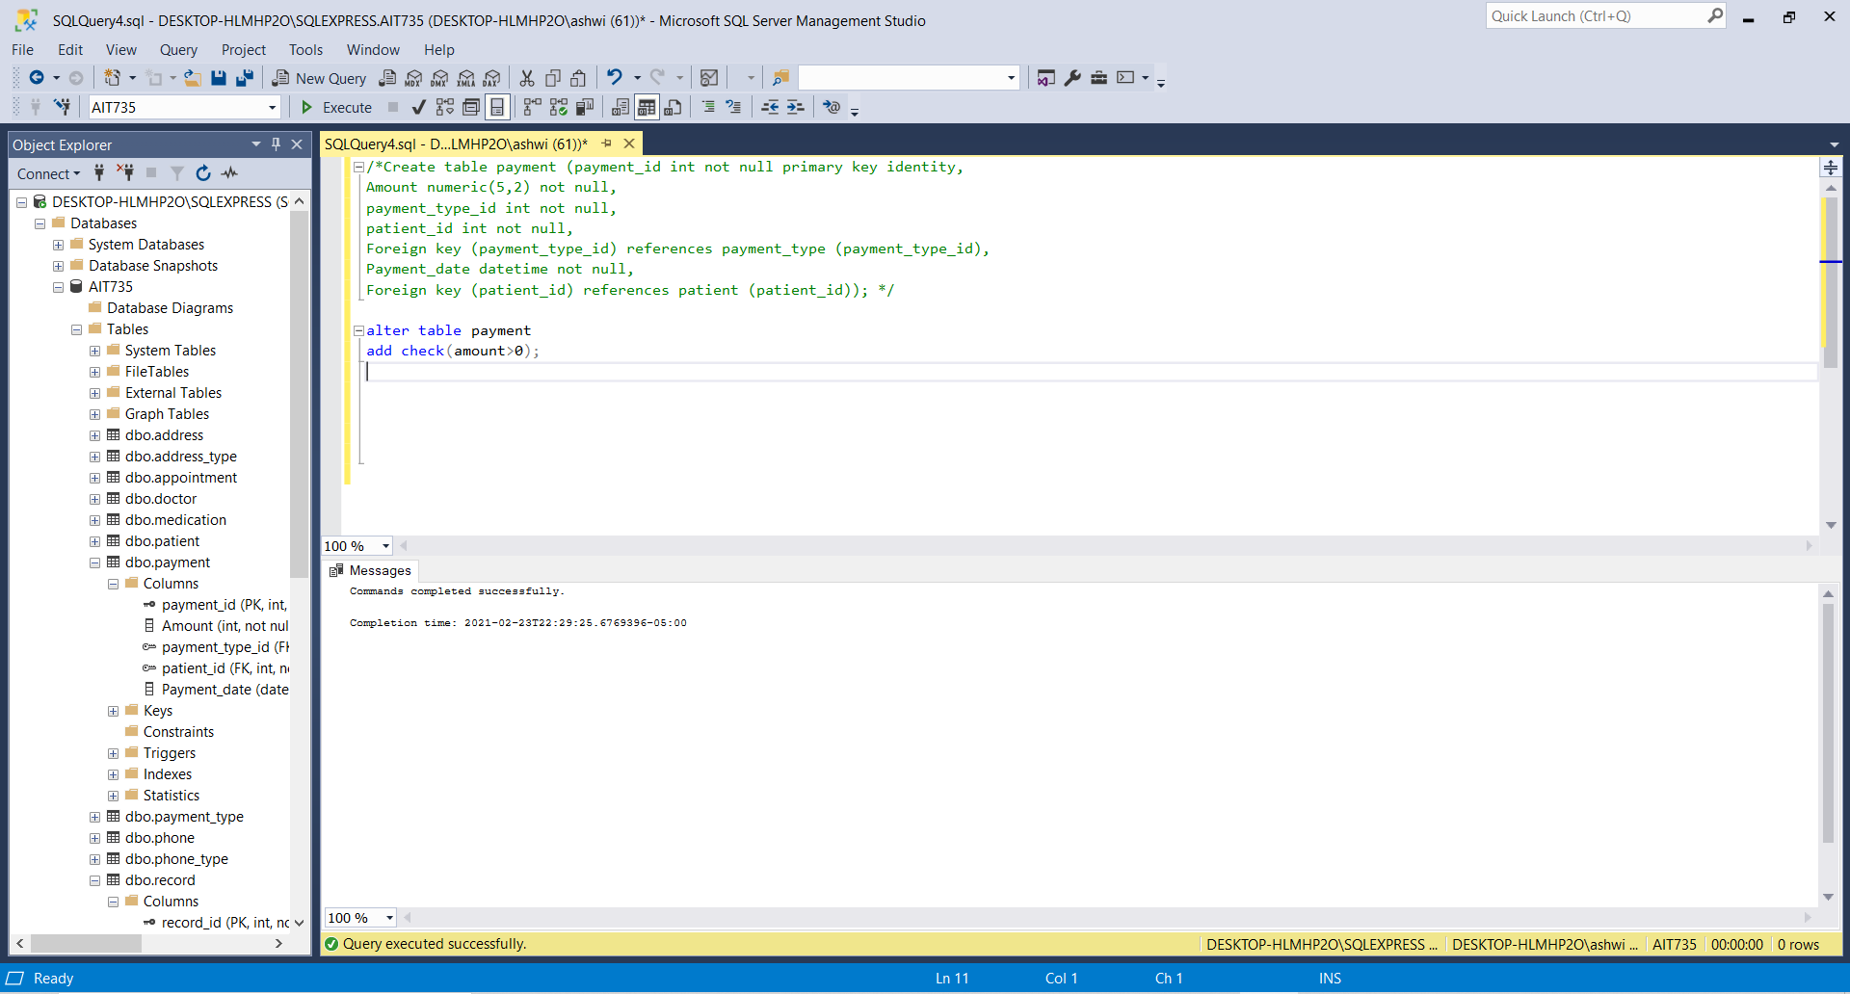

**Table 9: phone_type**

Create table phone_type (phone_type_id int not null primary key identity,

Phone_type_desc varchar(20) not null);

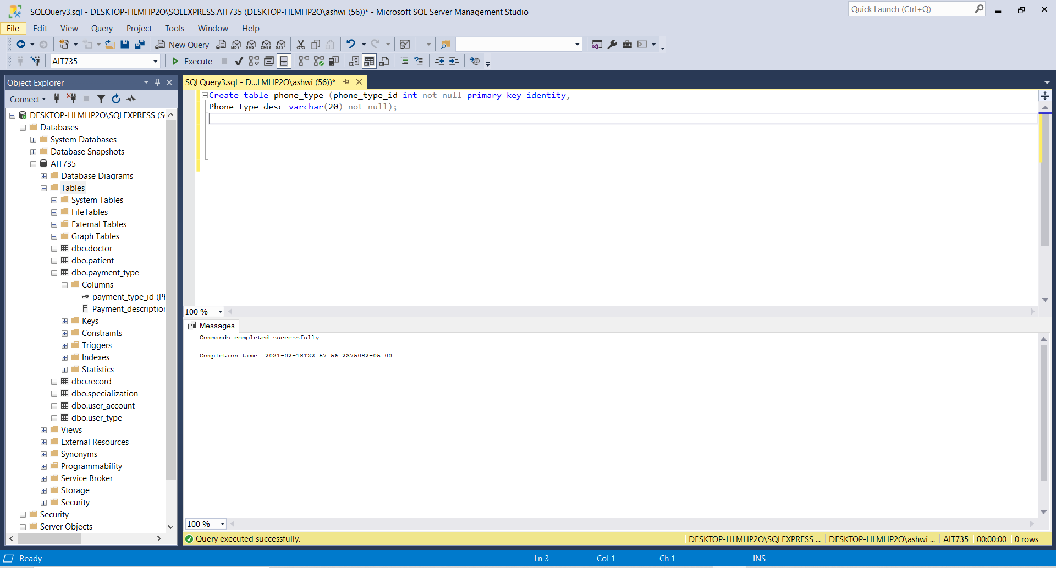

**Table 9: constraints**

alter table phone_type

add unique(phone_type_desc), constraint phone_type_desc check(phone_type_desc in('Daytime phone', 'Mobile', 'Evening phone'));

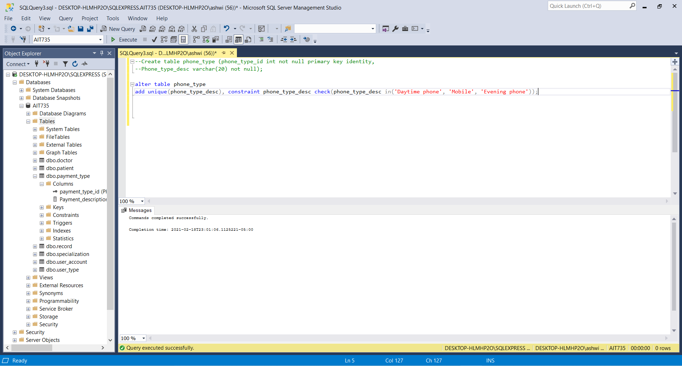

**Table10: Phone**

Create table phone (phone_id int not null primary key identity,

phone_type_id int not null,

user_id varchar(10) not null,

Foreign key (phone_type_id) references phone_type(phone_type_id),

Foreign key (user_id) references user_account(user_id),

Phone_number varchar(20) not null);

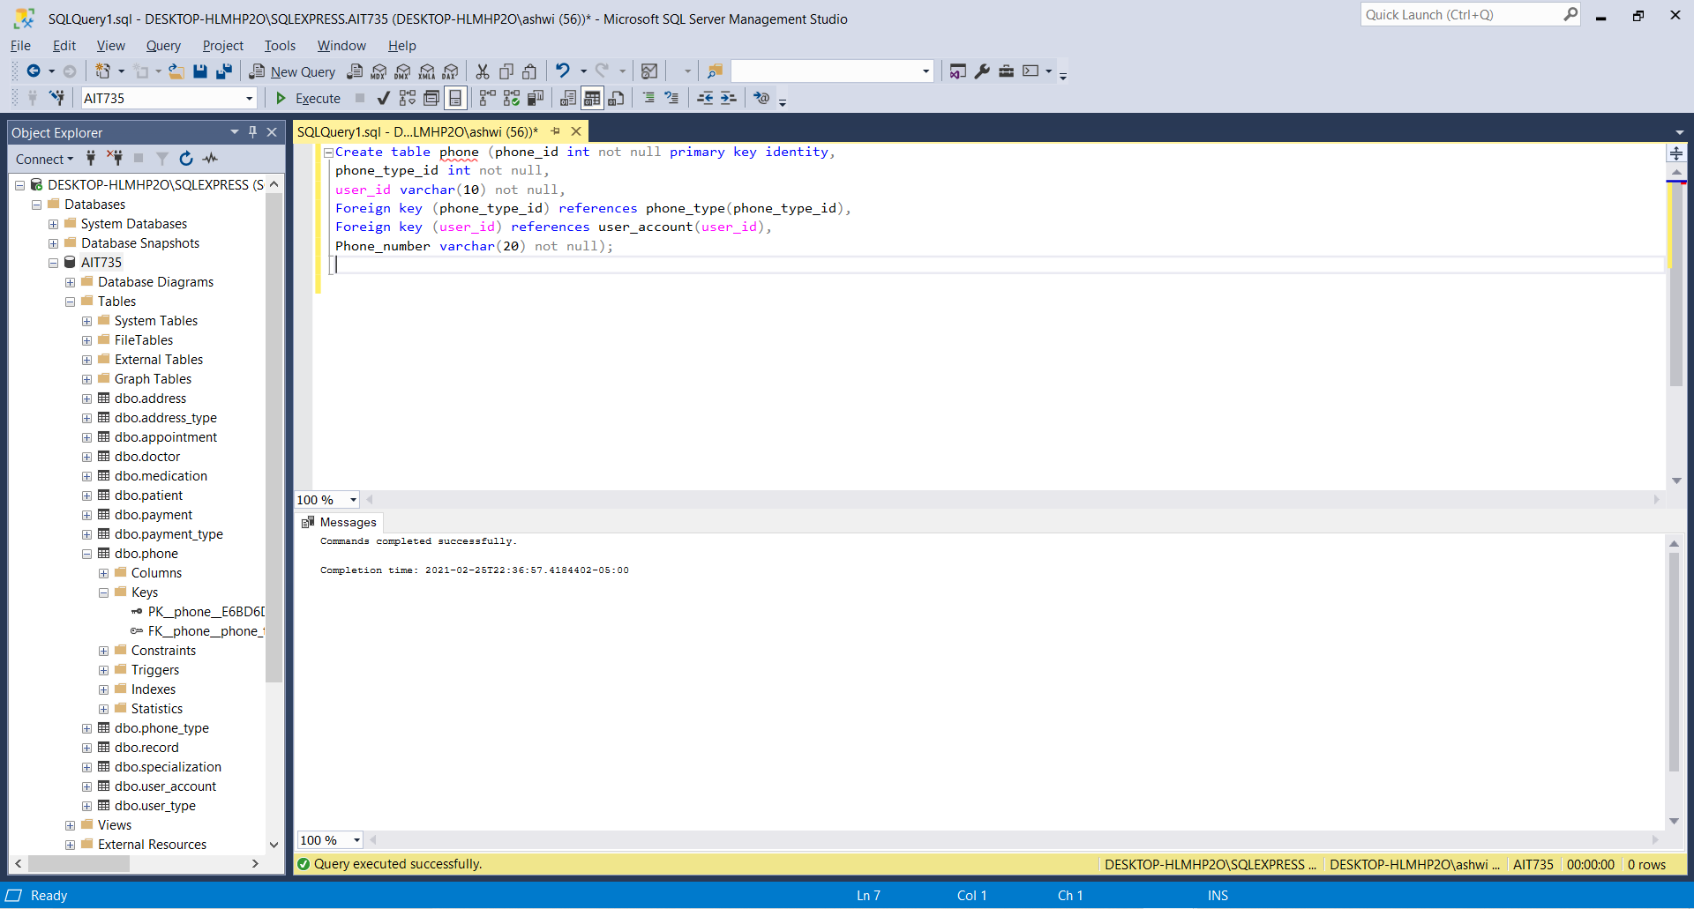

**Table 11: address_type**

Create table address_type (address_type_id int not null primary key identity,

address_type_desc varchar(30) not null);

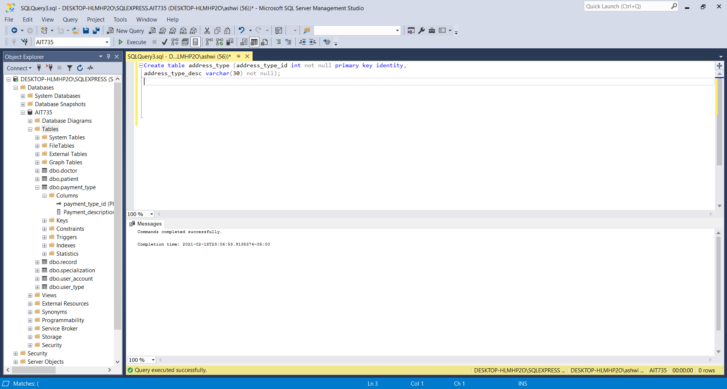

**Table 11: constraints**

alter table address_type

add unique (address_type_desc), constraint address_type_desc check(address_type_desc in(‘Mailing address’, ‘Permanent address’));

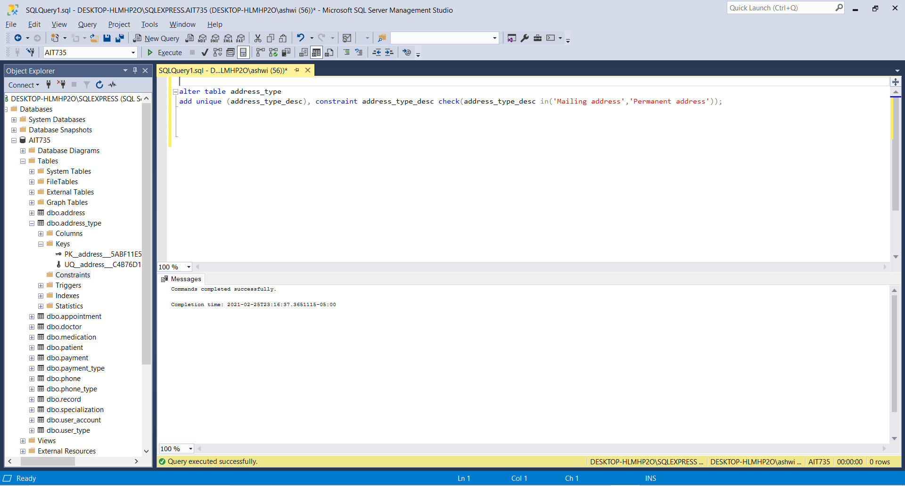

**Table 12: address**

Create table address (address_id int not null primary key identity,

address_type_id int,

user_id varchar(10) not null,

Foreign key (address_type_id) references address_type(address_type_id),

Foreign key (user_id) references user_account(user_id),

street varchar (20) not null,

city varchar (15) not null,

zipcode char(5) not null);

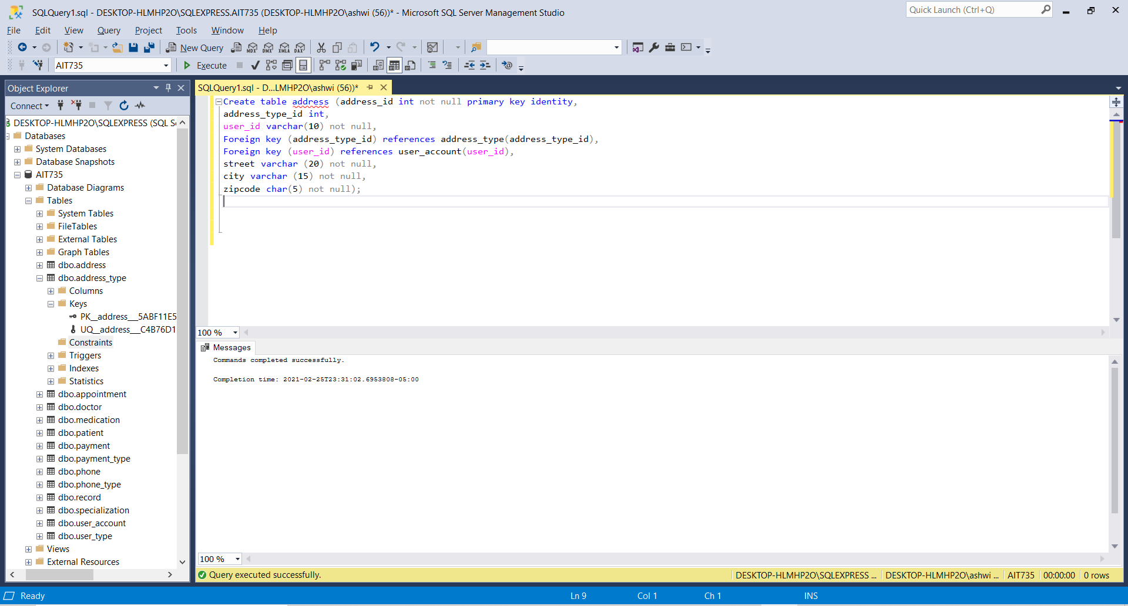

**Table 13: appointment**

Create table appointment (appointment_id int not null primary key identity,

patient_id int,

doctor_id int,

Foreign key (patient_id) references patient(patient_id),

Foreign key (doctor_id) references doctor(doctor_id),

Reason_of_visit varchar(25) not null);

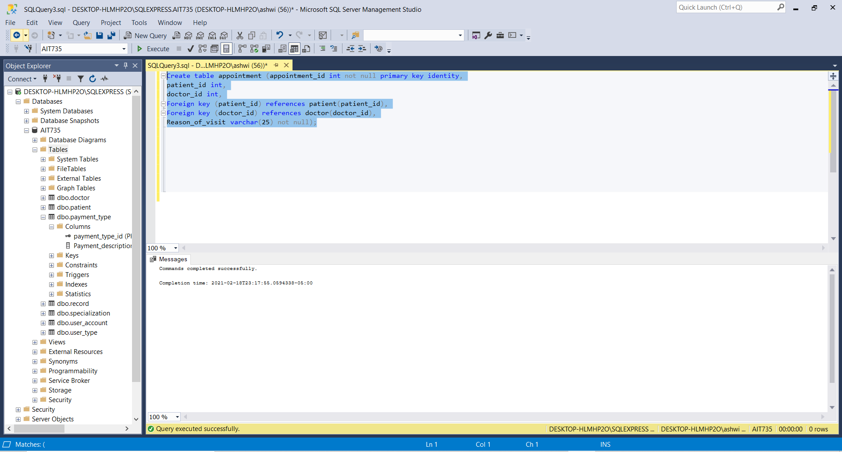

**Table 14: medication**

Create table medication (medication_id int not null primary key identity,

patient_id int,

doctor_id int,

Foreign key (patient_id) references patient(patient_id),

Foreign key (doctor_id) references doctor(doctor_id),

Medication_name varchar(20) not null,

Dosage varchar (15) not null);

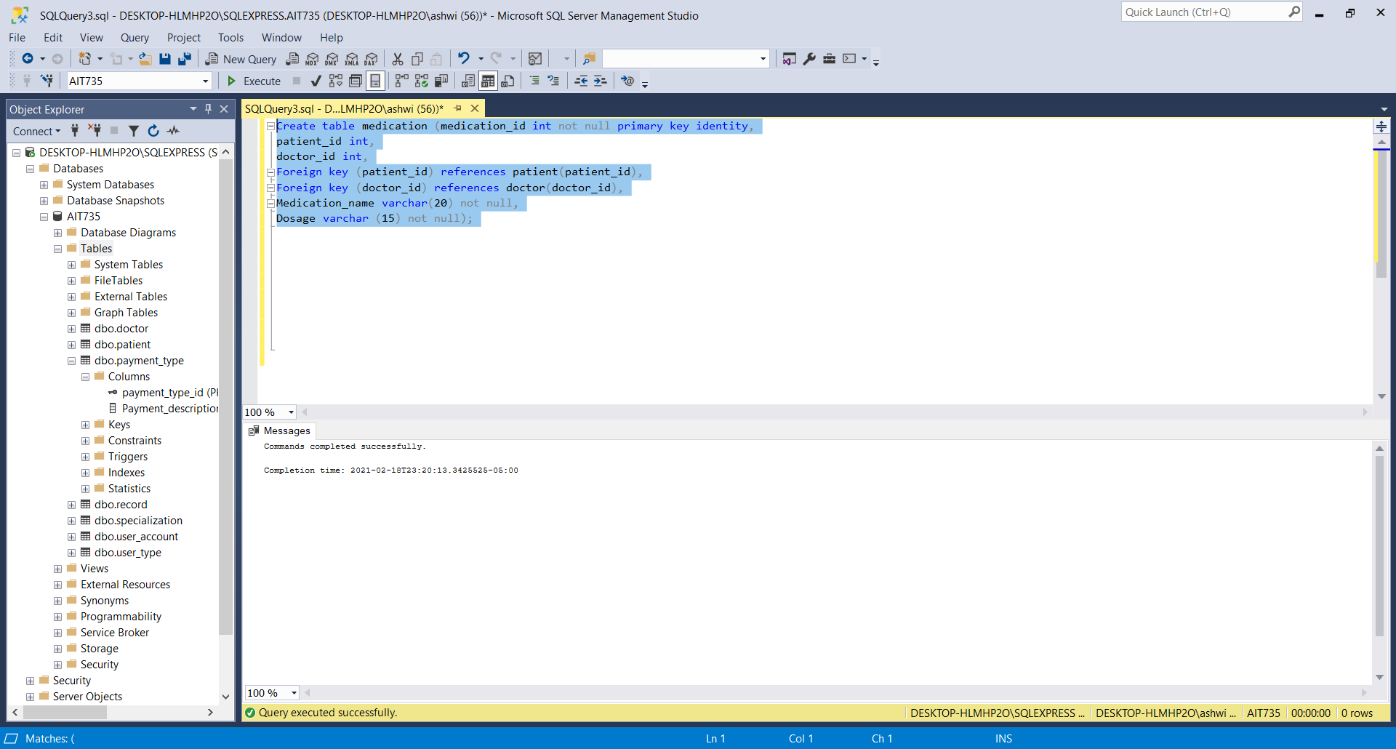

**Insertion of sample data into database tables**

**Table 1: user_type**

**Code:**

Insert into user_type values(‘admin’);

Insert into user_type values(‘doctor’);

Insert into user_type values(‘patient’);

Select * from user_type;

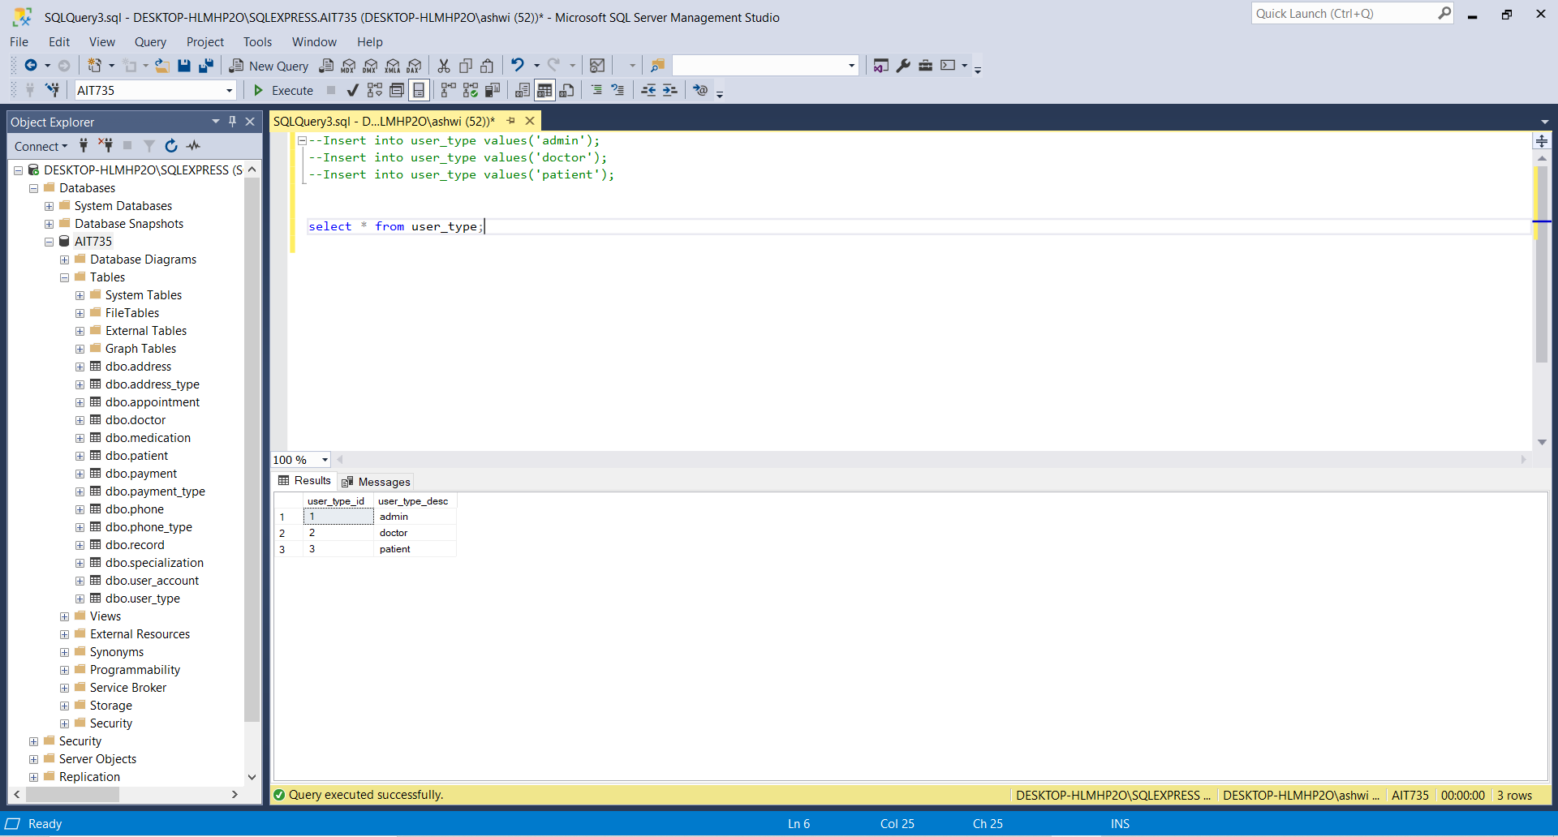

**Table 2: user_account**

**Foreign key reference codes:**

User_type_id for Admin user type: 1

User_type_id for Doctor user type: 2

User_type_id for Patient user type: 3

**User_id Identification:**

User_id for the Admin starts with A

User_id for Doctor starts with D

User_id for Patient starts with P

**Code:**

insert into user_account values(‘A001’,1,’pass001’);

insert into user_account values(‘A002’,1,’pass102’);

insert into user_account values(‘D001’,2,’word001’);

insert into user_account values(‘D002’,2,’word102’);

insert into user_account values(‘P001’,3,’pword001’);

insert into user_account values(‘P002’,3,’pword102’);

select * from user_account;

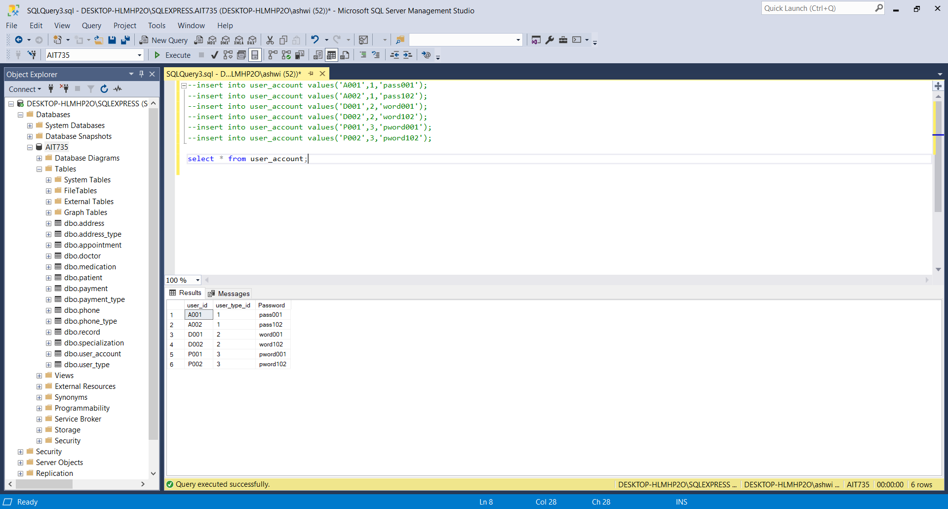

**Table 3: Patient**

**Foreign key reference codes:**

User_id for patient: P001 and P002

**Code:**

insert into patient values(‘Ashwini’,’Prakash’,’F’,’ash@gmail.com’,’1988-04-30’,’P001’,800.85);

insert into patient values(‘Scott’,’Ellison’,’M’,’Scott@gmail.com’,’1985-05-25’,’P002’,600.92);

select * from patient;

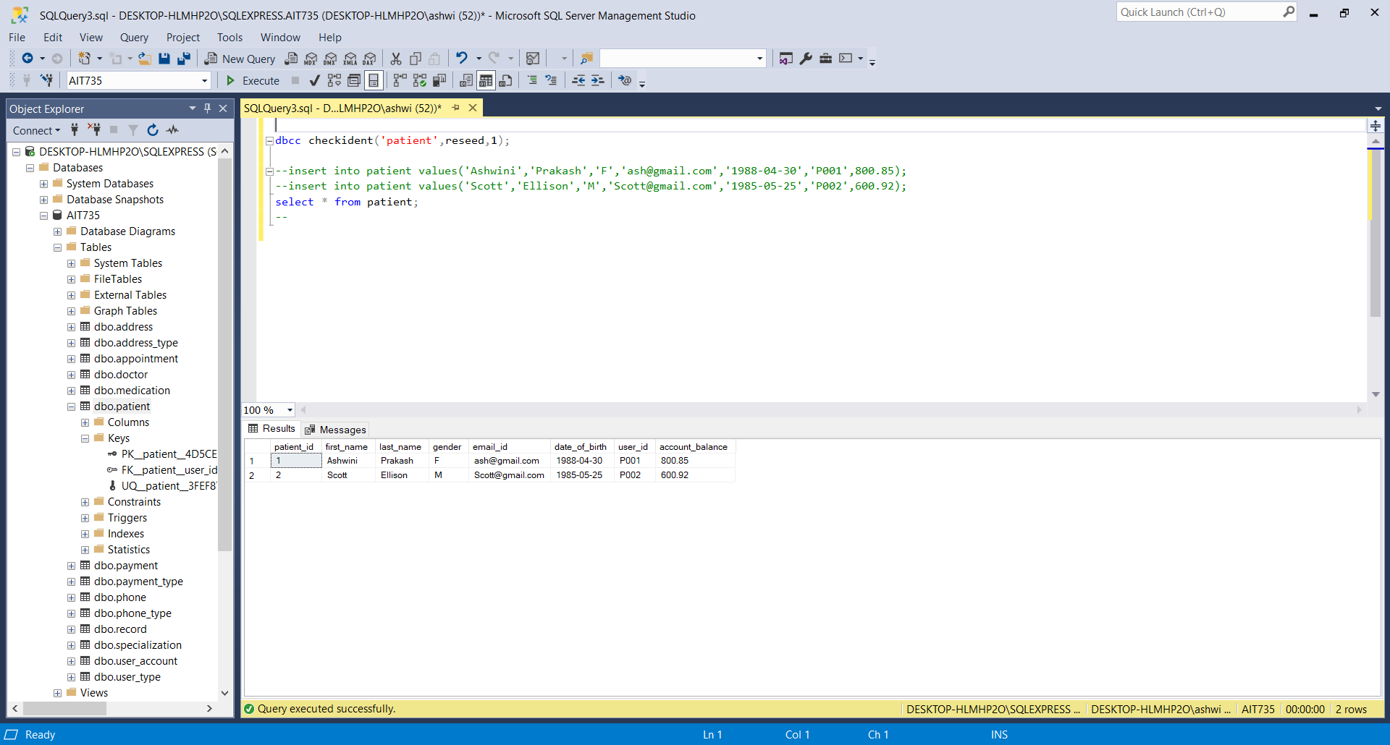

**Table 4: specialization**

**Foreign key reference codes:**

**Code:**

insert into specialization values (‘Physician’);

insert into specialization values (‘Gynecologist’);

insert into specialization values (‘Pediatrician’);

insert into specialization values (‘Allergist’);

insert into specialization values (‘Ophthalmologist’);

select * from specialization;

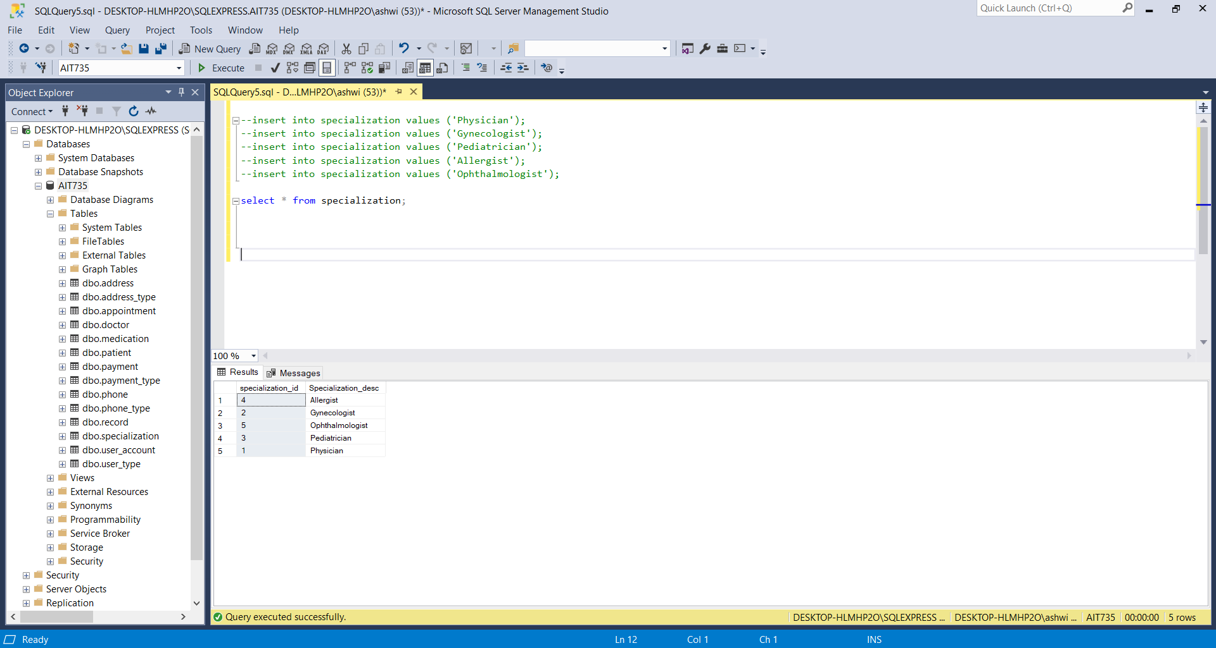

**Table 5: doctor**

**Code:**

insert into doctor values (‘Mathew Ryan’, ‘mat@gmail.com’, ‘D001’, 1, ‘2020-10-23’);

insert into doctor values (‘Suman Roy’, ‘suman@gmail.com’, ‘D002’, 2, ‘2019-09-25’);

select * from doctor;

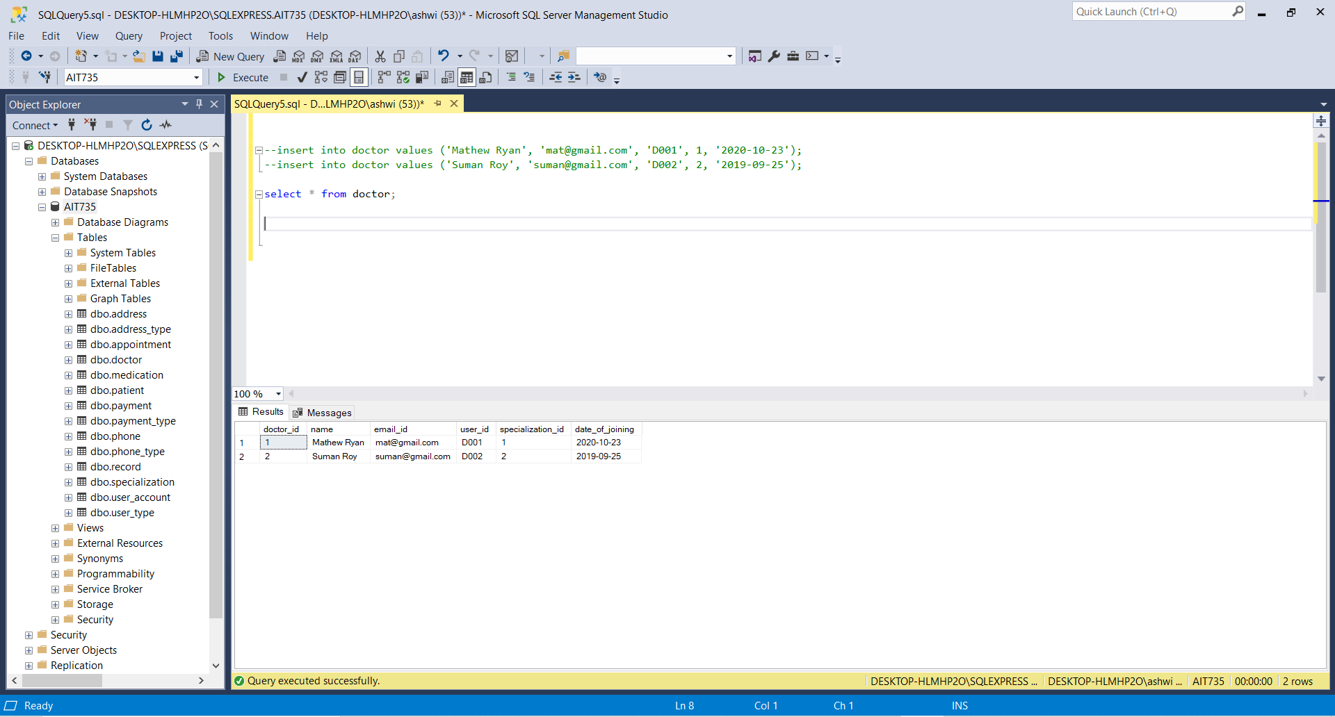

**Table 6: record**

**Code:**

insert into record values (‘2021-02-24’,’Diabetes’, 50.0, 1,1);

insert into record values (‘2021-02-22’,’Cyst’, 50.0, 2,2);

select * from record;

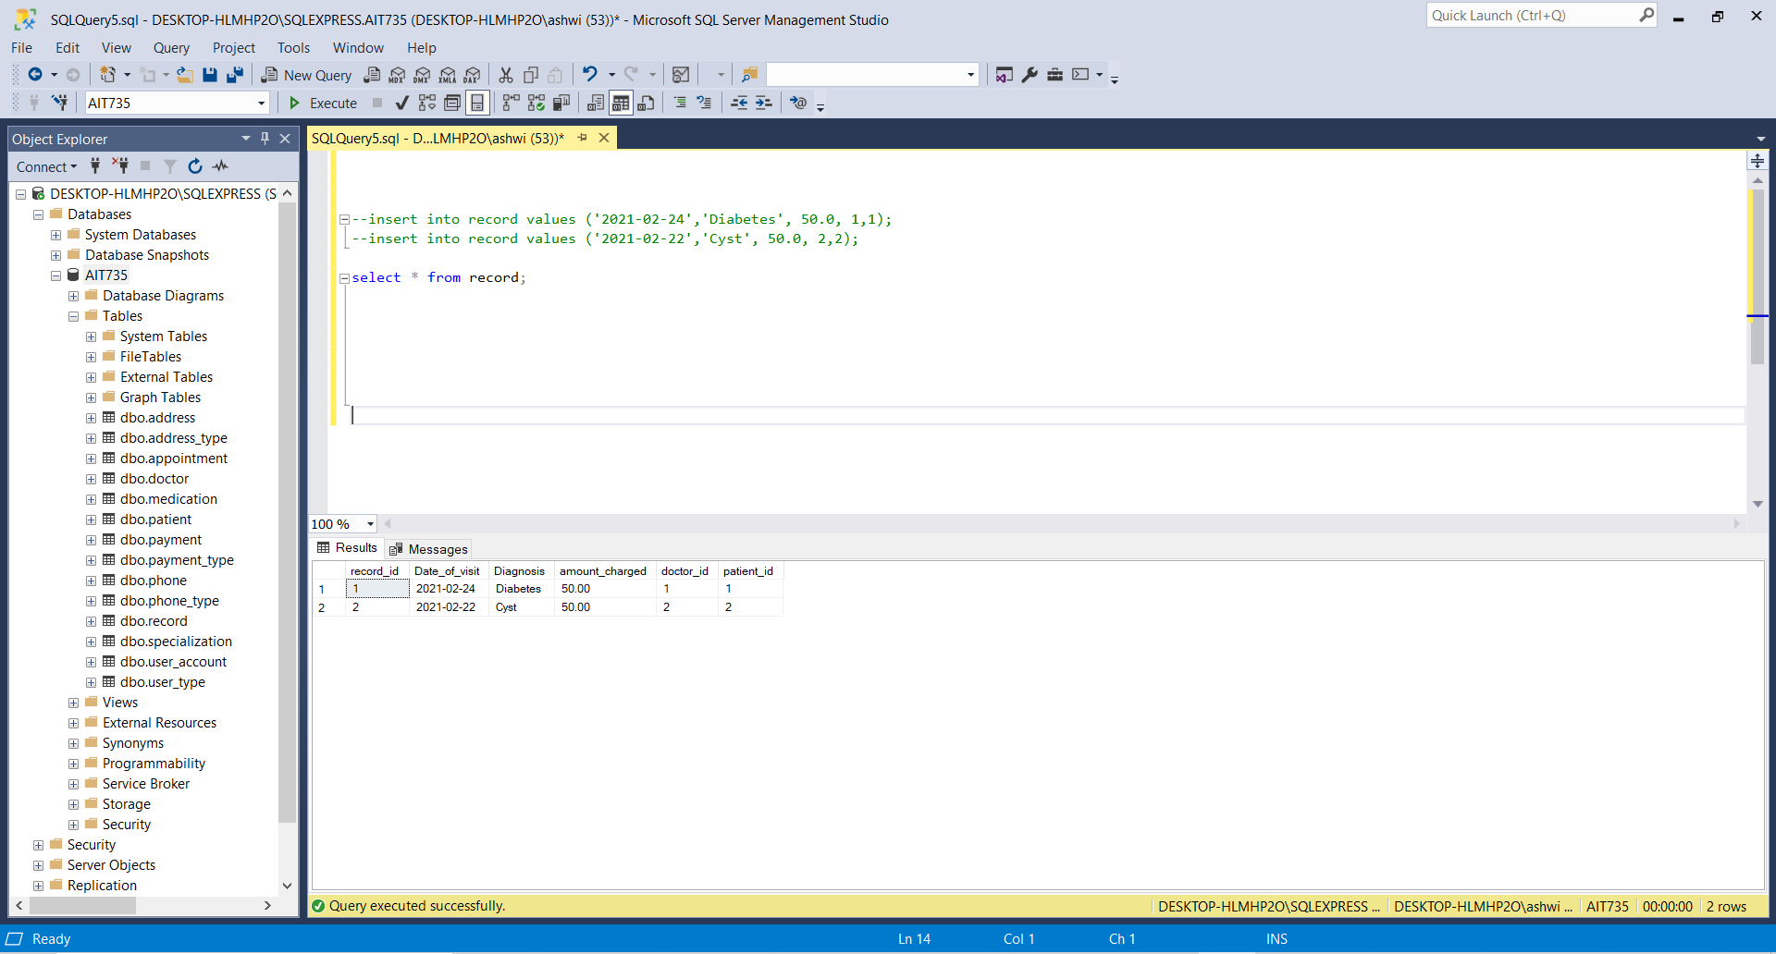

**Table 7: payment_type**

**Code:**

insert into payment_type values (‘Credit card’);

insert into payment_type values (‘Debit card’);

insert into payment_type values (‘Check’);

insert into payment_type values (‘Cash’);

Select * from payment_type;

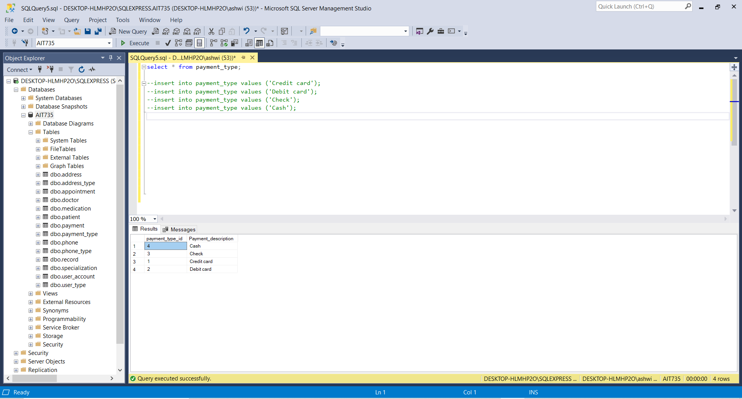

**Table 8: Payment**

**Code:**

insert into payment values (100, 1, 1, ‘2021-02-24 12:25:30’);

insert into payment values (200, 2, 2, ‘2021-02-23 08:55:35’);

Select * from payment;

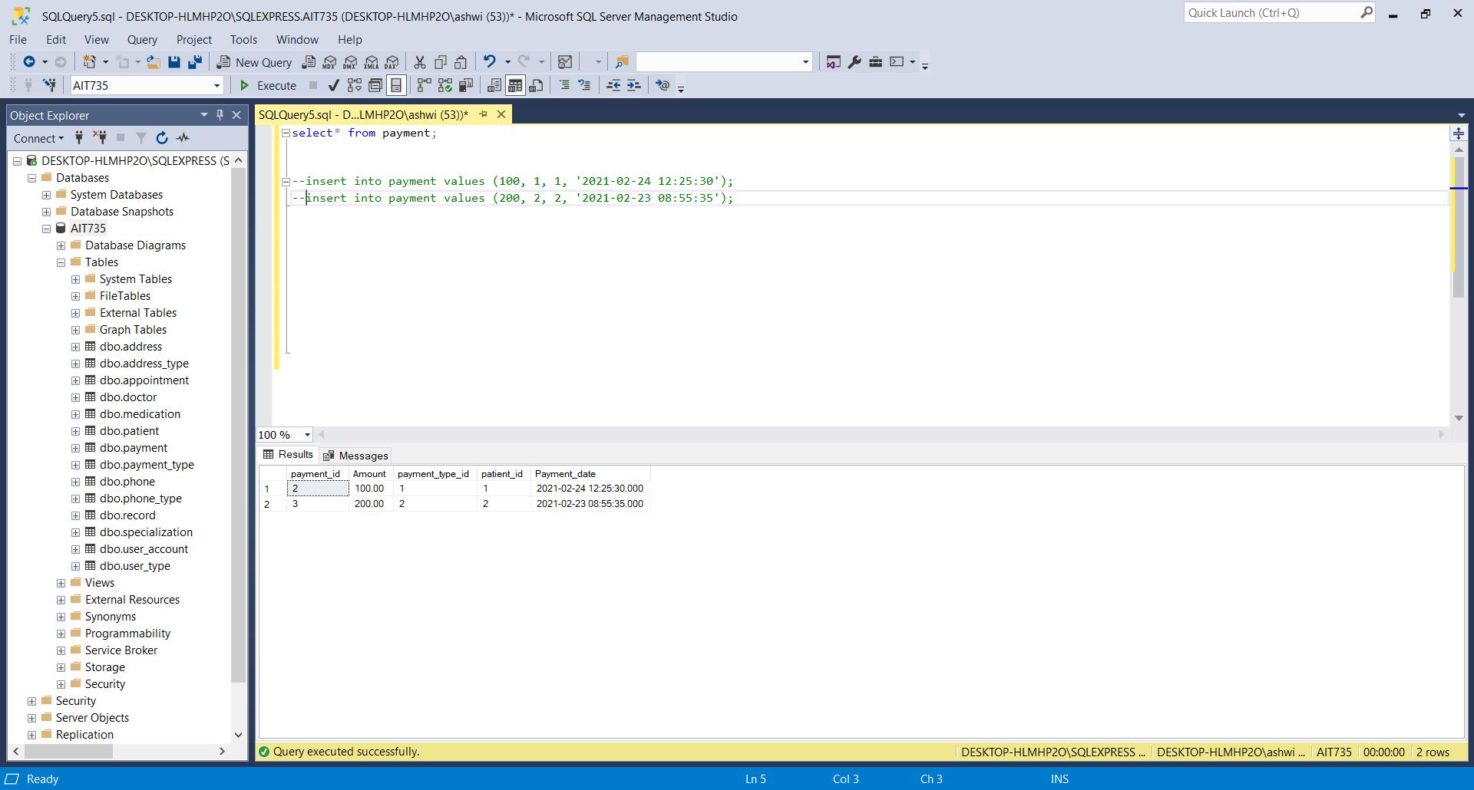

**Table 9: phone_type**

insert into phone_type values (‘Daytime phone’);

insert into phone_type values (‘Mobile’);

insert into phone_type values (‘Evening phone’);

Select * from phone_type;

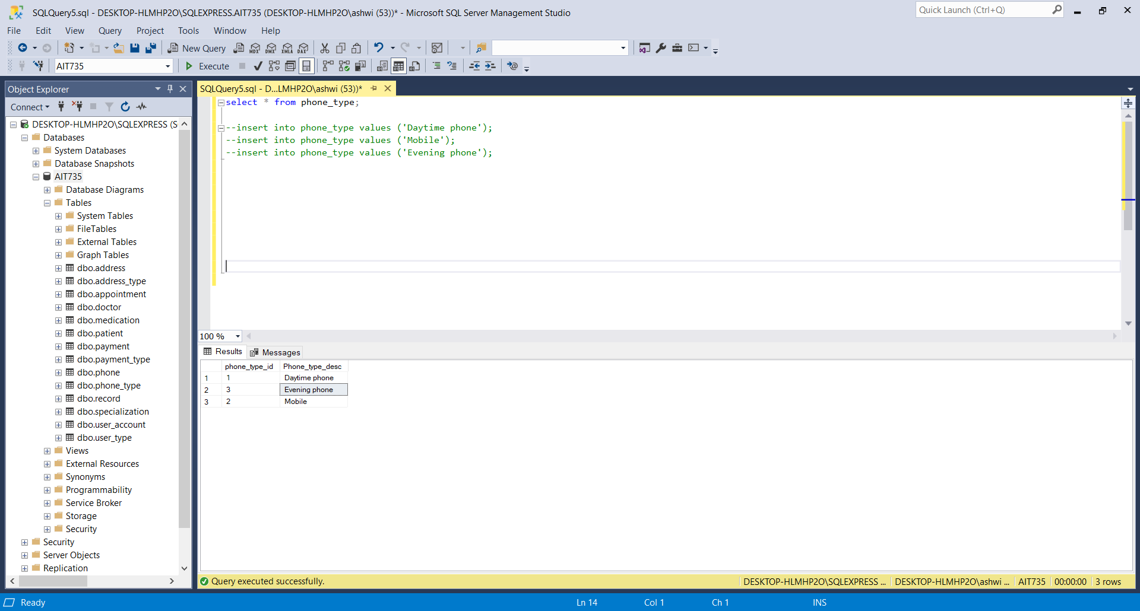

**Table 10: Phone**

**Code:**

insert into phone values (1,'P001','123-564-9542');

insert into phone values (2,'D001','333-444-6587');

insert into phone values (2,'P002','111-252-3545');

insert into phone values (3,'D002','345-678-4345');

select * from phone;

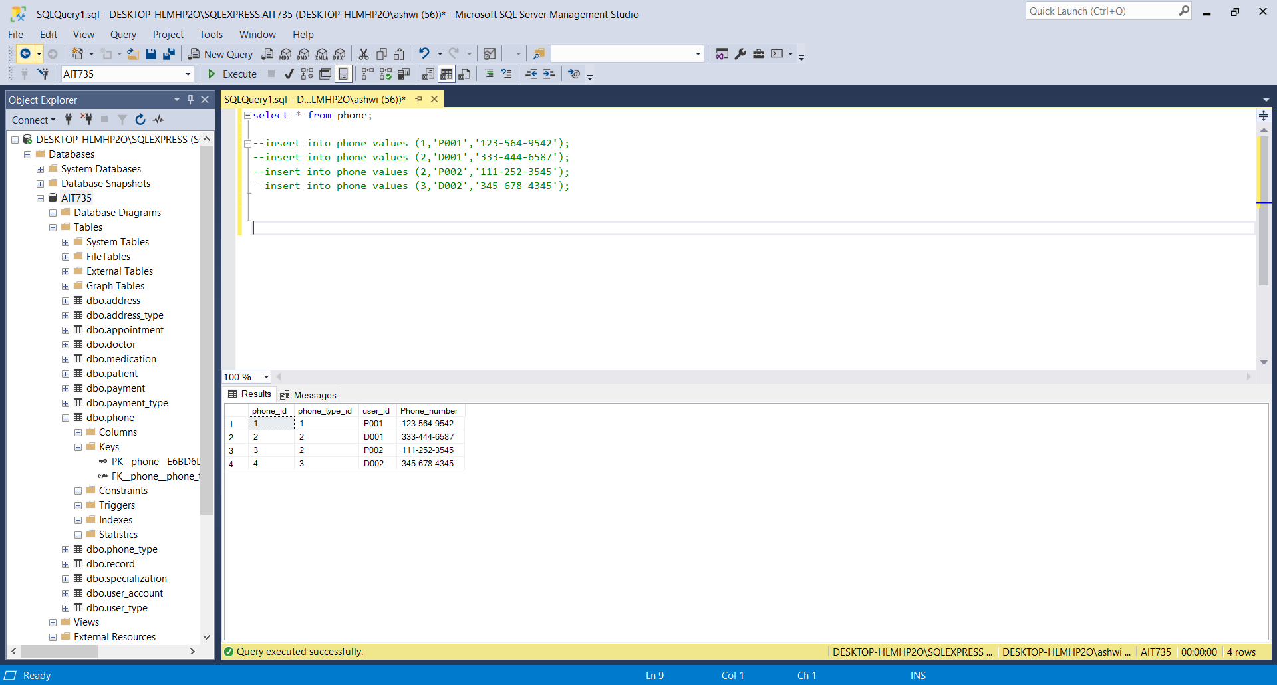

**Table 11: address_type**

**Code:**

insert into address_type values('Mailing address');

insert into address_type values('Permanent address');

Select * from address_type;

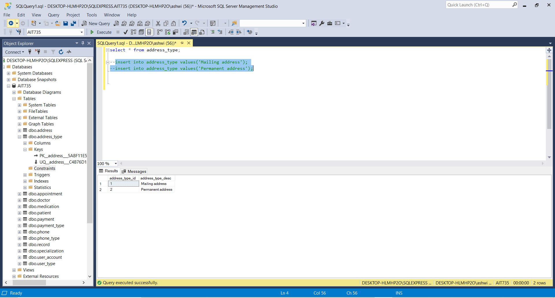

**Table 12: Address**

**Code:**

insert into address values (1, 'P001', 'Lord Byron Ln', 'Towson','21030');

insert into address values (2, 'P002', 'Greenside Ln', 'Cockeysville','21022');

insert into address values (1, 'D001', 'Duke Ln', 'Timonium','21025');

insert into address values (2, 'D002', 'Kent Drive', 'Baltimore','21045');

Select * from address;

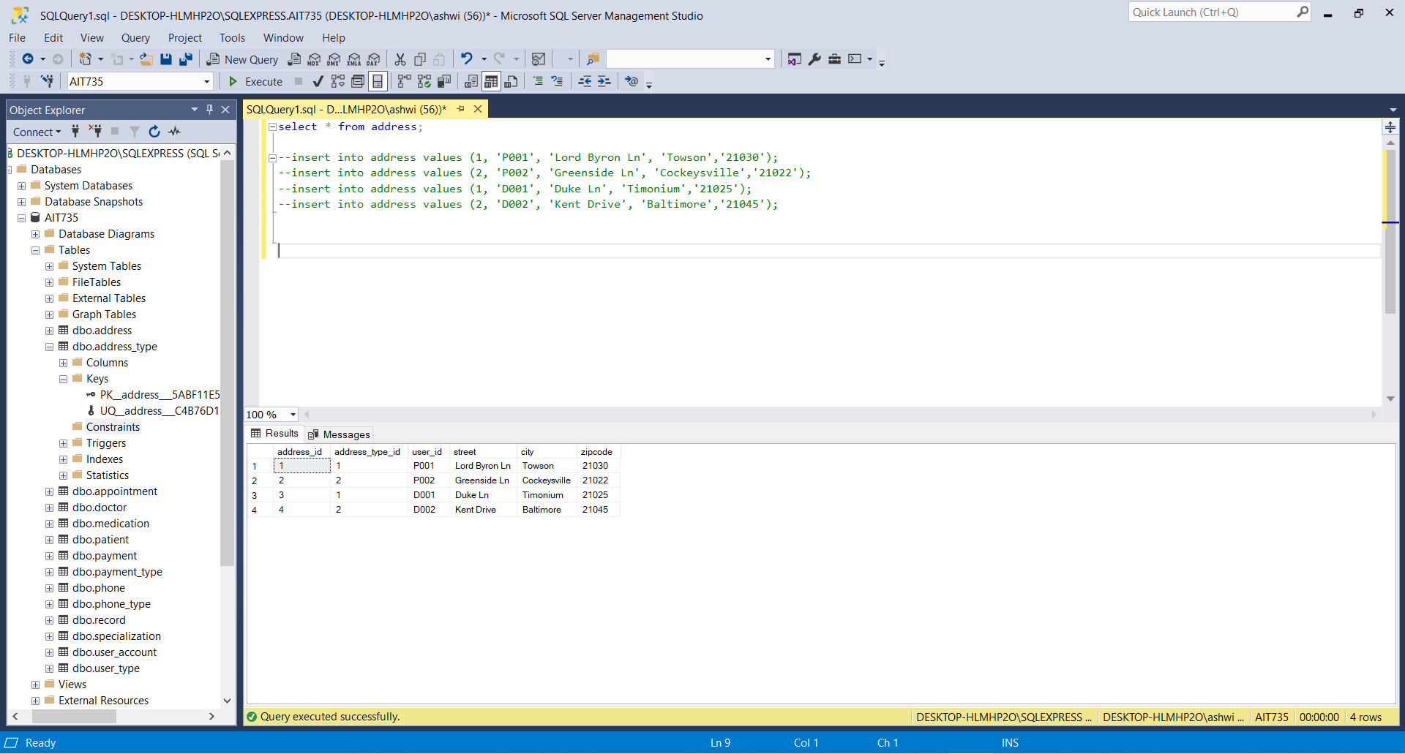

**Table 13: Appointment**

**Code:**

insert into appointment values(1, 1, 'Fatigue', '2021-02-24 11:12:24');

insert into appointment values(2, 2, 'Pelvic pain','2021-02-22 10:35:40');

Select * from appointment;

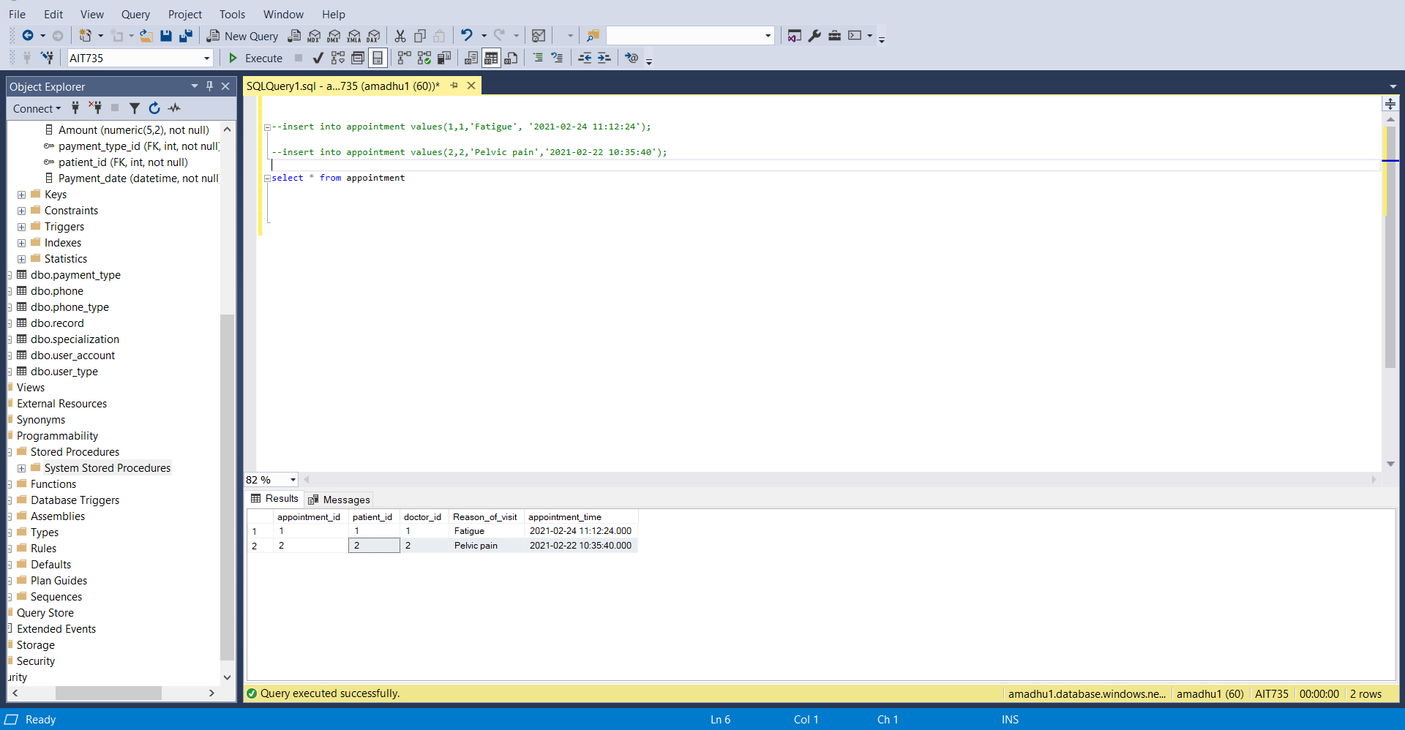

**Table 14: Medication**

**Code:**

insert into medication values (1,1,'Metformin','500mg');

insert into medication values (1,1,'Ibuprofen','50mg');

Select * from medication;

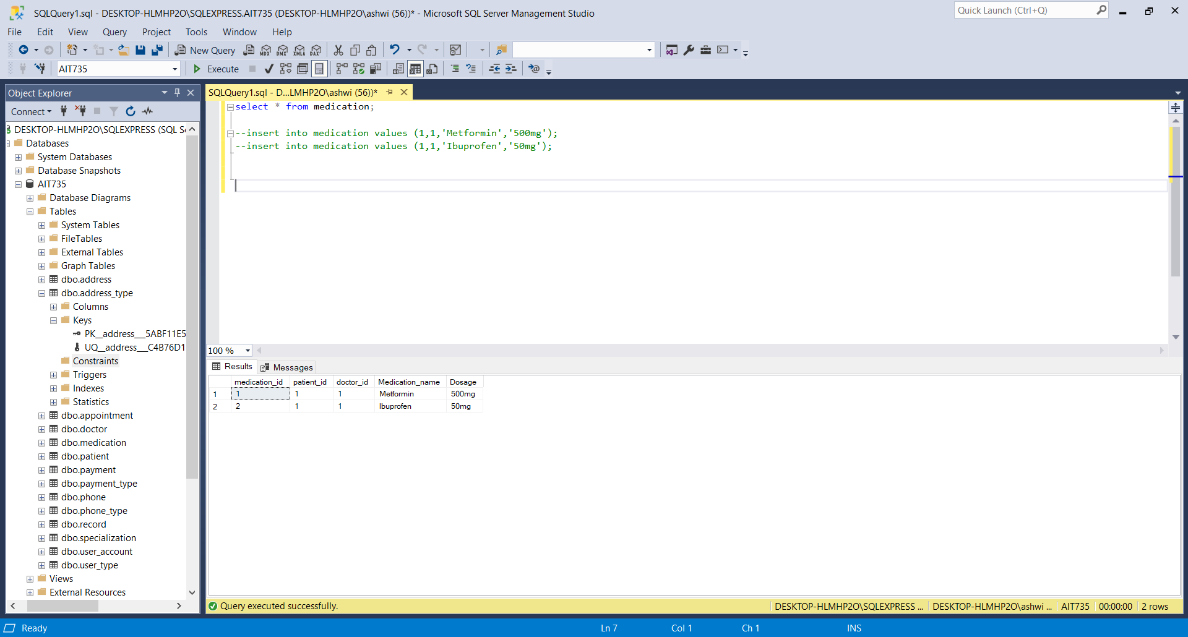

# 7. Migration

**Migration of data from on-premises to Microsoft Azure cloud database:**

First and the foremost step in the migration process is to create a Microsoft Azure account. Once the Microsoft Azure account is created, the user can login to the Microsoft Azure portal using the login credentials.

**Username**: amadhu1@students.towson.edu

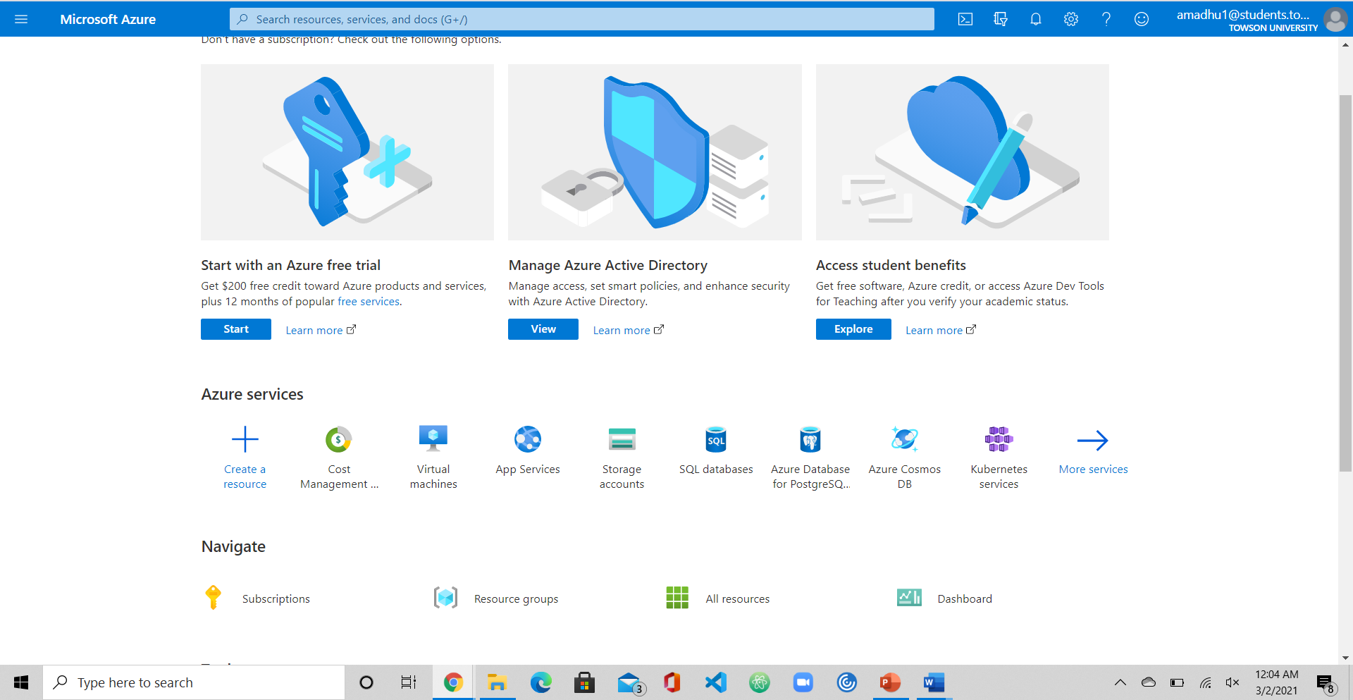

Second step is to prepare the data for migration. The preparation steps include exporting the existing on-premises database that is in the Database management system and saving it in a specified location.

Right click on the Database🡪task🡪Export data tier application

Export data-tier application wizard appears

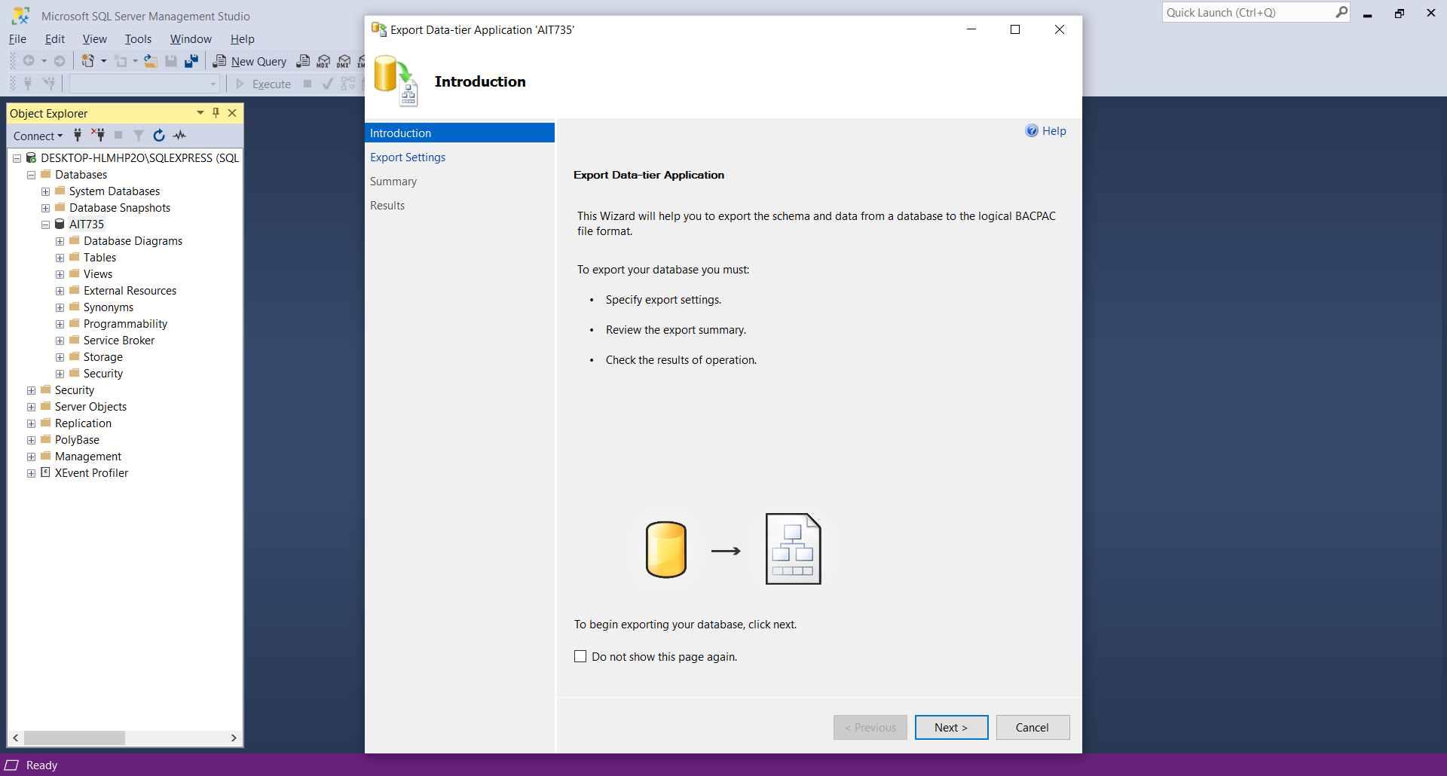

When clicked on next Export settings wizard appears

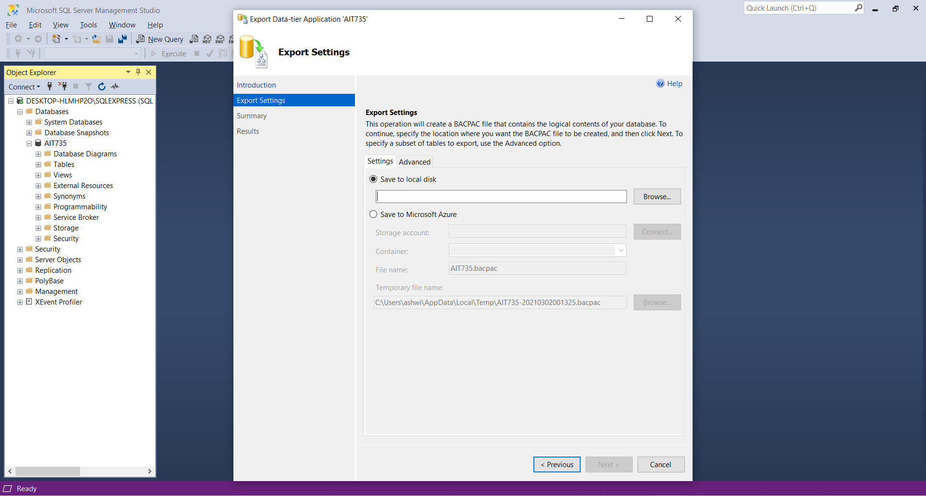

Click on browse and select the location to save the copy of the database

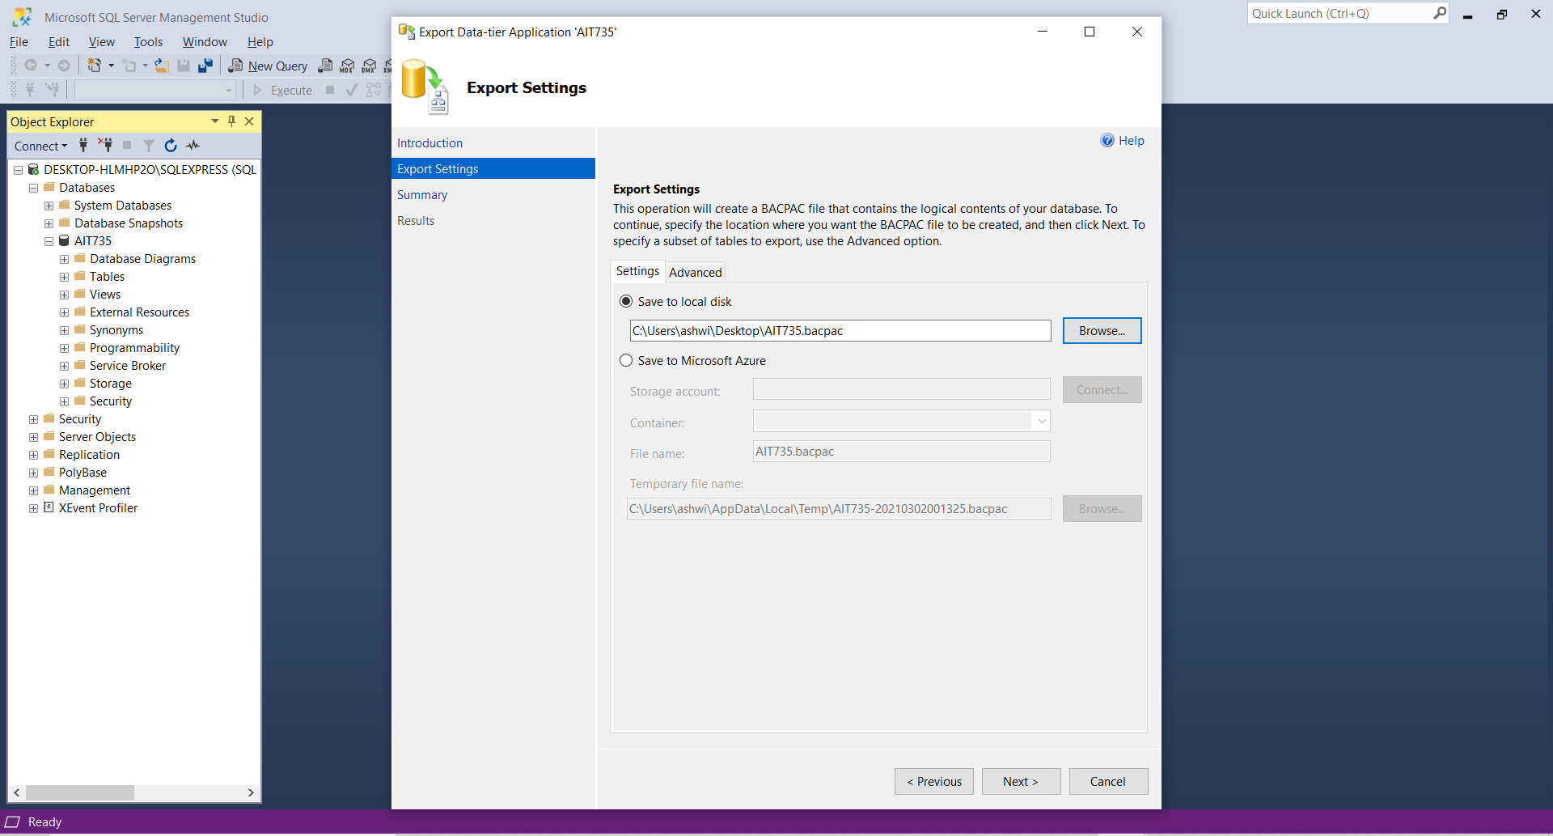

Confirmation windows appears with summary of the selection

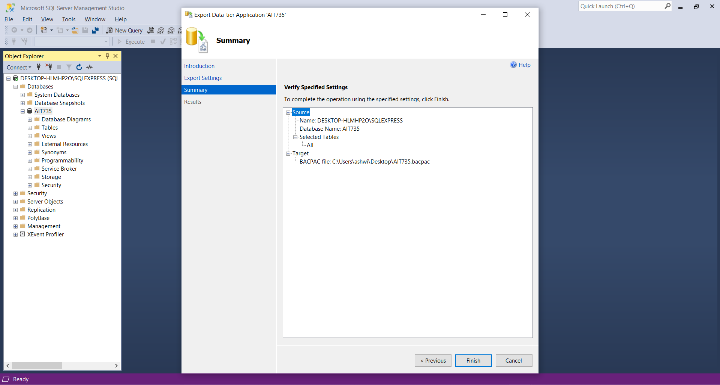

One the finish option is clicked database export will be executed. This completes the preparation of database for migration.

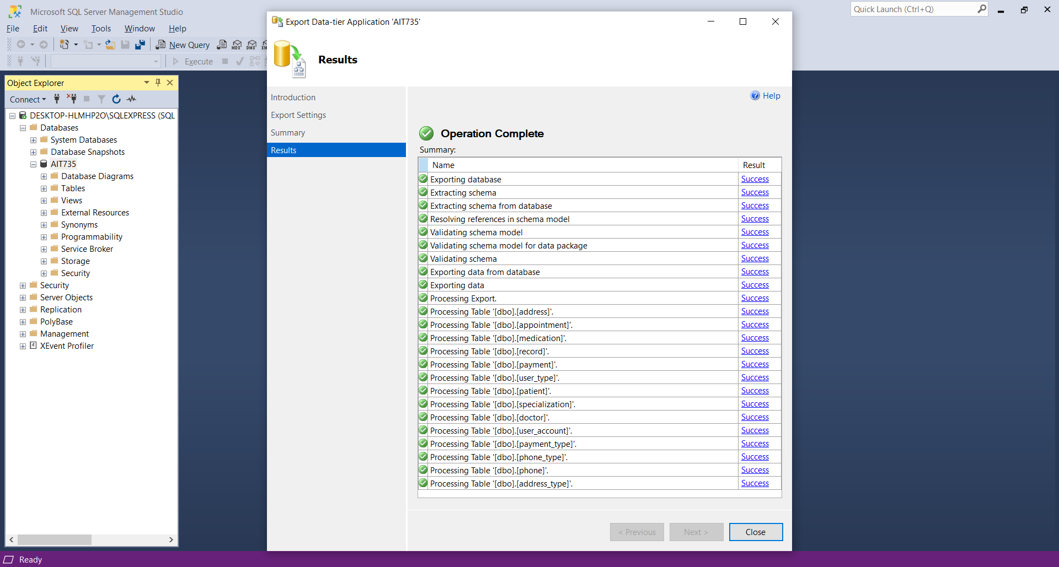

Third step create a database and server in Microsoft Azure as per our requirement. To perform this action, we follow the below mentioned steps.

Login to azure portal

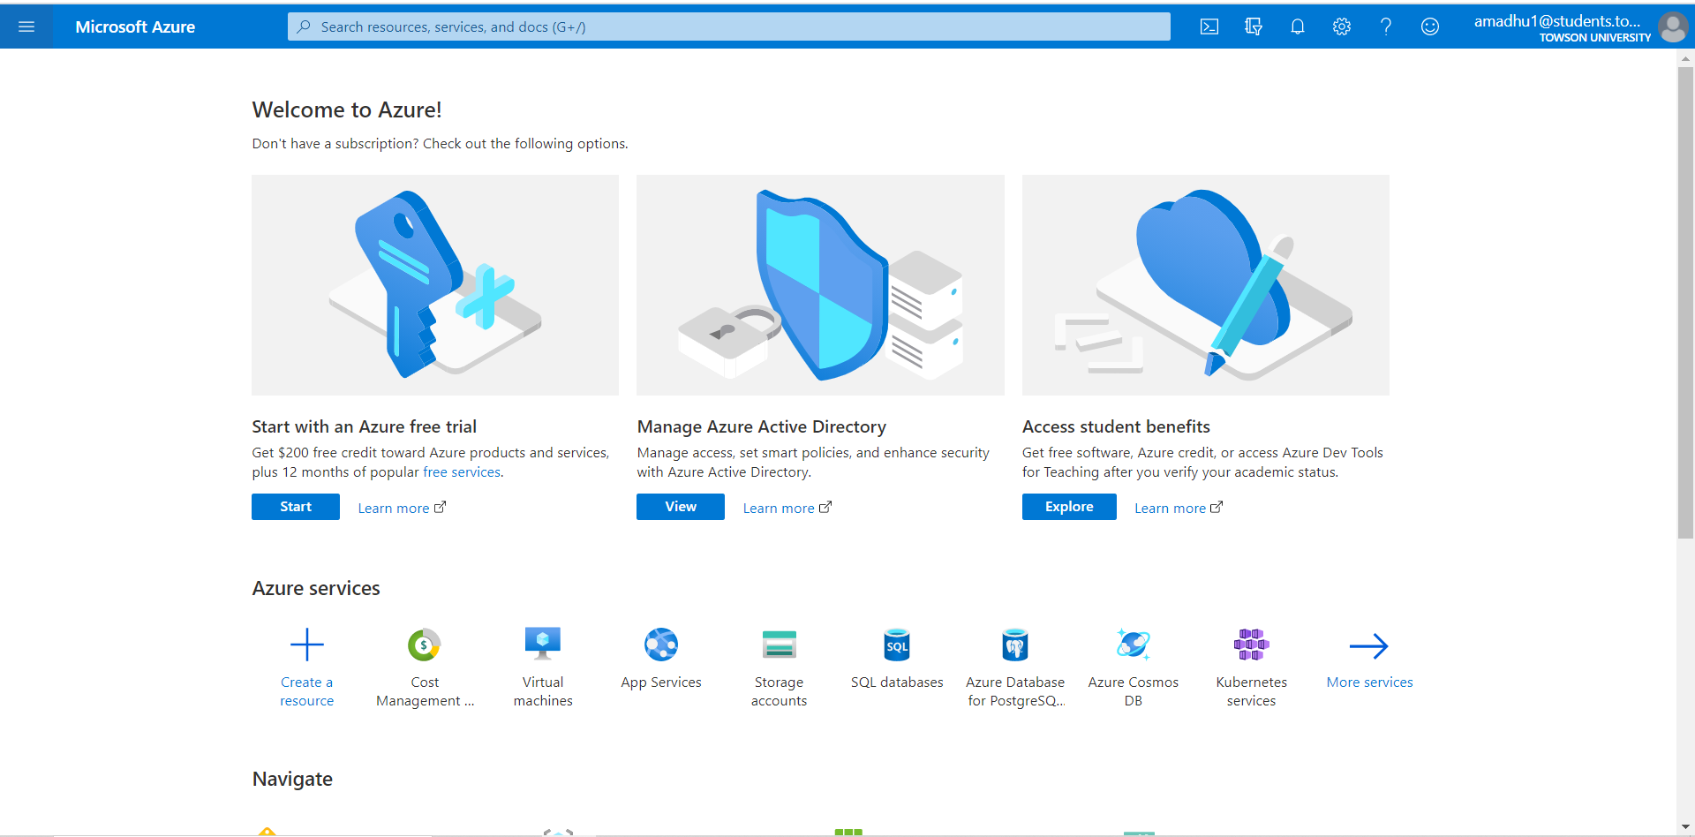

Click on the three lines at the top left corner of the window. It will display the menu options

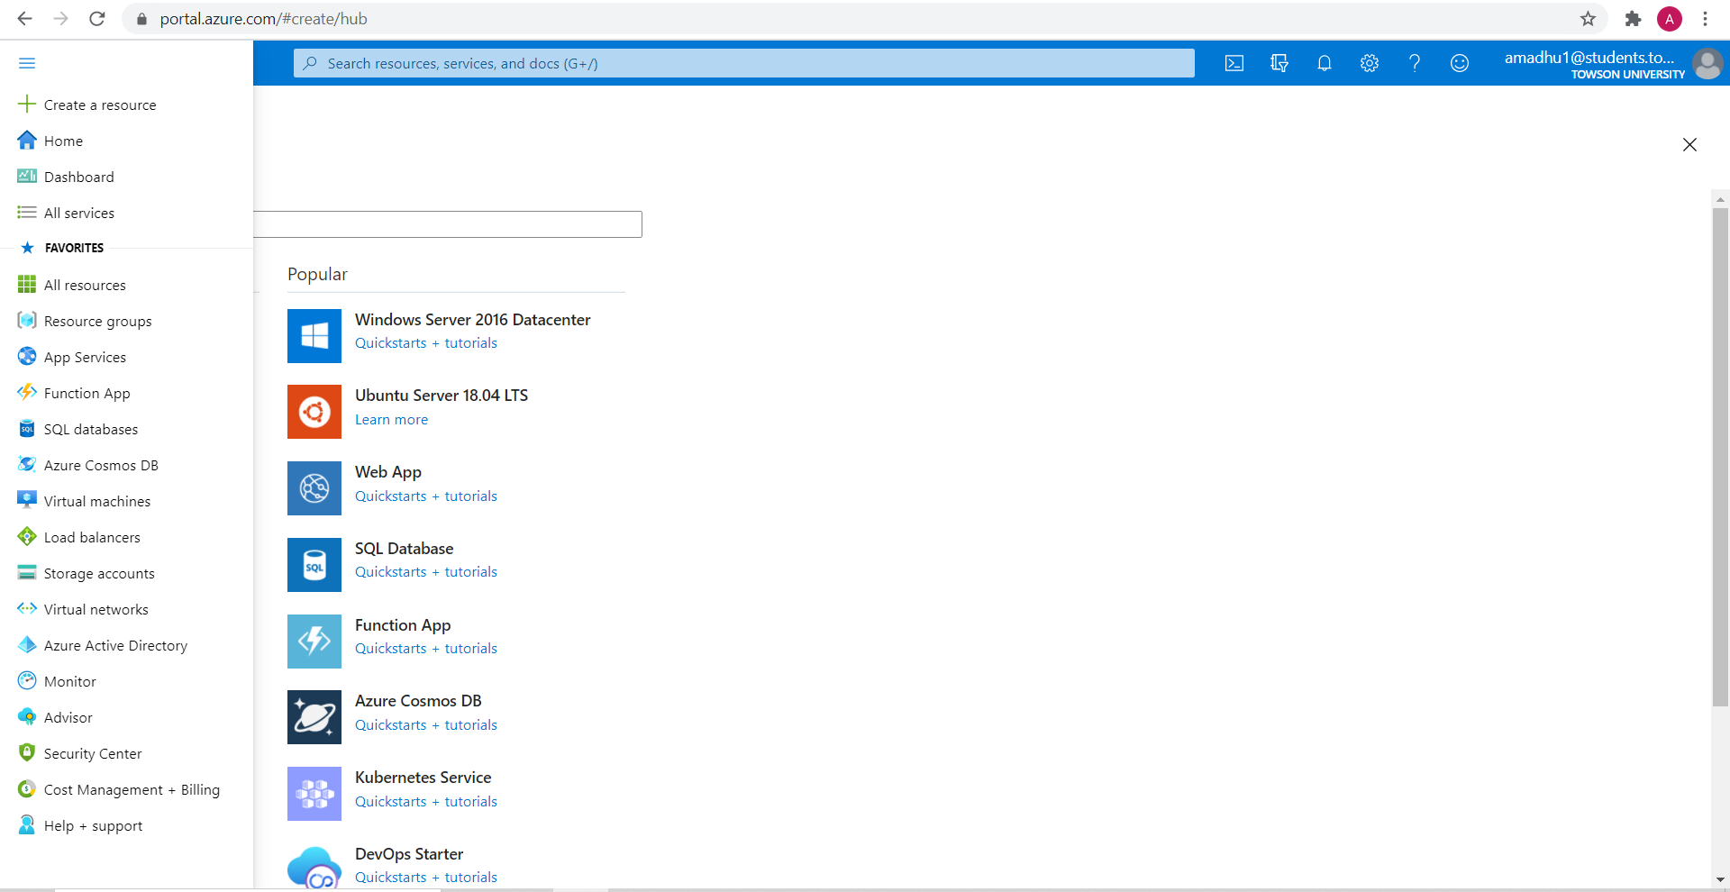

When the mouse is hovered over resource group, create option will be displayed. Click on create to create a resource group. Resource group is a container that holds related resources. Resources group facilitates efficient management and tracking of resources.

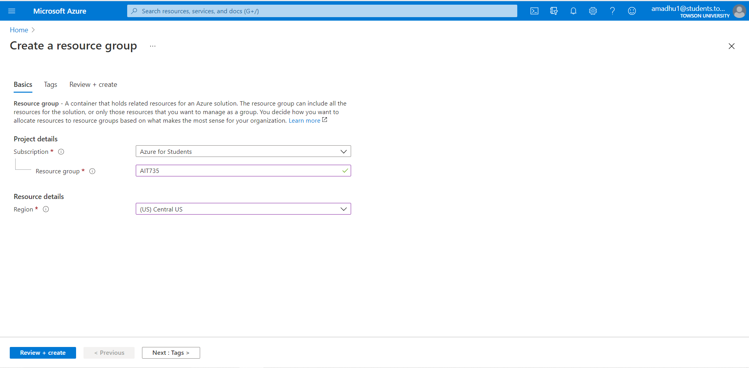

AIT735 resource group has been created

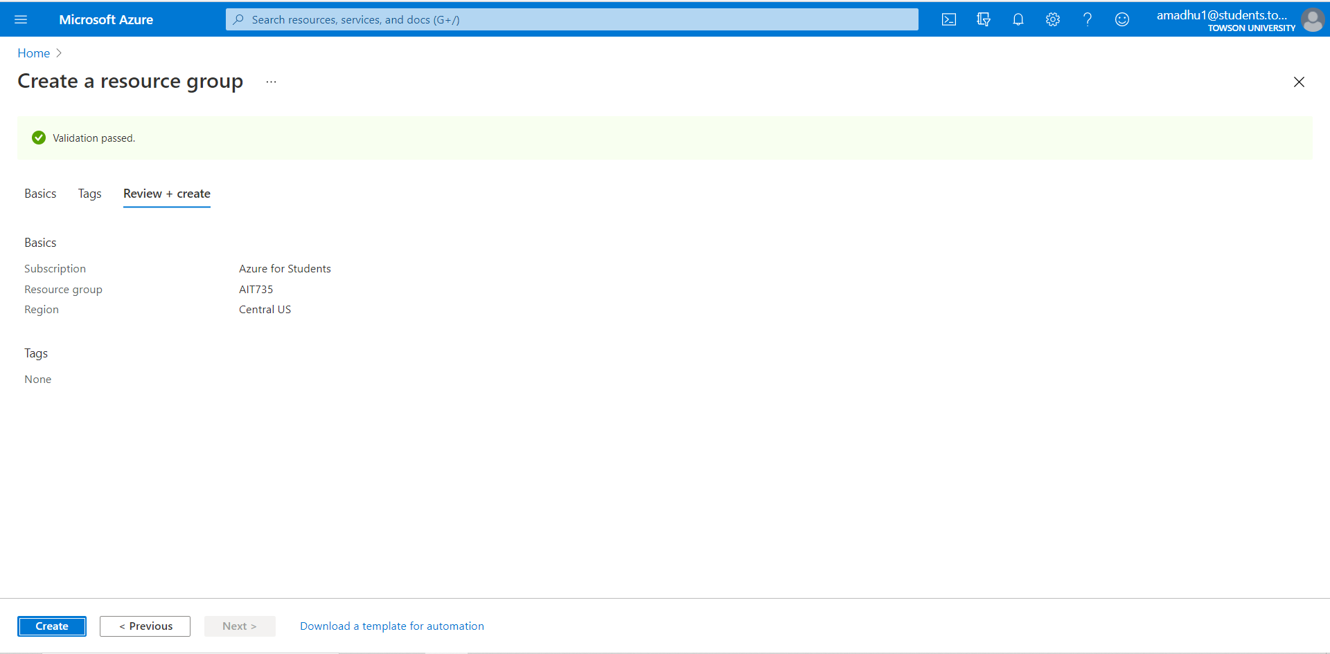

Resource group name “AIT735” is created. When we click on the resource group name, it displays the options to manage the resource group

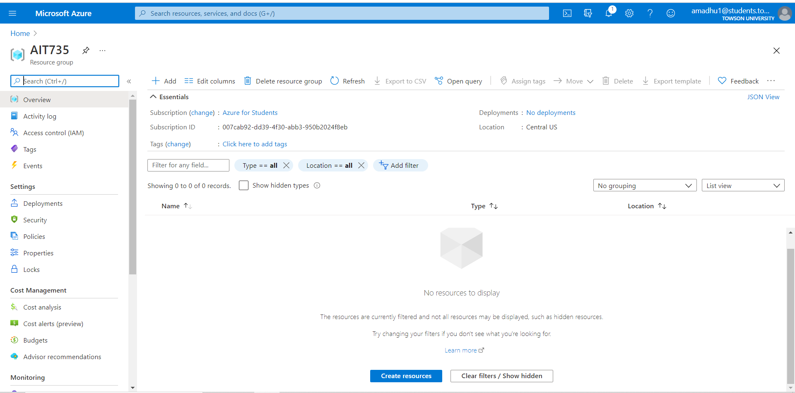

Now all the required resources for our migration will be created in the AIT 735 resource group.

Click on create resources and select create SQL database. A new wizard that allows the user to configure the resources opens. First a new server will be created. After creating a new server, database needs to be configured.

**Credentials of the server:**

Username: amadhu1

Password: ****

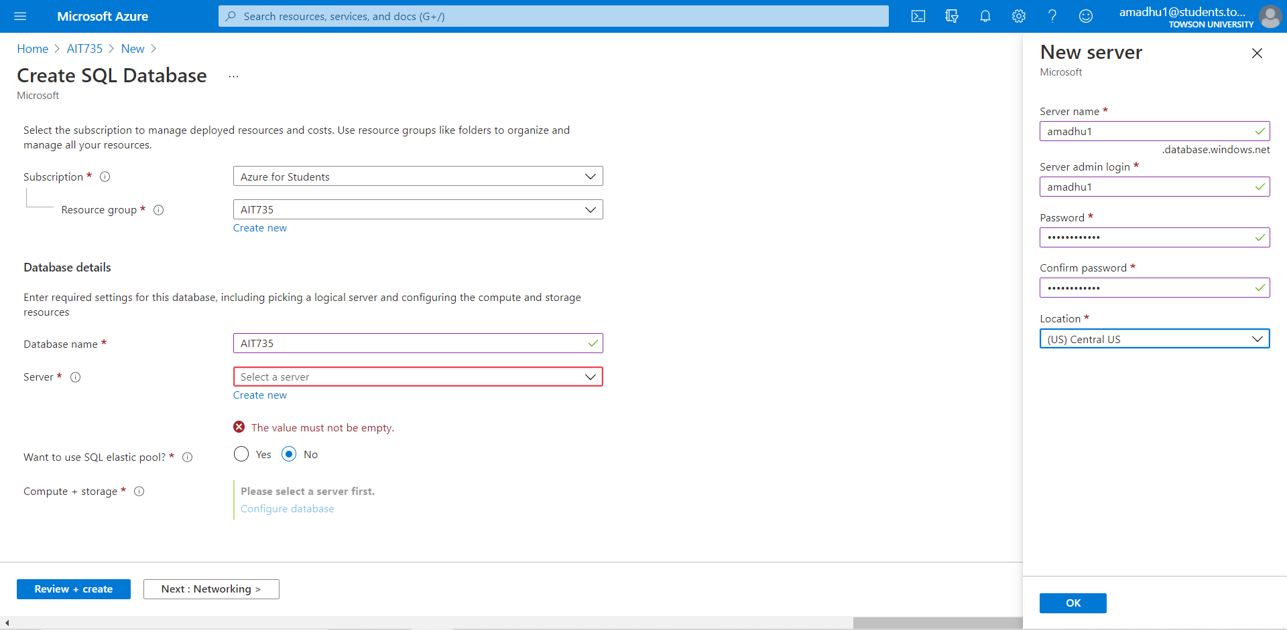

After creating the server database will be configured. Configurations for the database will be selected as per our requirement. Different options are available based on the subscription levels. I have configured database with 10 DTUs(Database Transaction Unit) and 1 GB storage.

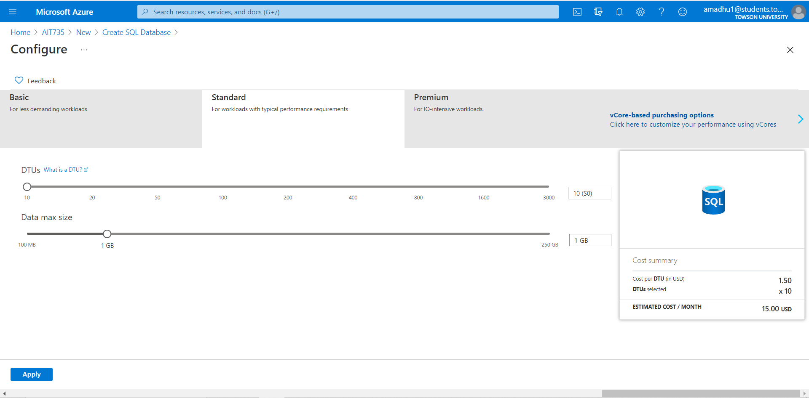

Click on review and create. The new window will display the selected options. At this stage the user can go back and change the configuration if any changes required

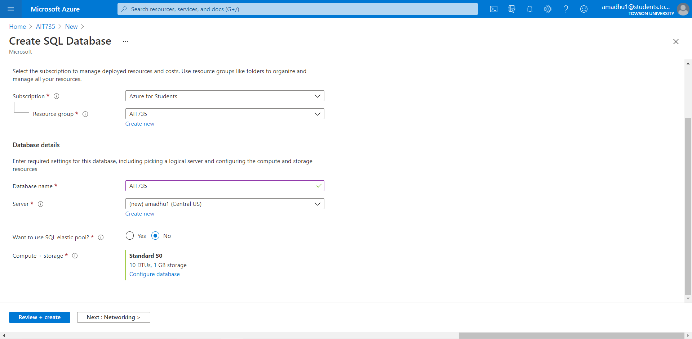

Once the create option is clicked, deployment starts

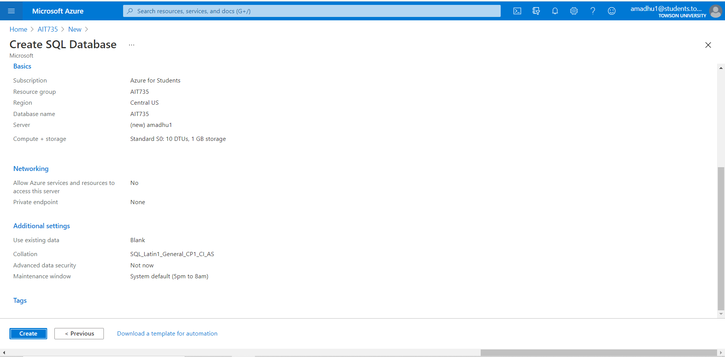

The notification icon at the right top of the window displays the status of the resource deployment

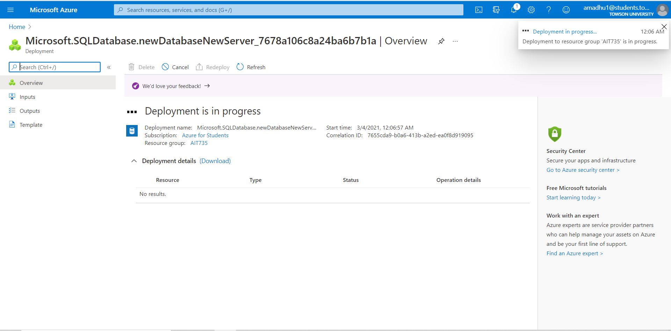

The user will be notified when the deployment is complete

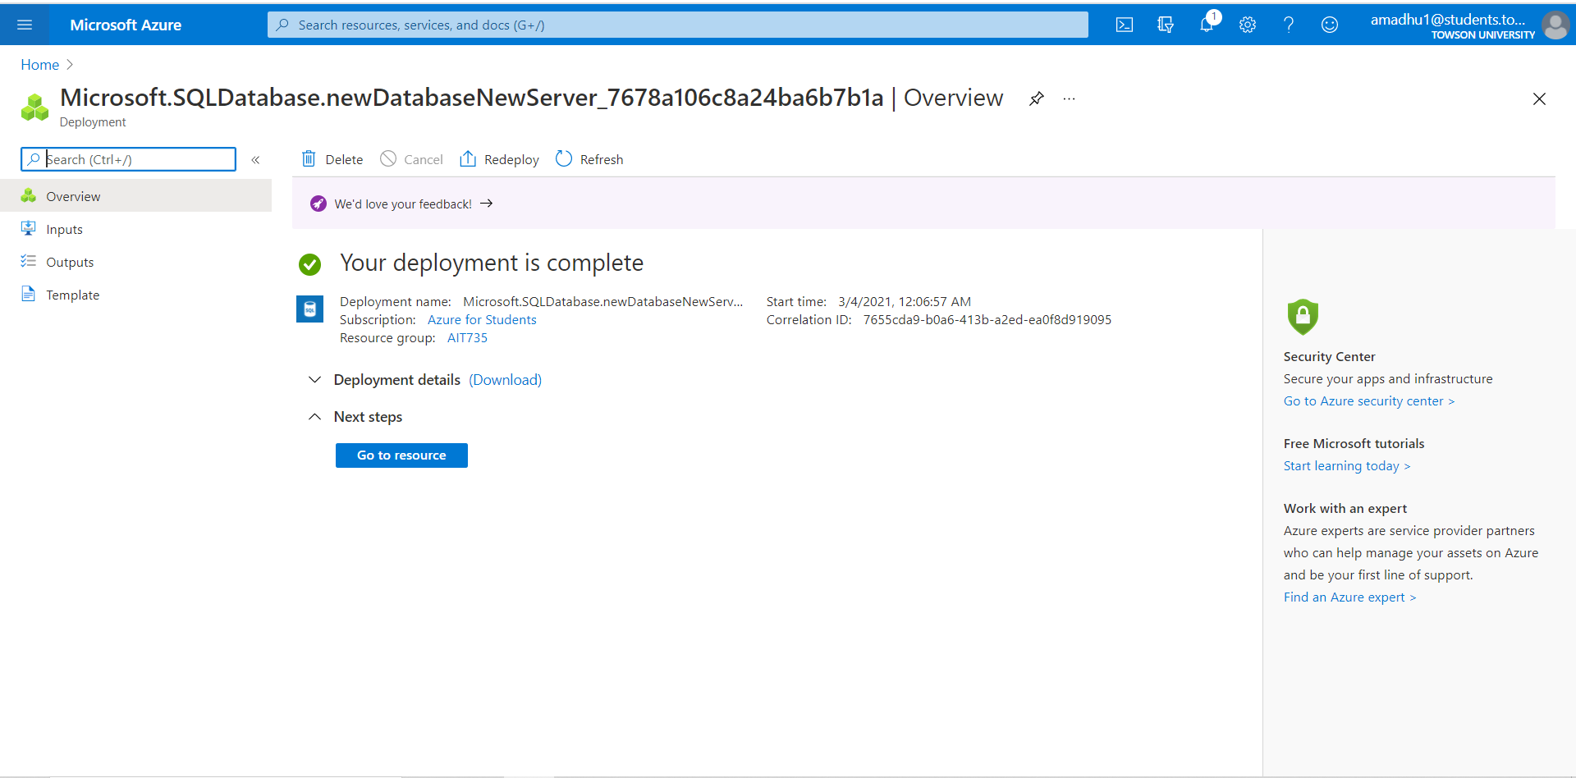

When the user clicks on the AIT735 resource group name, it will display the provisioned resources under that resource group.

**Microsoft Azure SQL Database name**: AIT735

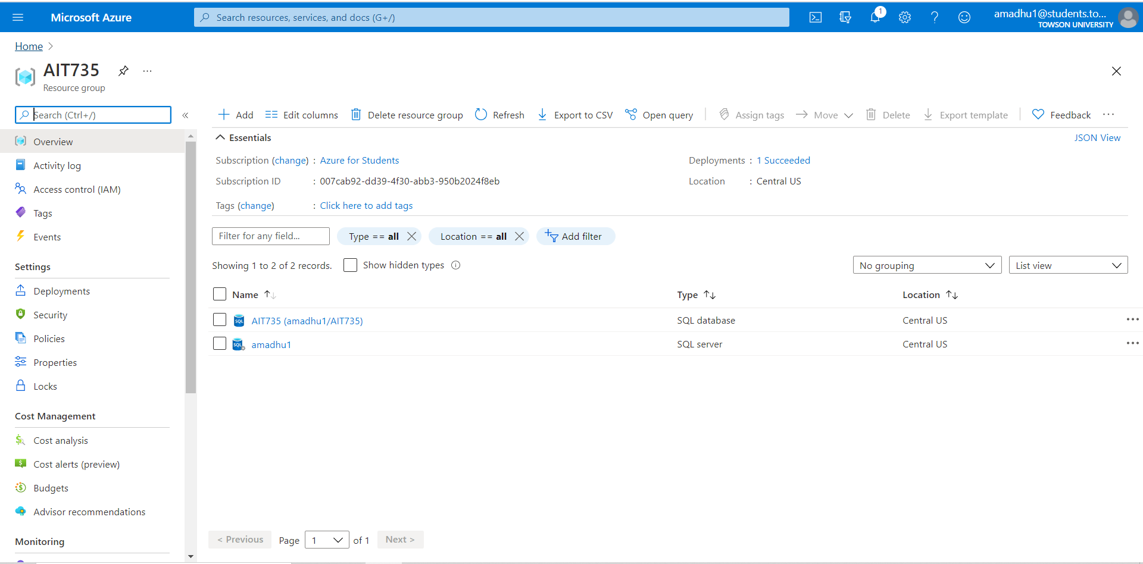

When clicked on resource name, it displays the various options available for that resource.

When clicked on the Azure SQL database

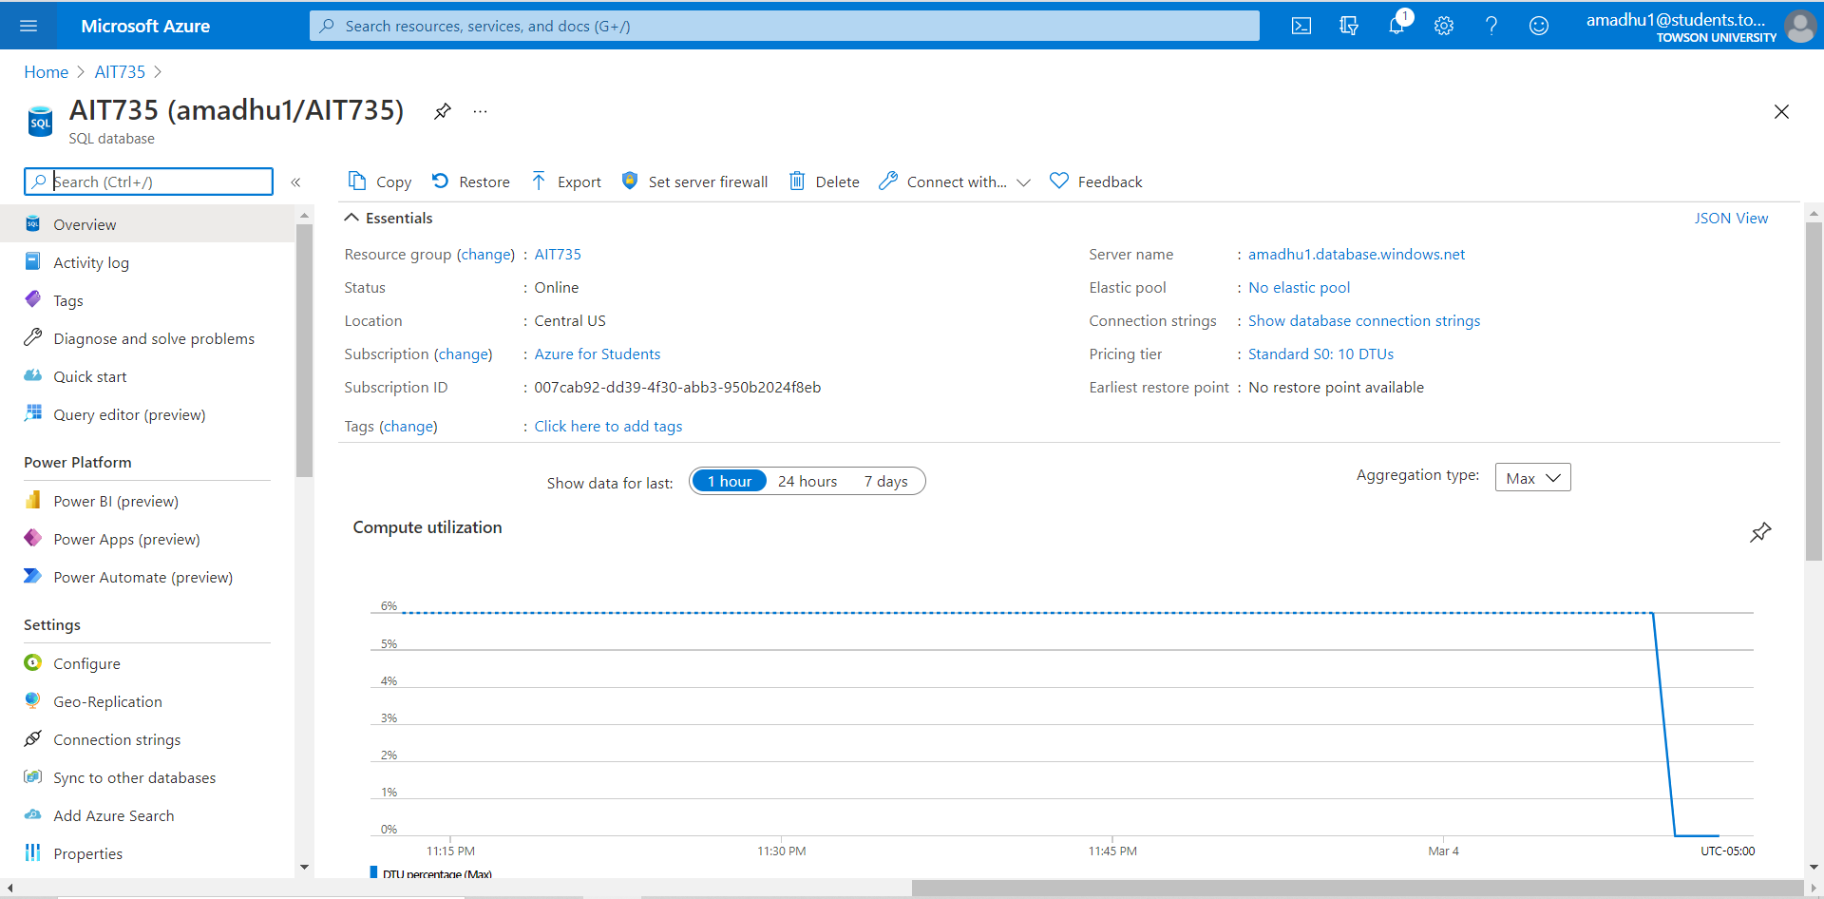

When clicked on the Azure SQL Server

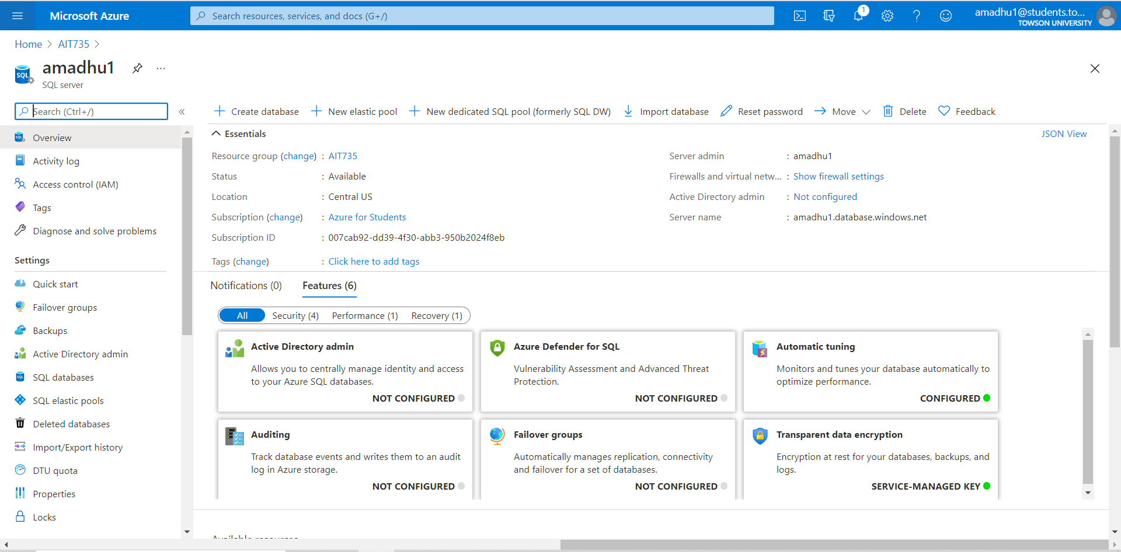

Now Microsoft Azure SQL server needs to be connected to our system. Click on Copy the server credentials

**Microsoft Azure SQL Server name**: amadhu1.database.windows.net

**Username**: amadhu1

**Password**: ***

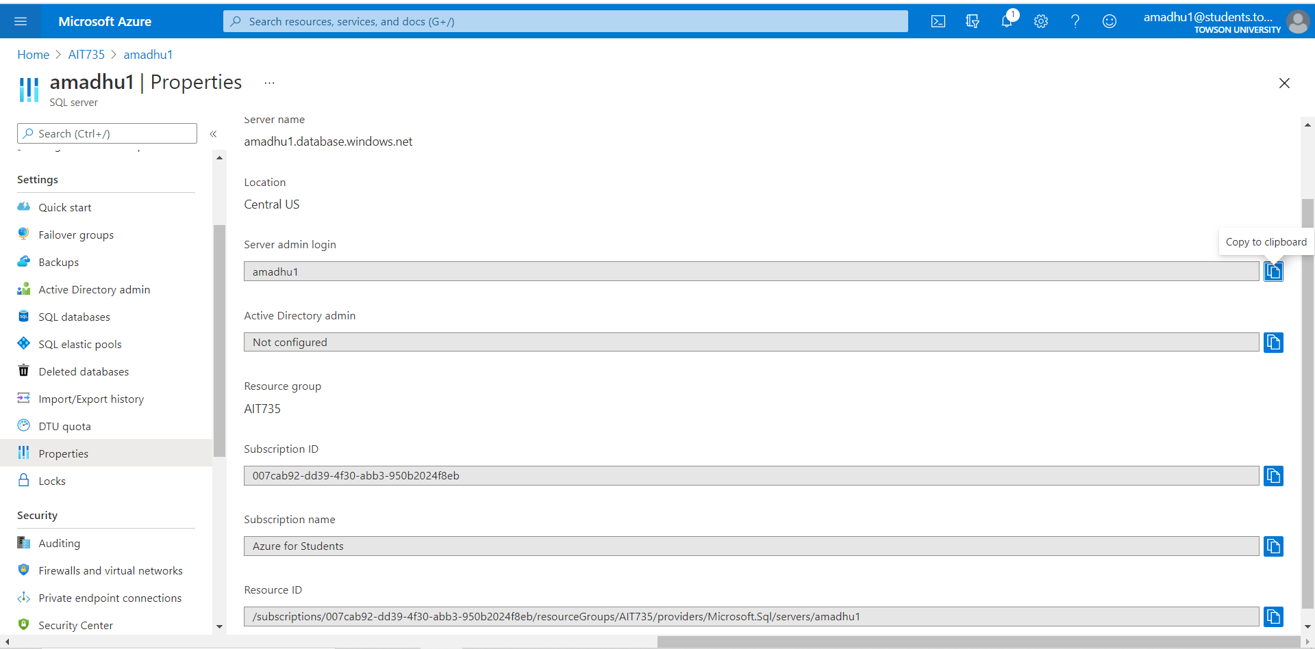

**Interface**: SQL Server Management Studio

From the authentication drop down changed the windows authentication to the server authentication, also changed the server’s name to “amadhu1.database.windows.net”

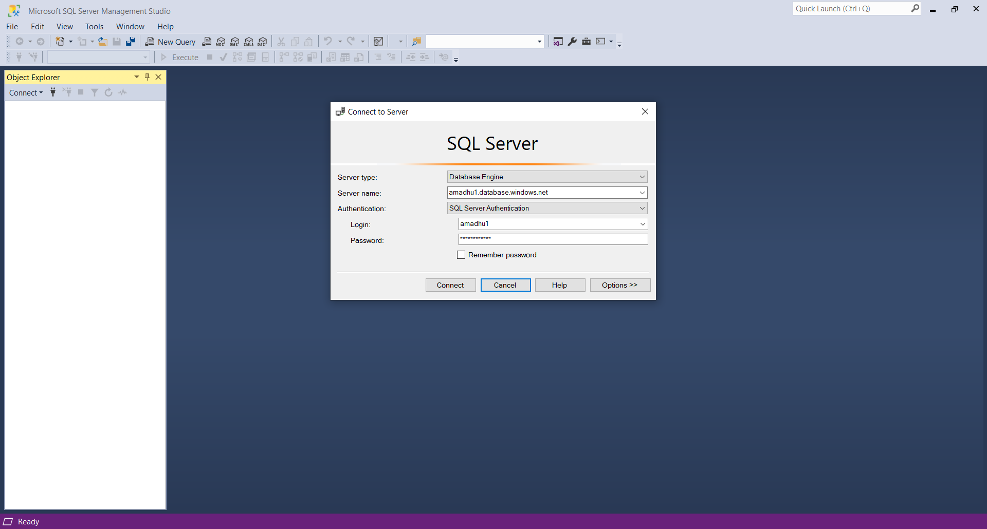

To connect to Microsoft Azure SQL Server firewall needs to be set for the client’s IP address. Microsoft also provides an option to perform the step while establishing the connection.

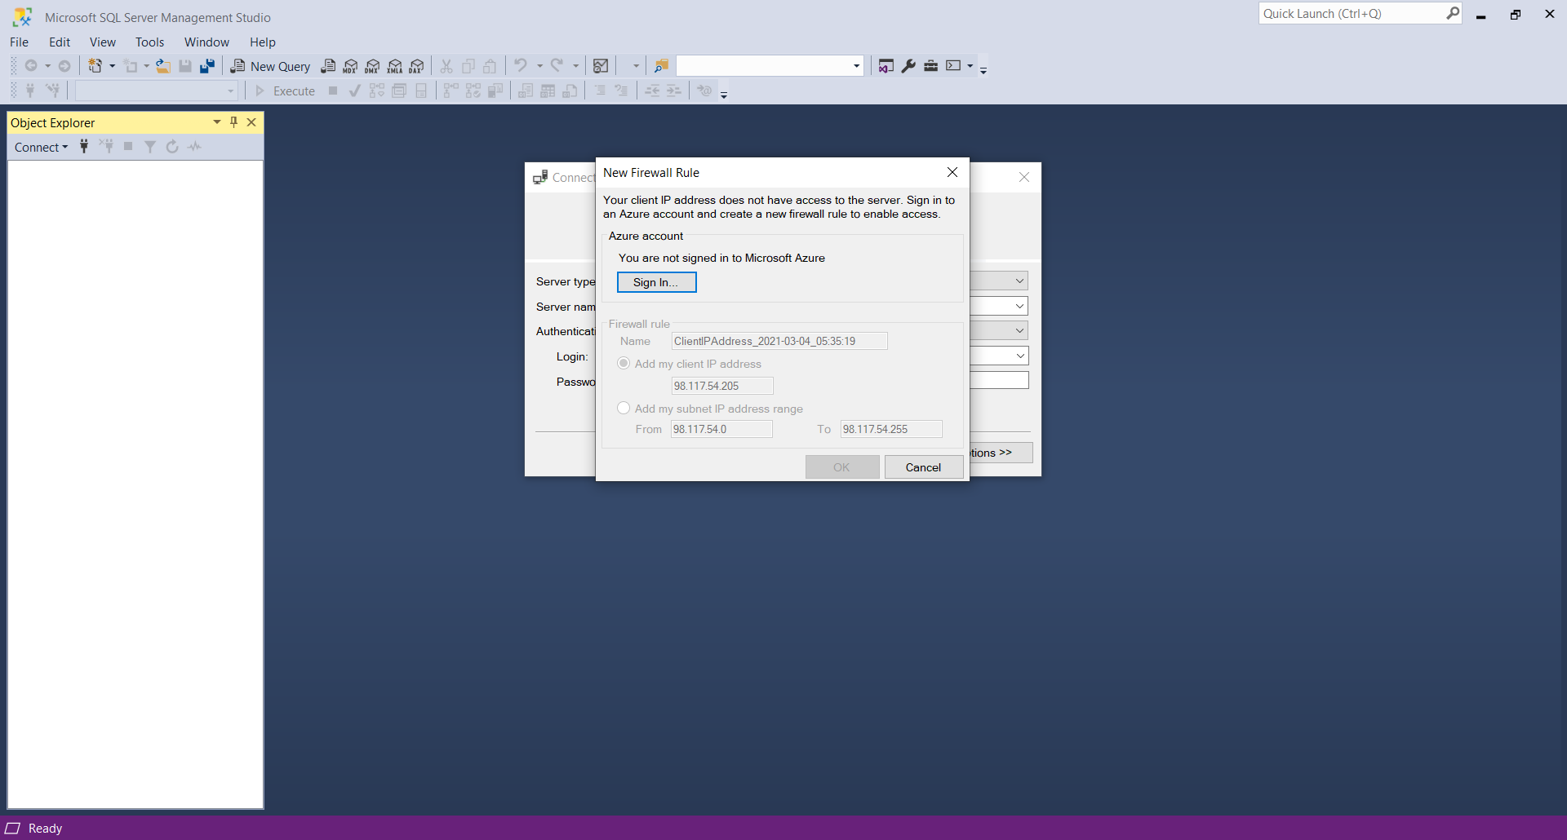

Client’s IP address is configured. This prevents additional security to prevent unauthorized access to the database server.

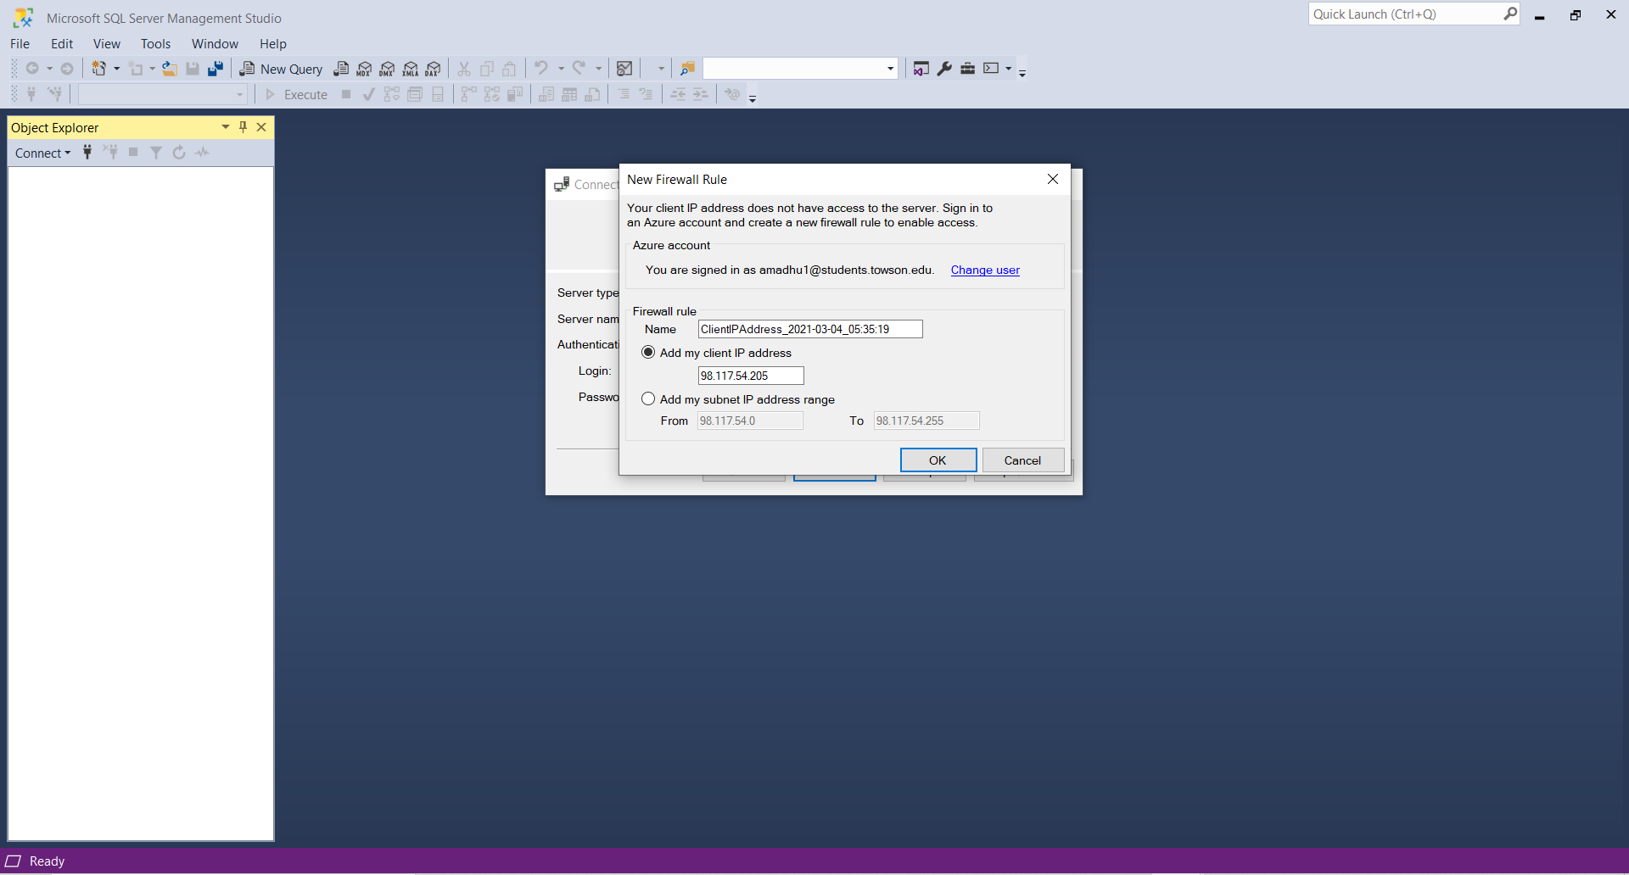

Now the system is connected to the Microsoft Azure SQL server through which Azure SQL database can be accessed.

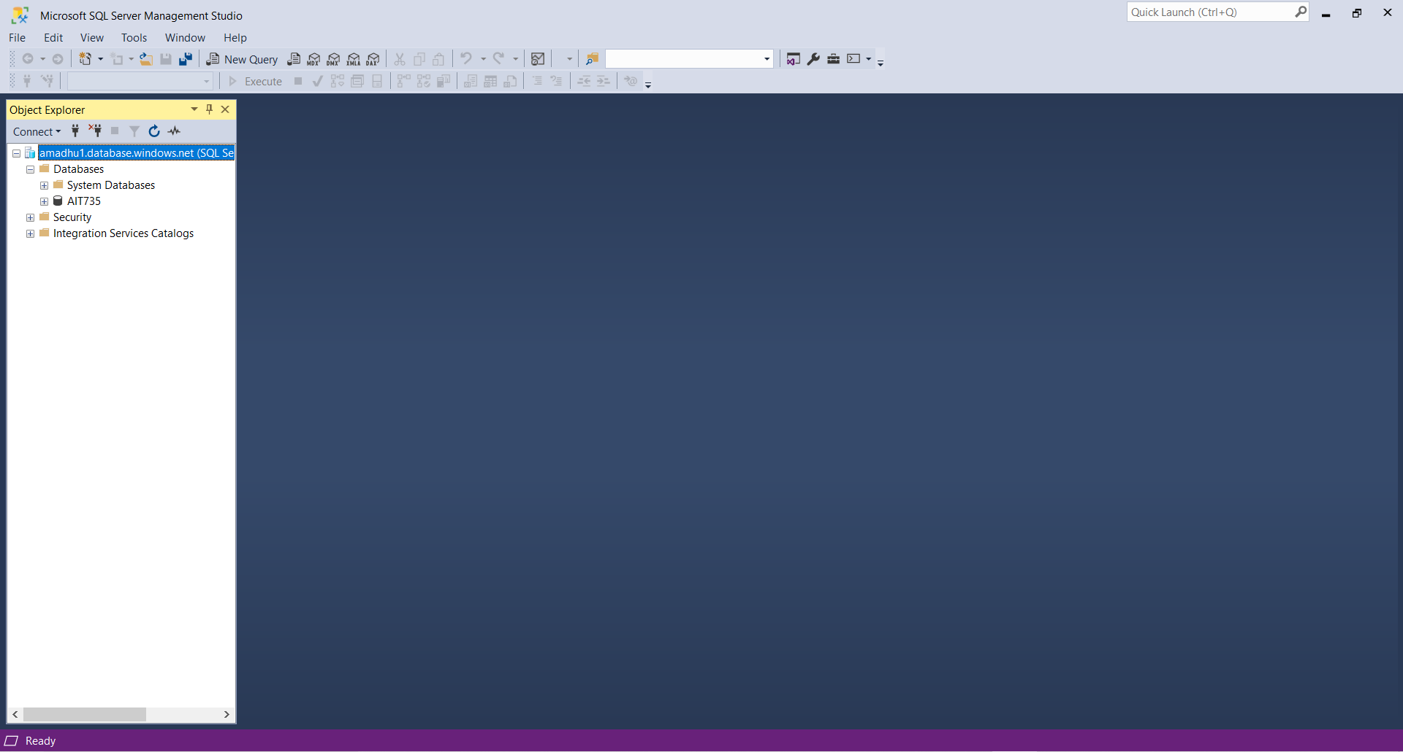

Clicked on the database named “AIT735” and made sure that there are no existing data or tables in the database

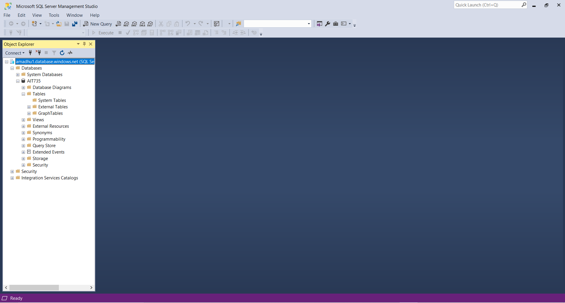

Now the on-premises database back up will be imported to the Microsoft Azure cloud database. Right click on the databases and click on import-tier application

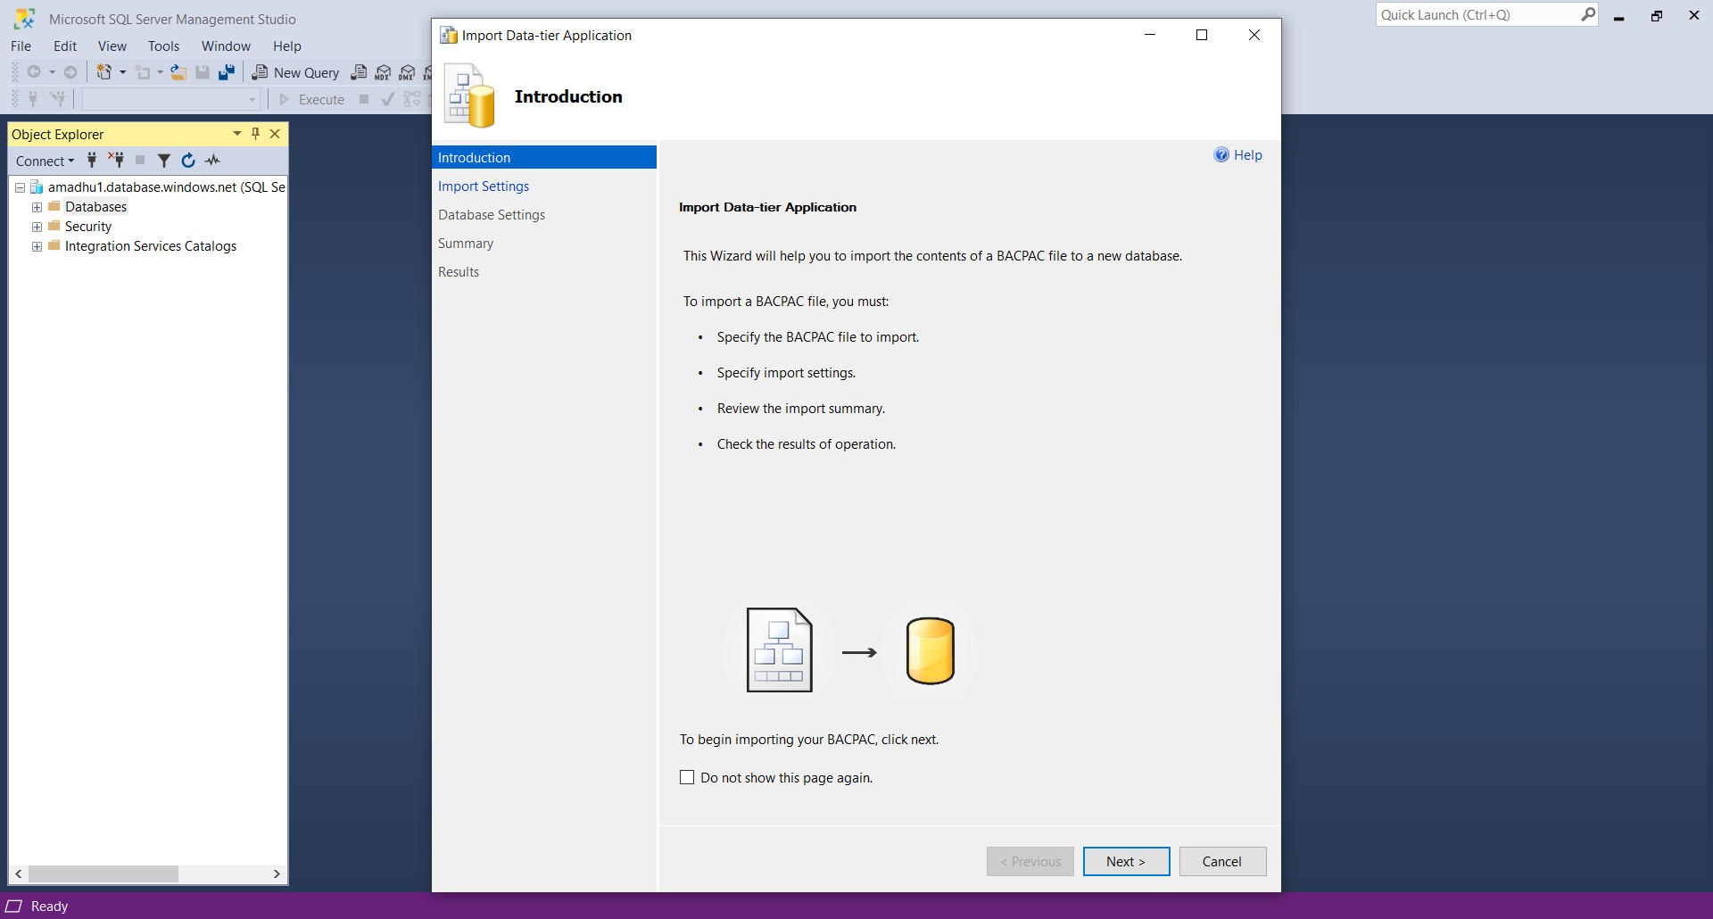

Clicked on browse and selected the database back up from the saved location

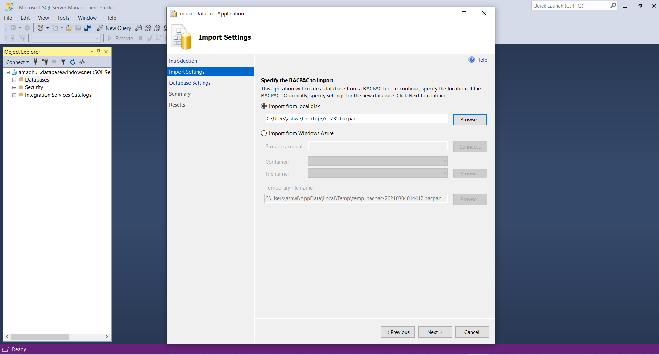

Clicked on next

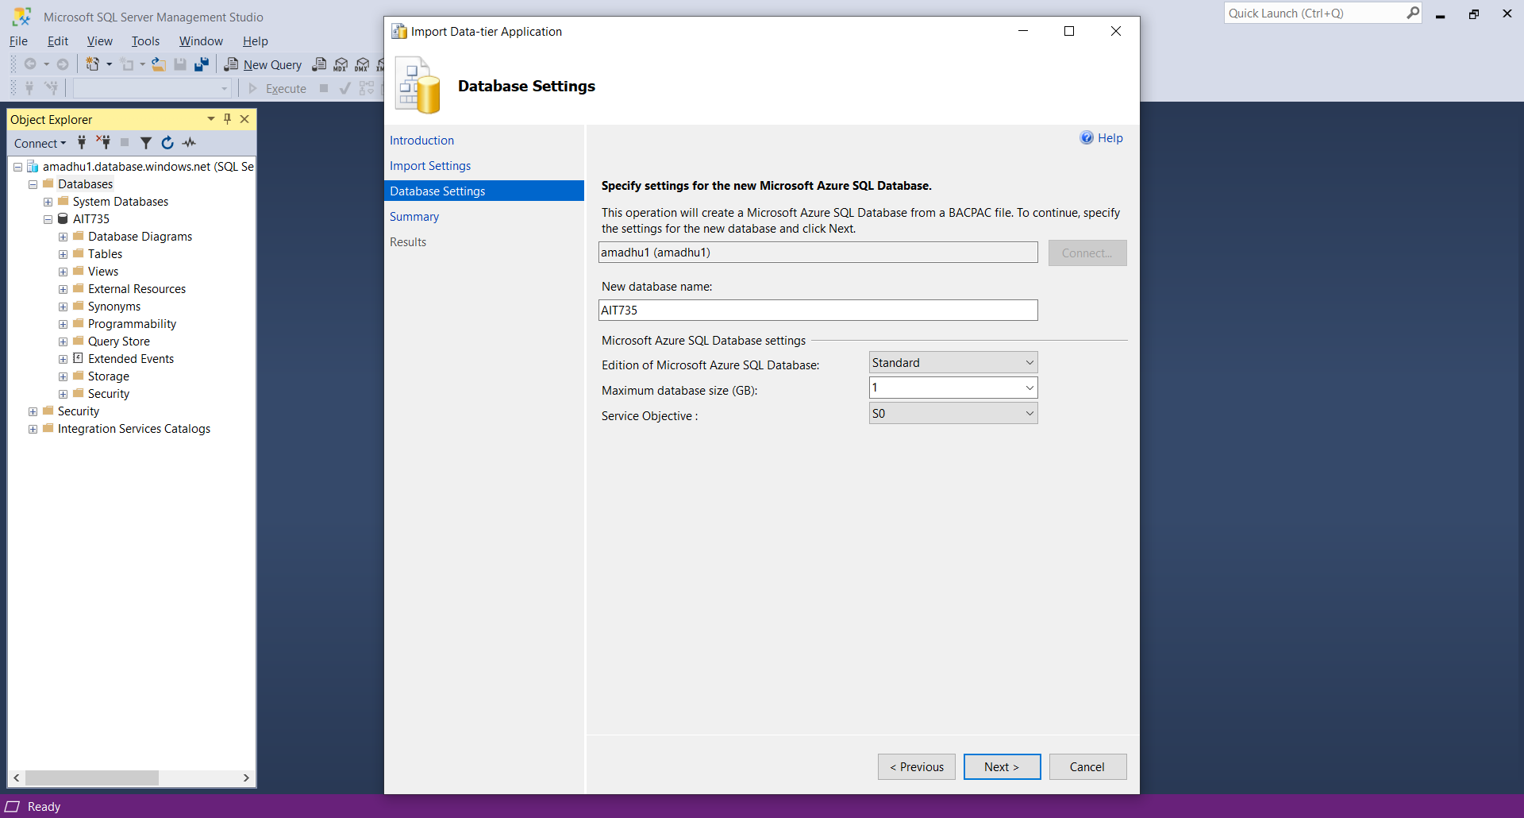

Data is imported to the Microsoft Azure cloud Database. Clicked on close

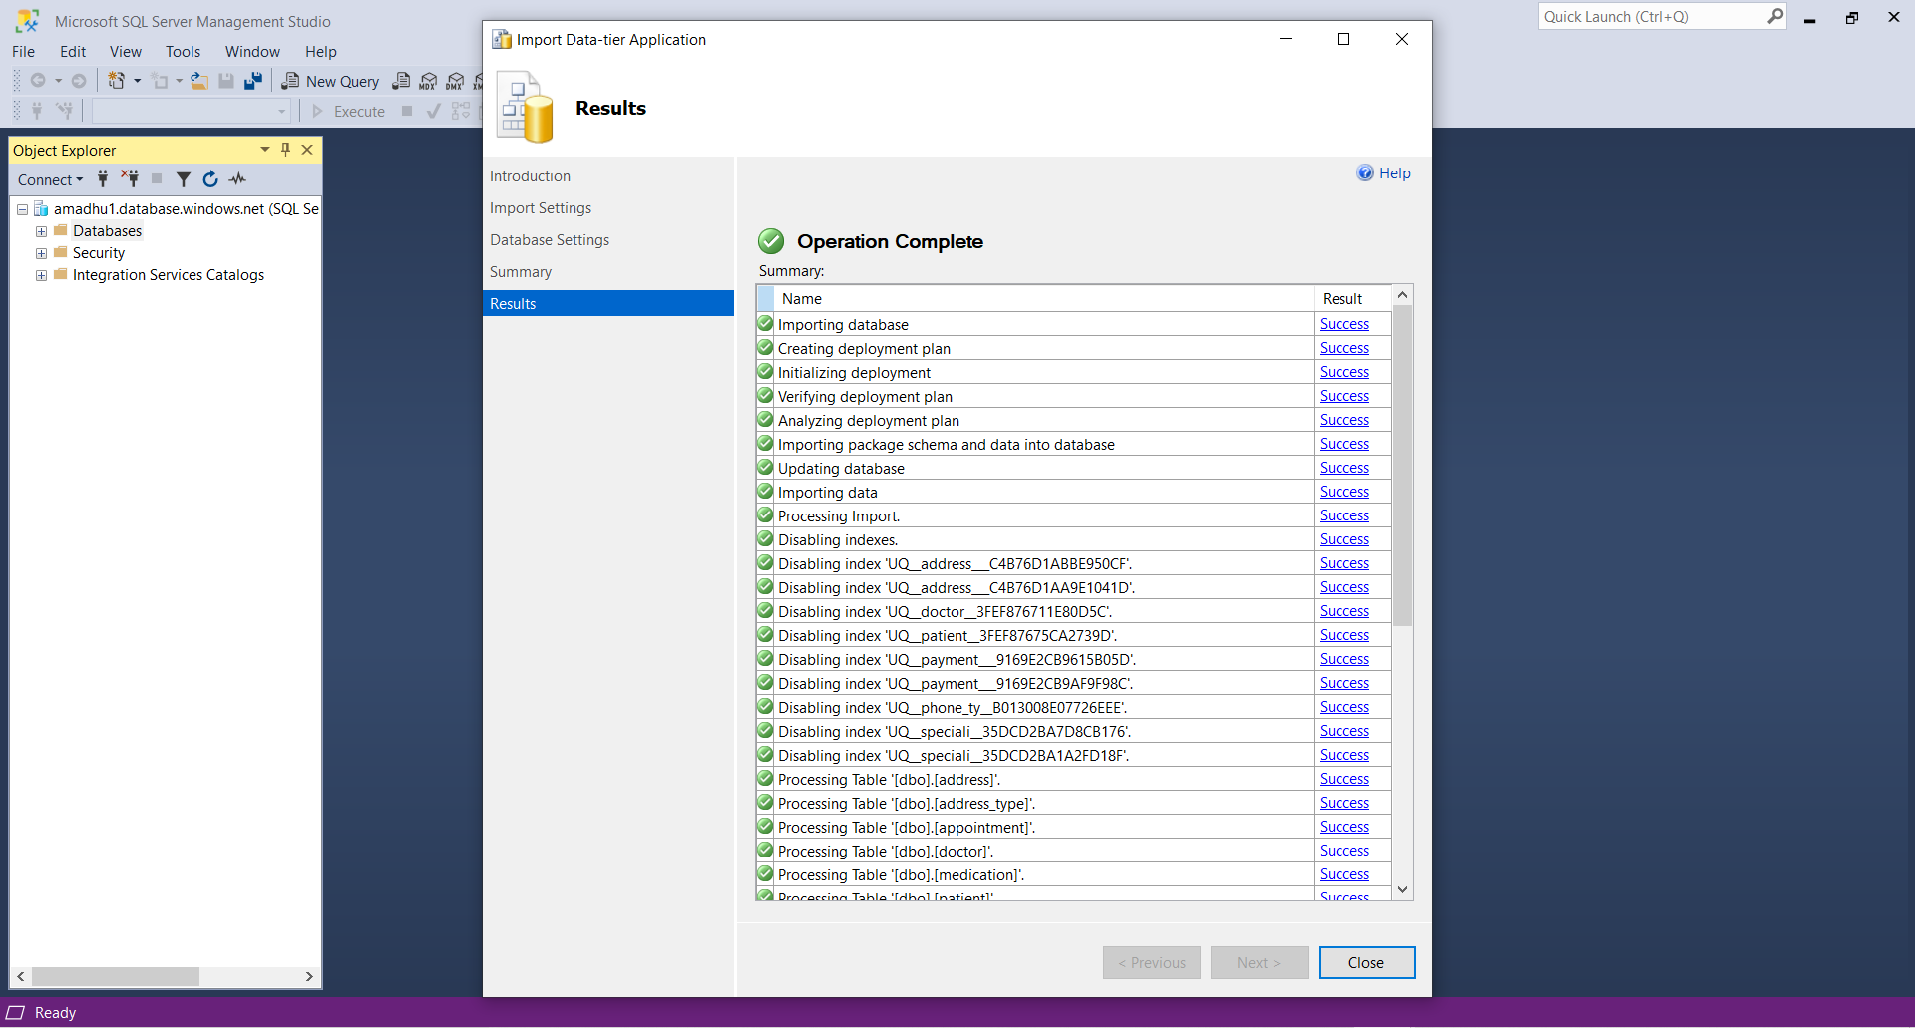

Now the hospital database is migrated from the on-premises database to the Microsoft Azure cloud database. The below screenshot displays the data that is migrated to the cloud database.

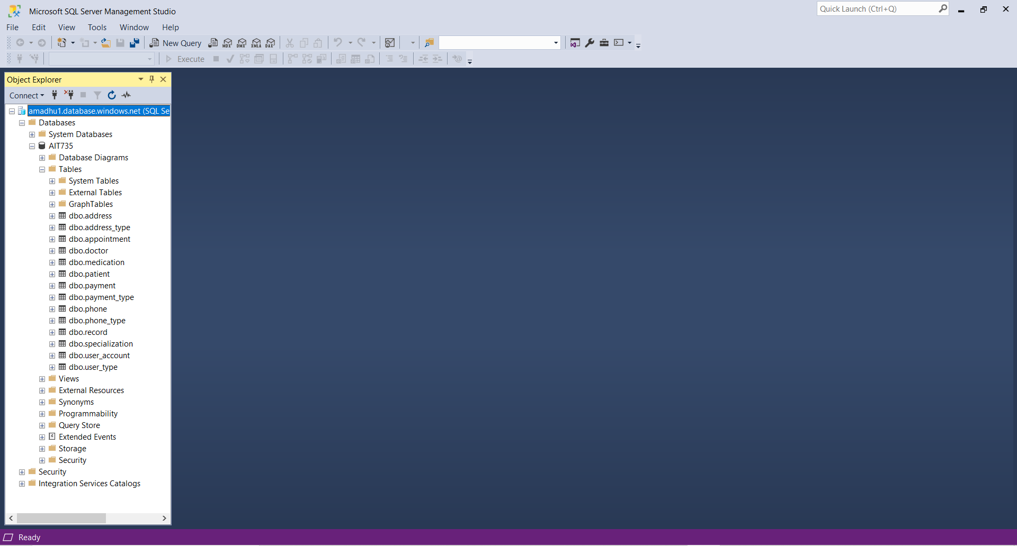

**Geo Replication**

The replica of the database will be created in the secondary region for back up in case of primary region failure. Go to Resource group and click on SQL Database name i.e. AIT735

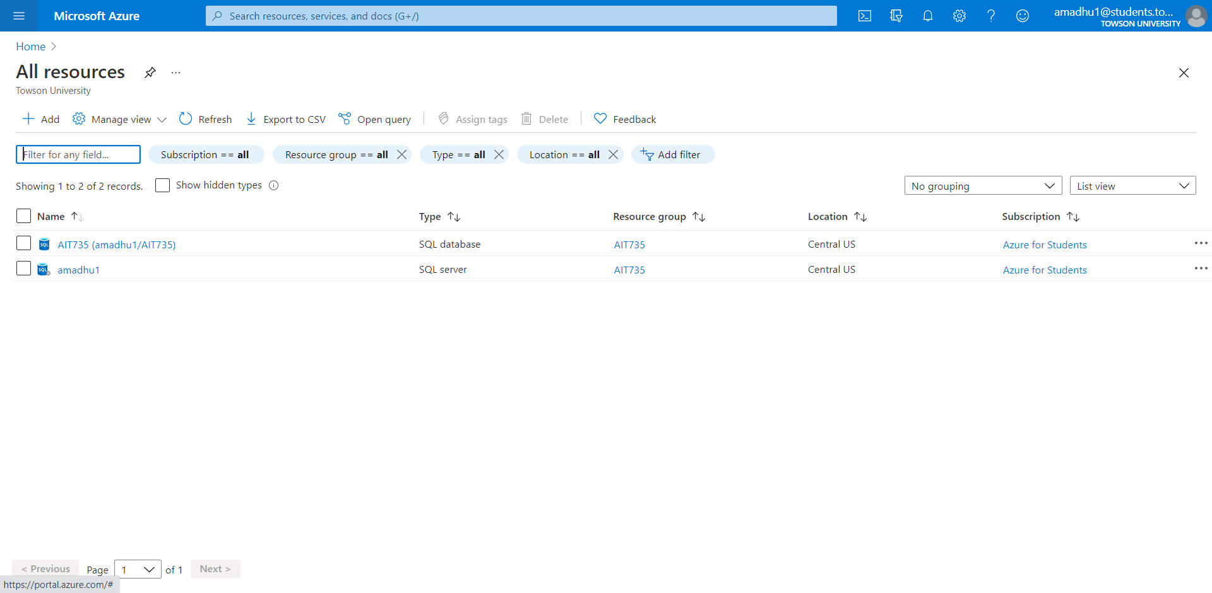

Options for the database appears and click on Geo-replication on the left side of the window and the available regions for Geo-replications appears. Click on East US as that will be our secondary region

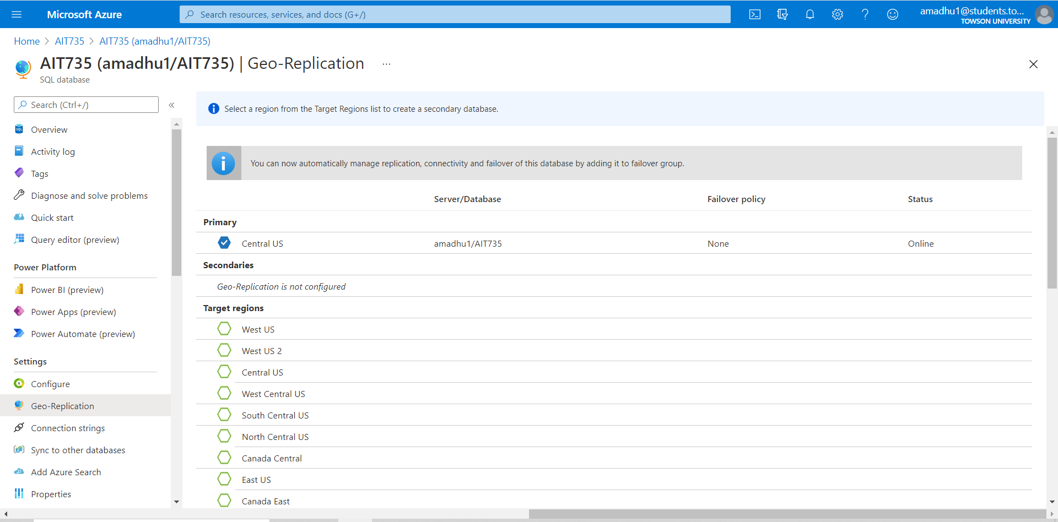

Dialogue box appears prompting the user to select the region and configure settings as per the requirement

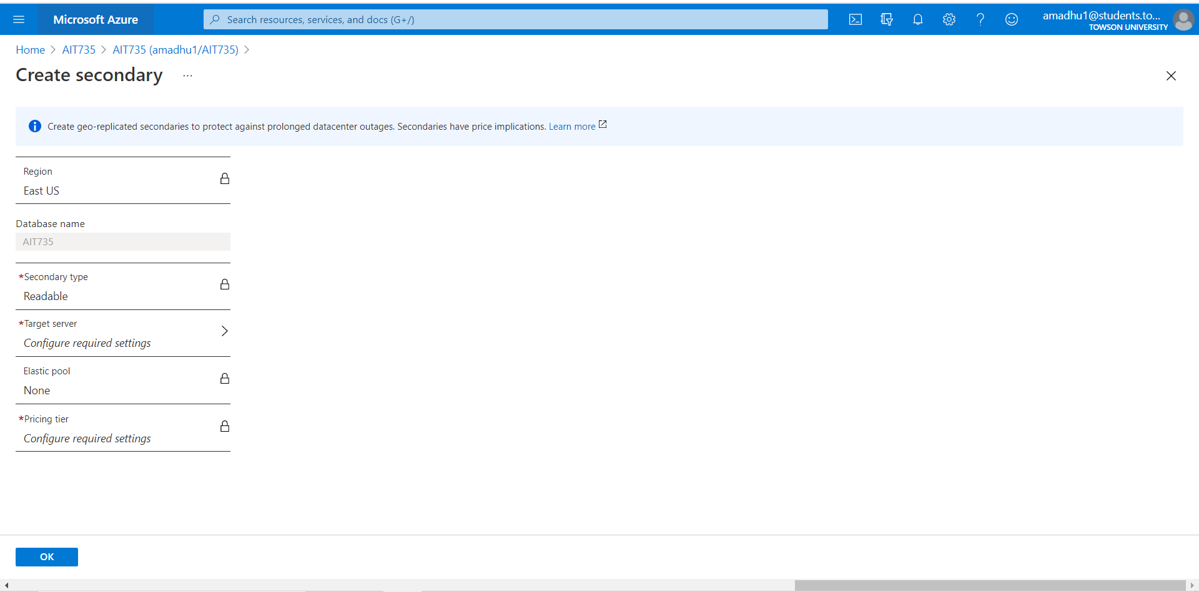

After selecting the region , click on the arrow near the “Target Server”. A new window appears

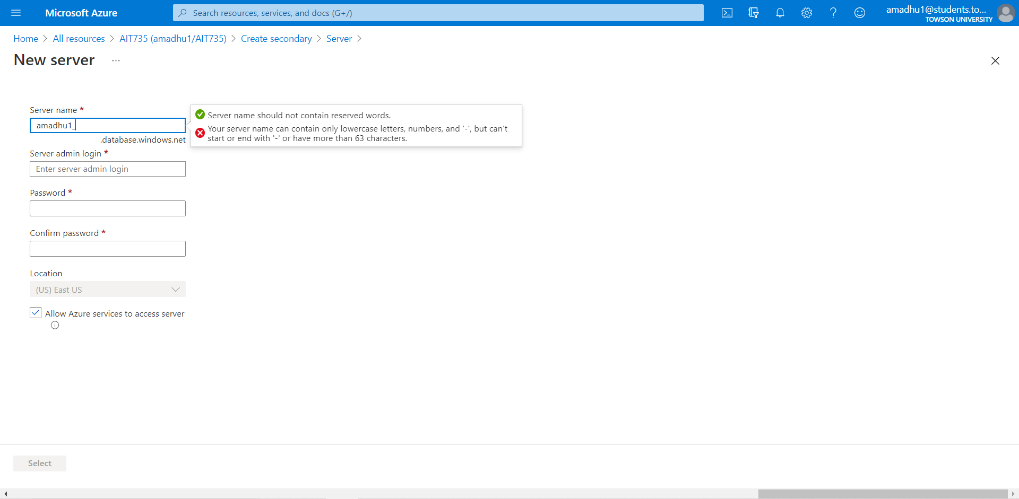

Choose the credentials for the secondary server and click on select

**Secondary server credentials**

Username: amadhu1

Password: ***

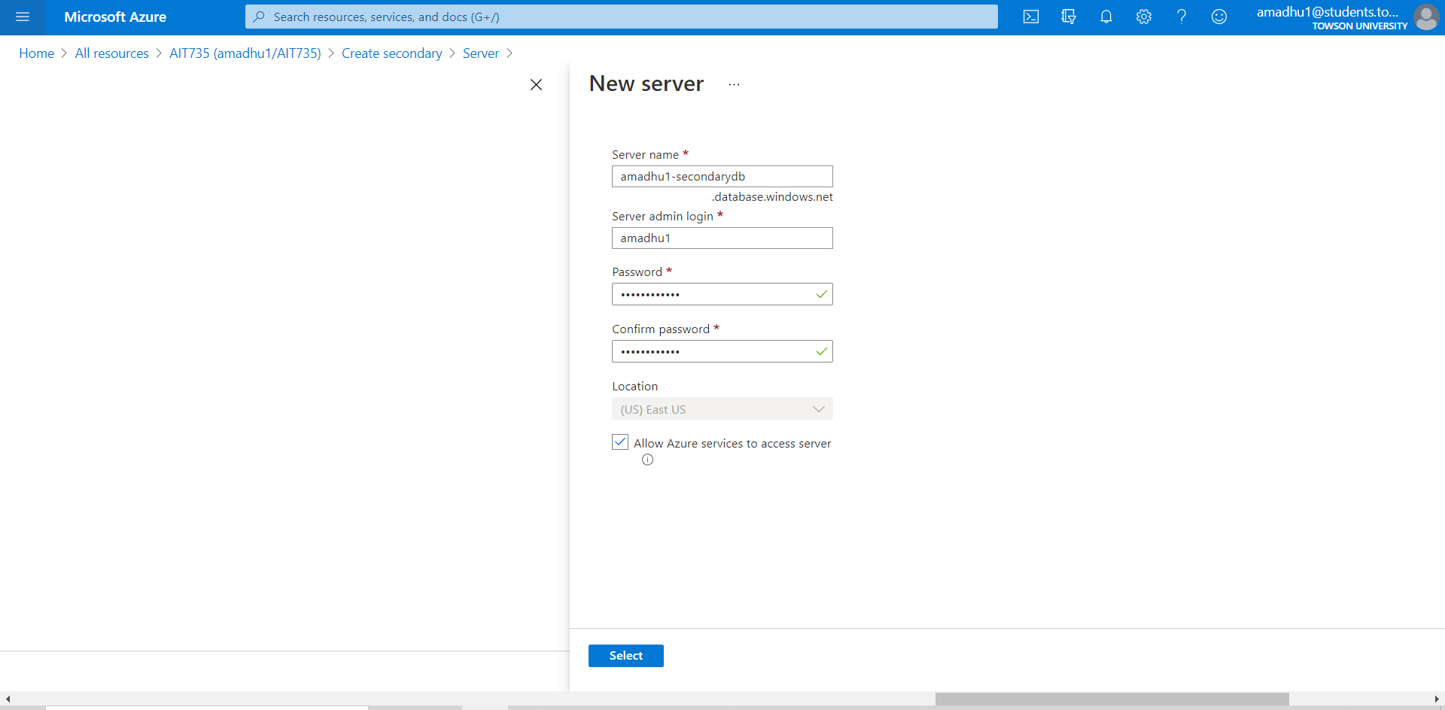

Completed the configuration of the secondary database

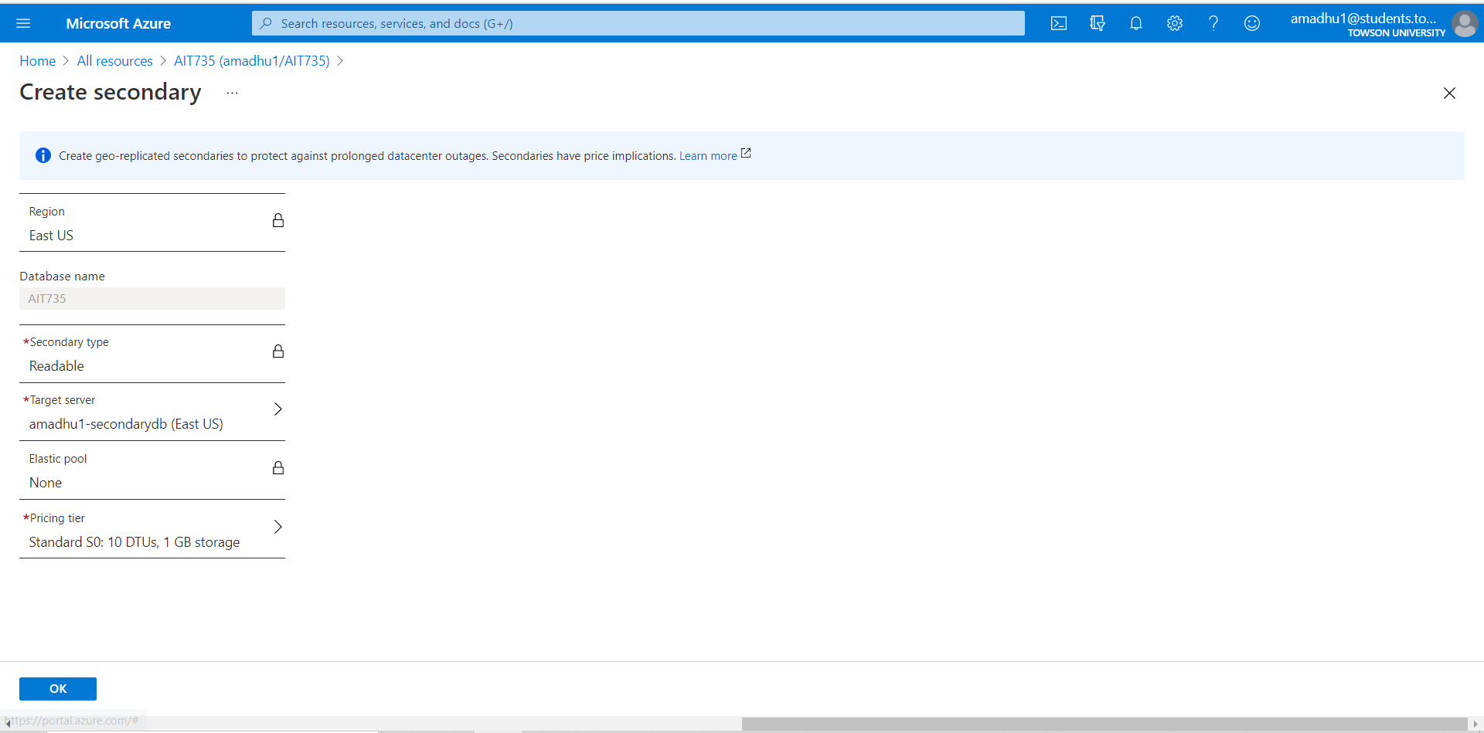

Secondary database deployment is in progress

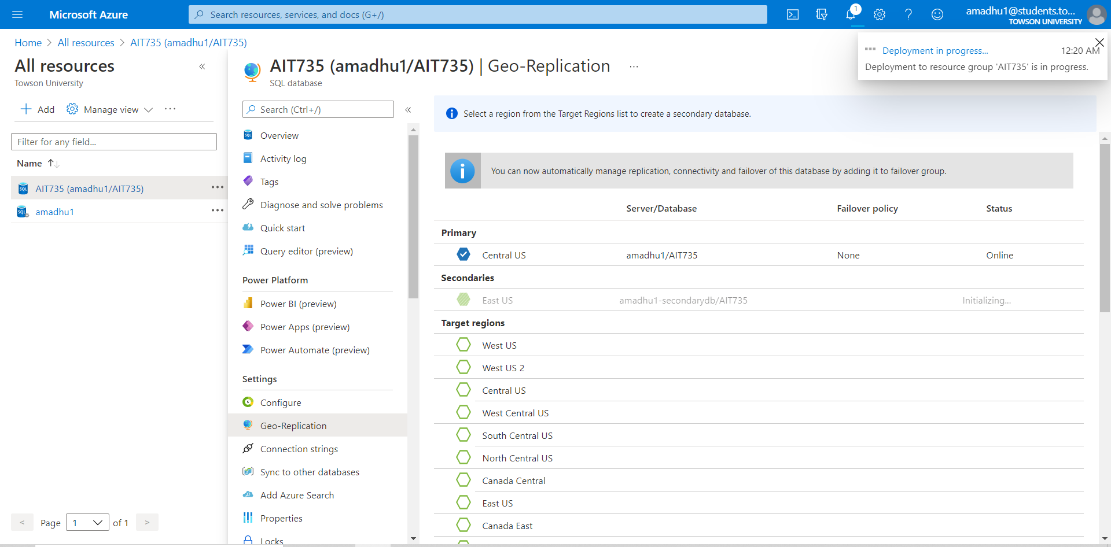

Microsoft Azure is initializing seeding of the secondary replica of the database

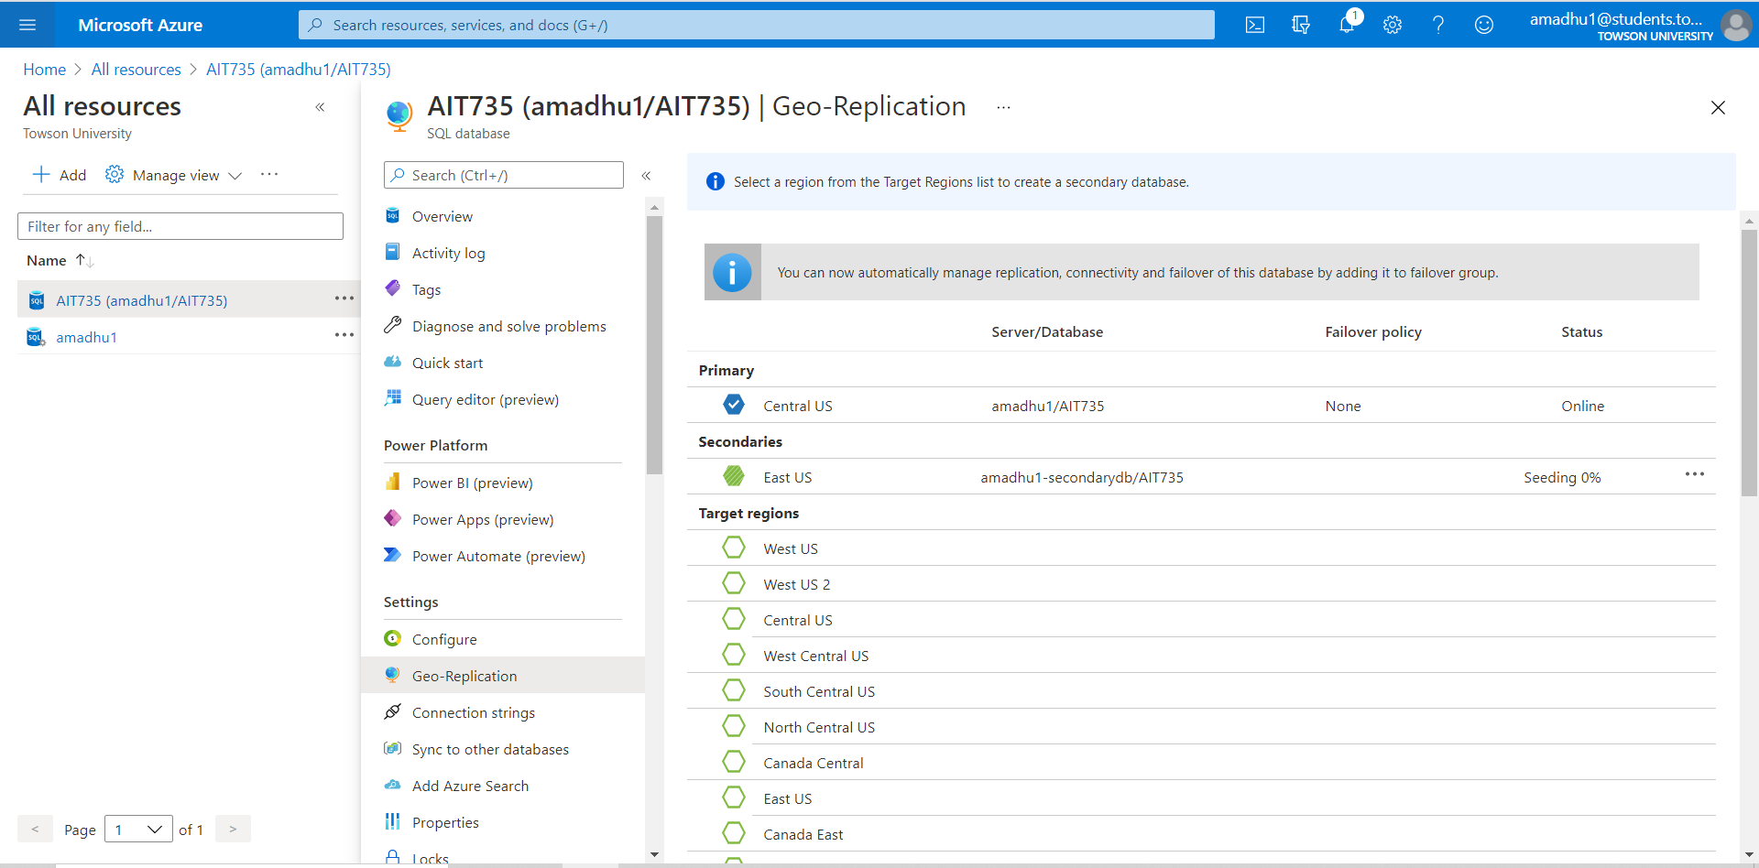

Deployment completed and the migrated database is replicated to the secondary region i.e., East US

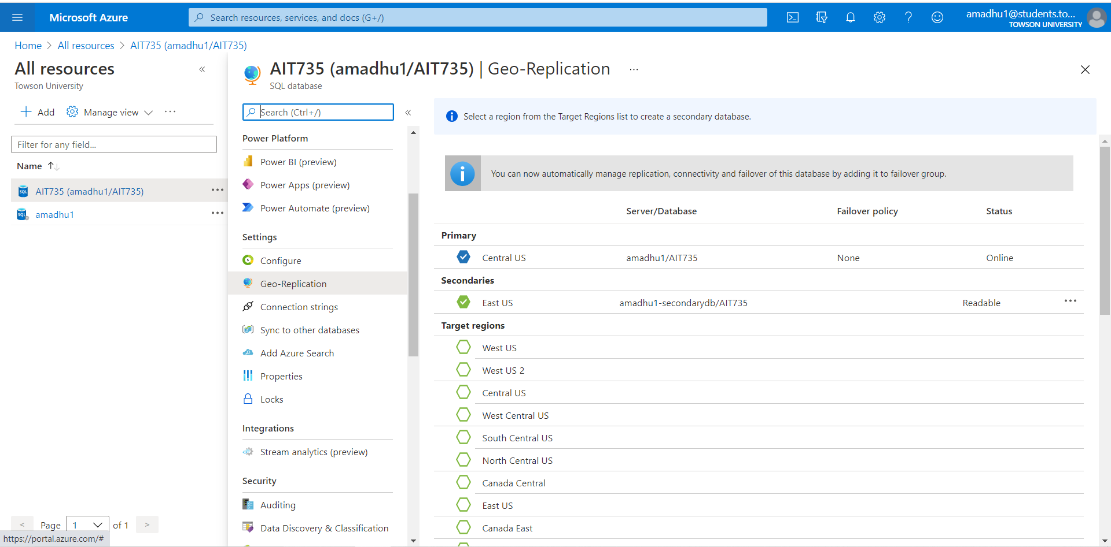

**Configuring Database Backups:**

Point in time restore is configured for security purposes. PITR varies depending on the subscription. In Microsoft Azure database backups are taken automatically without additional cost but additional cost will incur when we use the restore capability.

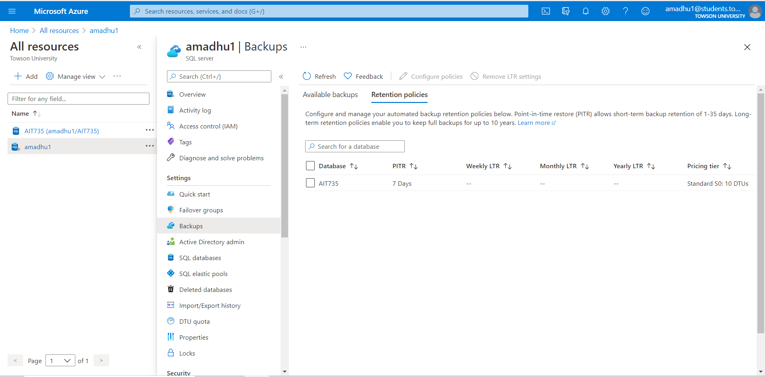

Select the database and click on configure policies. Changed the Point in time restore (PITR) and Long-term back up (LTR) backups as per our requirement.

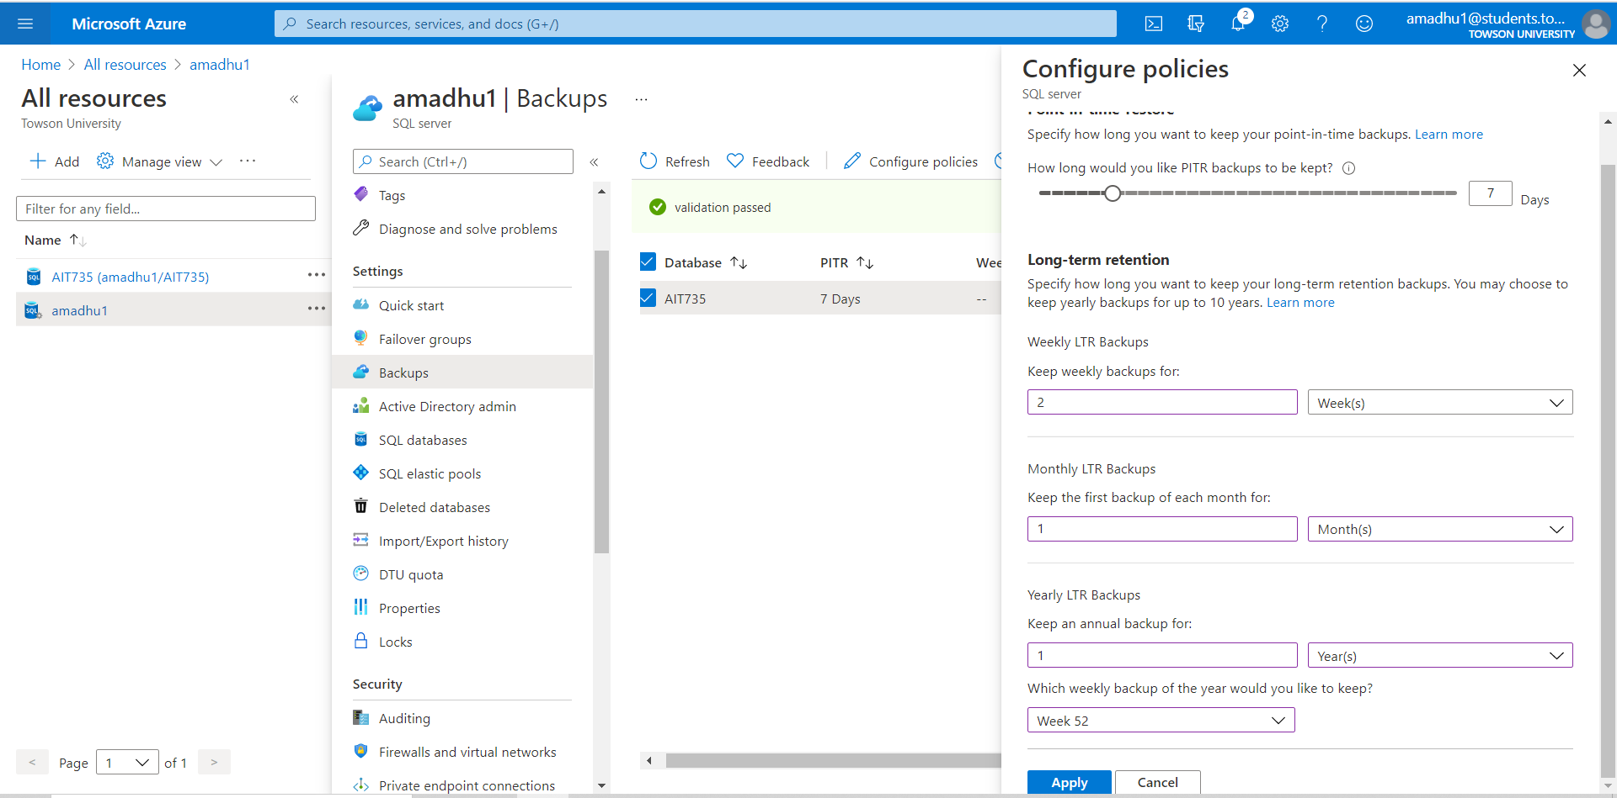

Azure will validate the eligibility and the validation passed

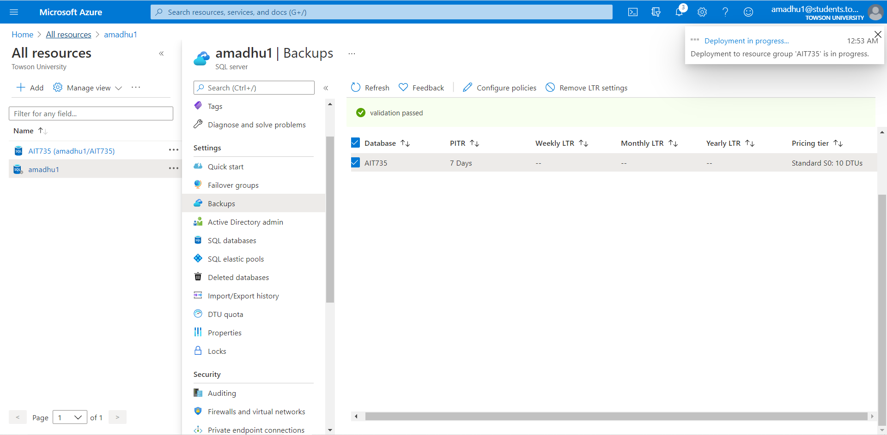

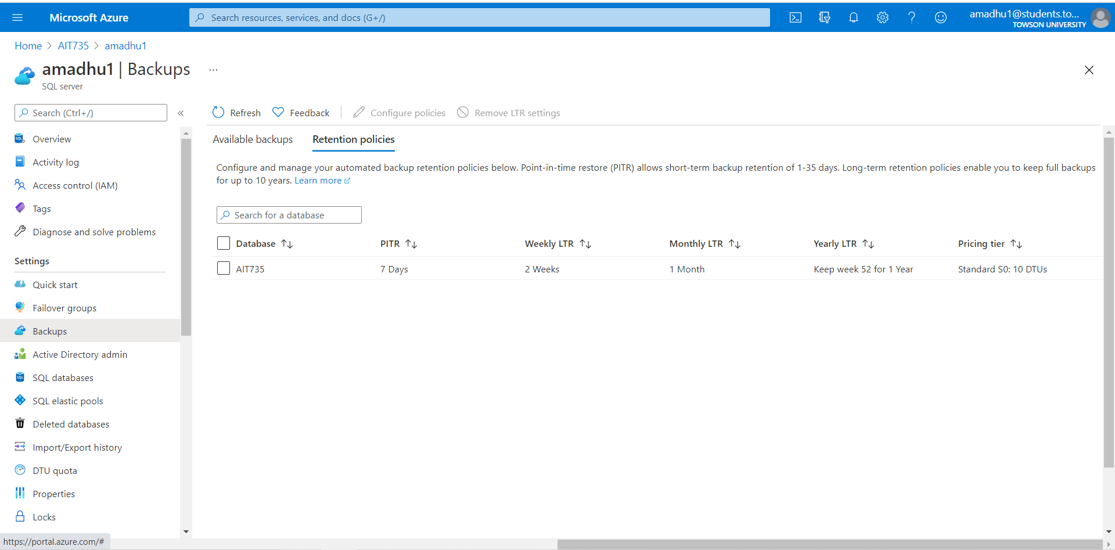

Deployment succeeded and the changes applied accordingly. Microsoft azure also provides options to remove policies or change policies according to our requirement.

## 7.1 Validation of the requirements implementation

**Requirement 1**: The system will allow to add new user.

Inserted two new users in the migrated database

**Code**: Insert into user_account values (‘P003’, 3, ‘pword003’);

Insert into user_account values (‘D004’, 3, ‘word003’);

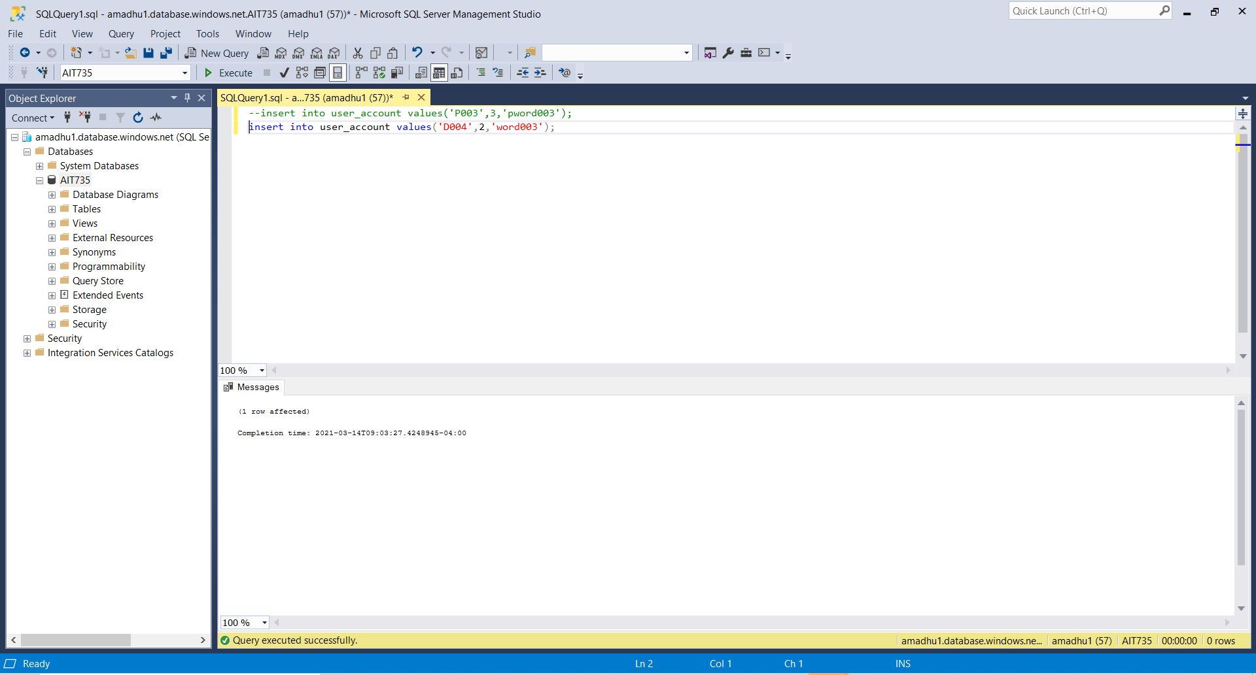

New users have been added in the system

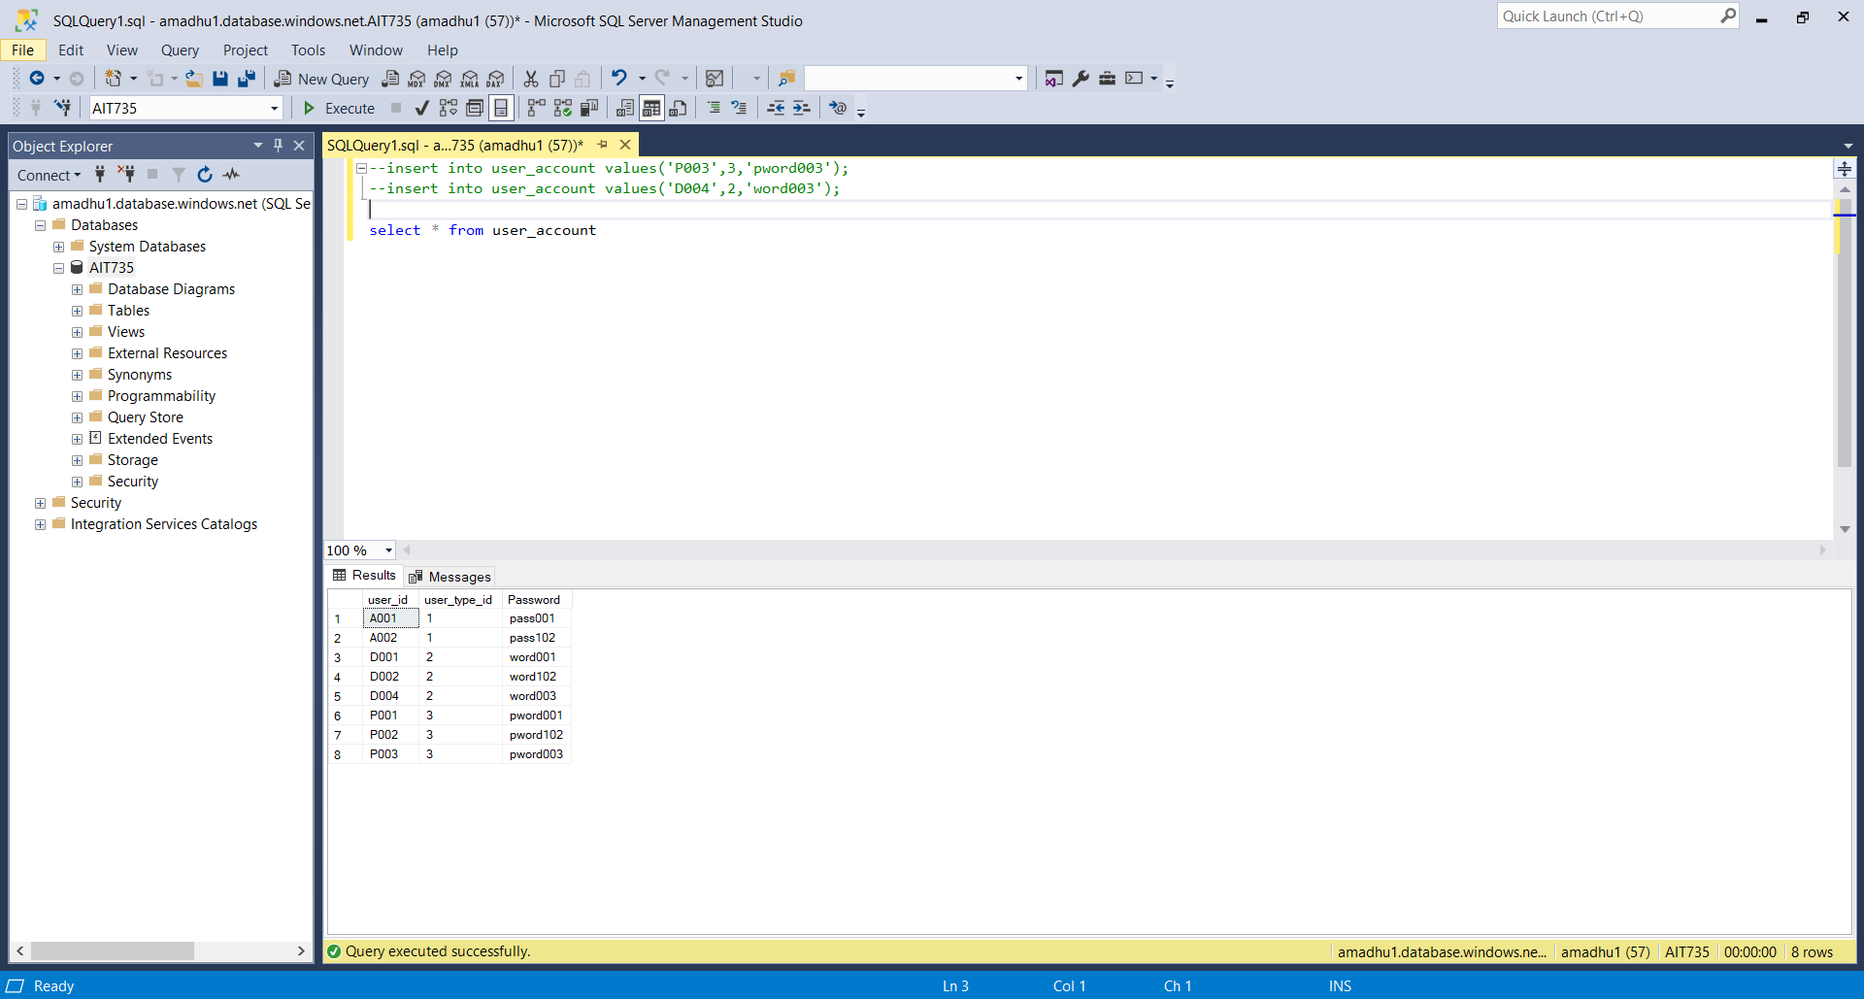

**Requirement 2:** The System will allow to add new patients

**Code:** Insert into patient values(‘Aadhyant’, ‘Anil’, ‘M’, ‘adi@gmail.com’, ‘1990-02-15’, ‘P003’, 0.0);

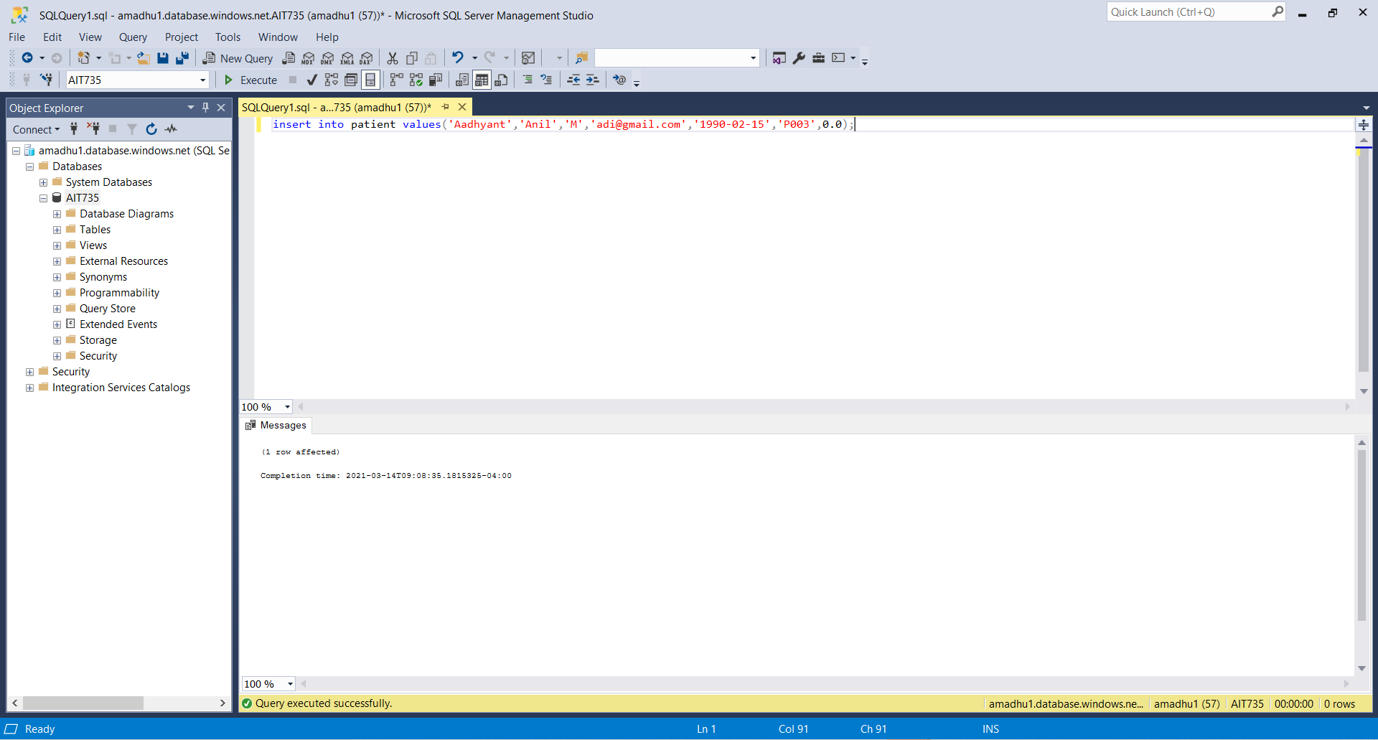

New patient is added into the system

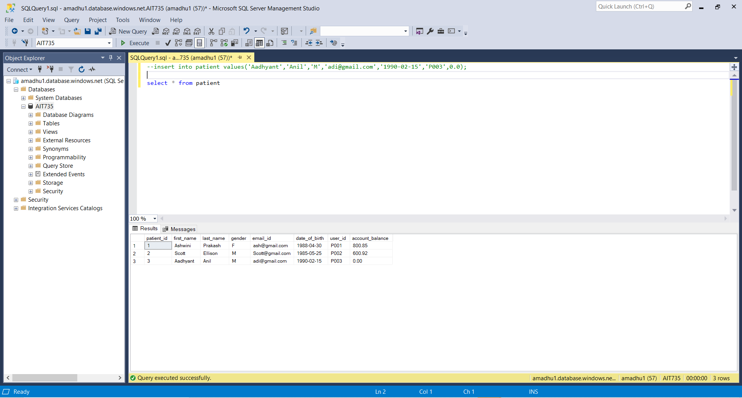

**Requirement 3:** The system will allow to add new doctors

**Code:** Insert into doctor values (‘Janet Hunt’, ‘janet@gmail.com’, ‘D004’, 1, ‘2019-01-20);

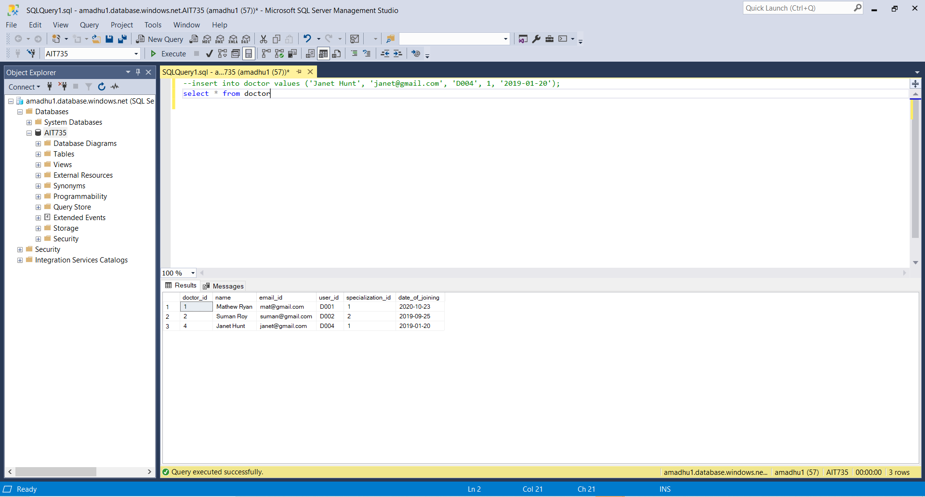

Doctor added into the system

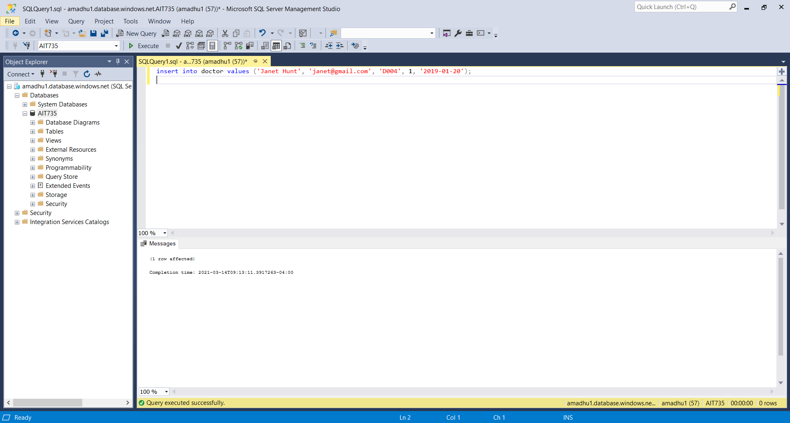

**Requirement 4:** The system will need the following details from the patient to create a new account. (First Name, Last Name, Phone number, Address, Gender, Email address, Date of Birth).

**Code:** Insert into patient values(‘Aadhyant’, ‘Anil’, ‘M’, ‘adi@gmail.com’, ‘1990-02-15’, ‘P003’, 0.0);



**Requirement 5:** The system will need the below details from the doctor to create a new account.( Name, Phone number, Email ID, Specialization, Date of joining)



**Requirement 6:** The system will allow to allocate unique user ID for each patient.

**Code:** Select * from Patient;

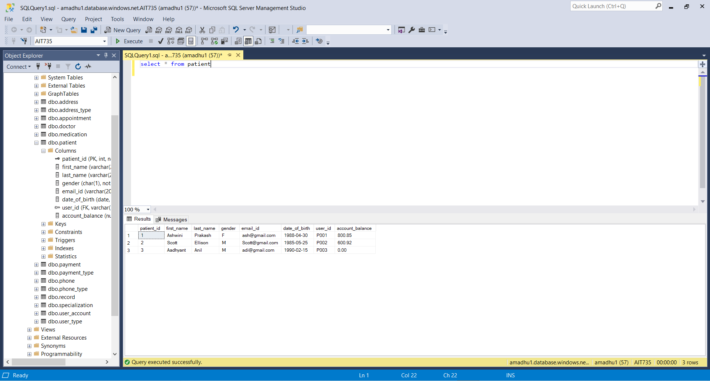

**Requirement 7:** The system will allow to allocate unique user ID for each doctor.

**Code:** Select * from doctor;

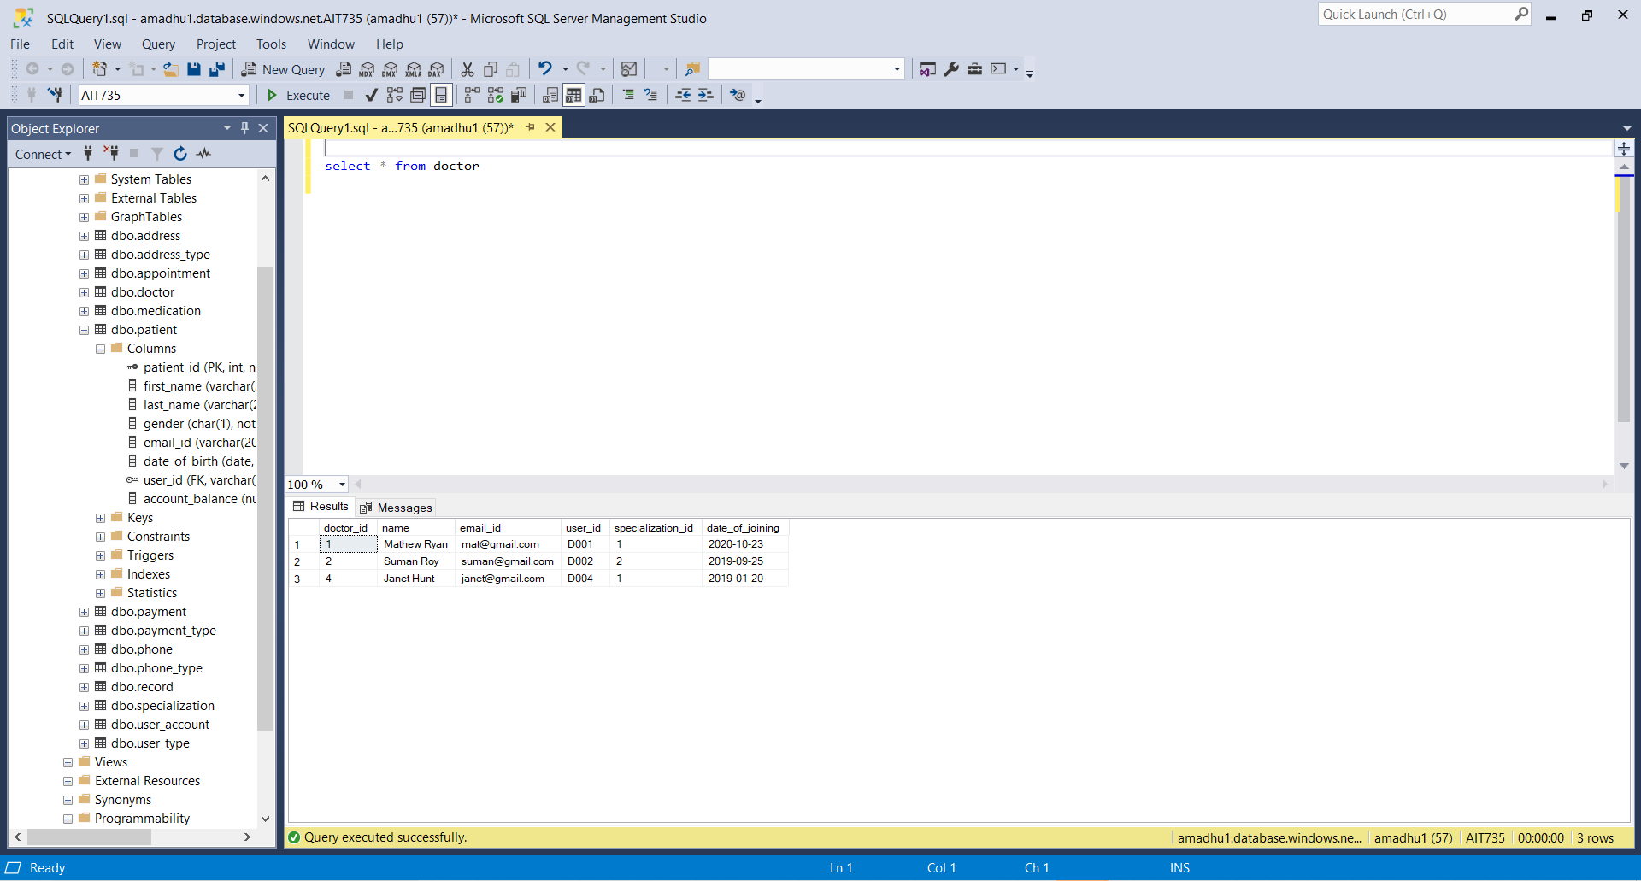

**Requirement 8:** The system will allow users to login to their account credentials

**Code:** select * from user_account where user_id=’P001’ and password=’pword001’;

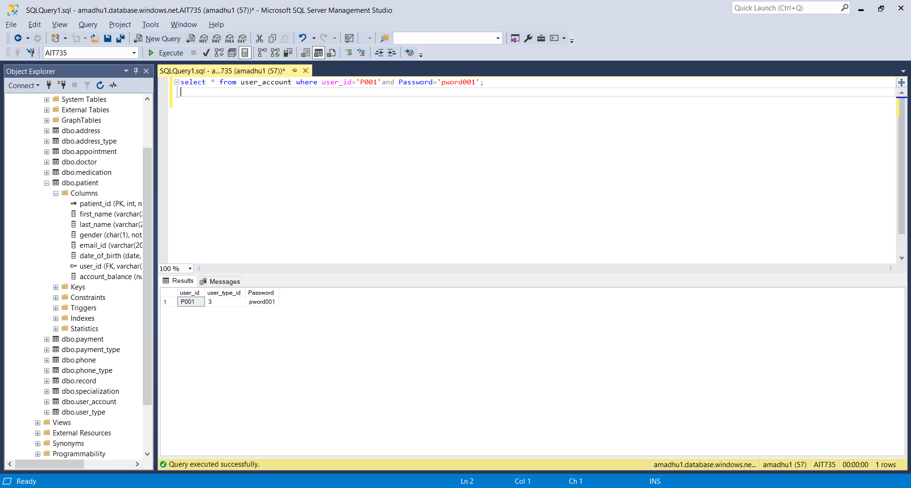

**Requirement 9:** The system will allow user to edit the following personal data (Phone number and address).

Existing data in the phone table

Updating phone number:

**Code:** update phone set phone_number='333-555-4344' where user_id='P001'

Select * from phone;

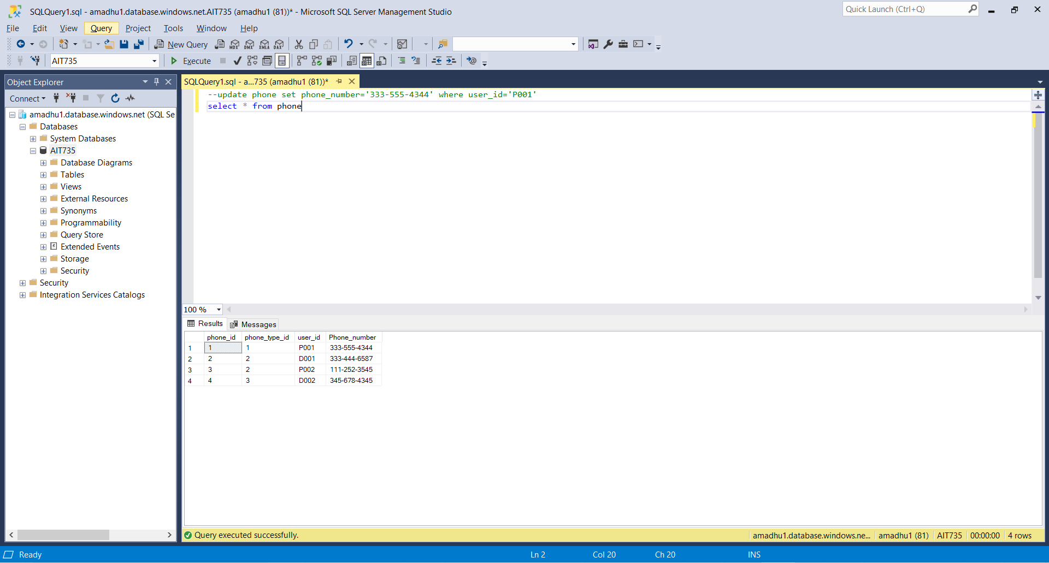

Updating the address:

Existing data on the address table



**Code:** update address set street='Valley RD', city='Catonsville', zipcode='21252' where user_id='P001'

Select * from address;

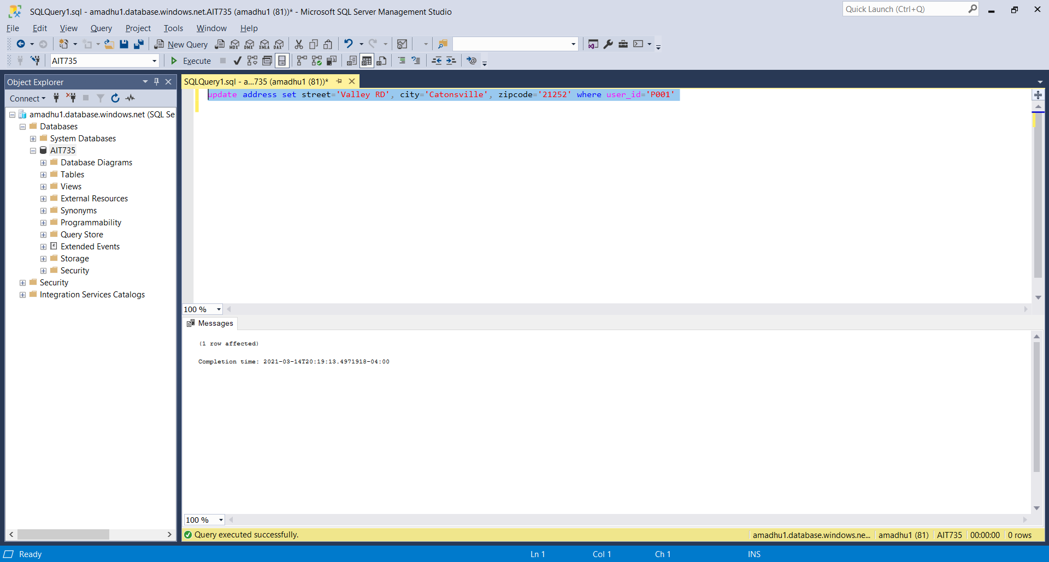

Address update is validated: select * from address;

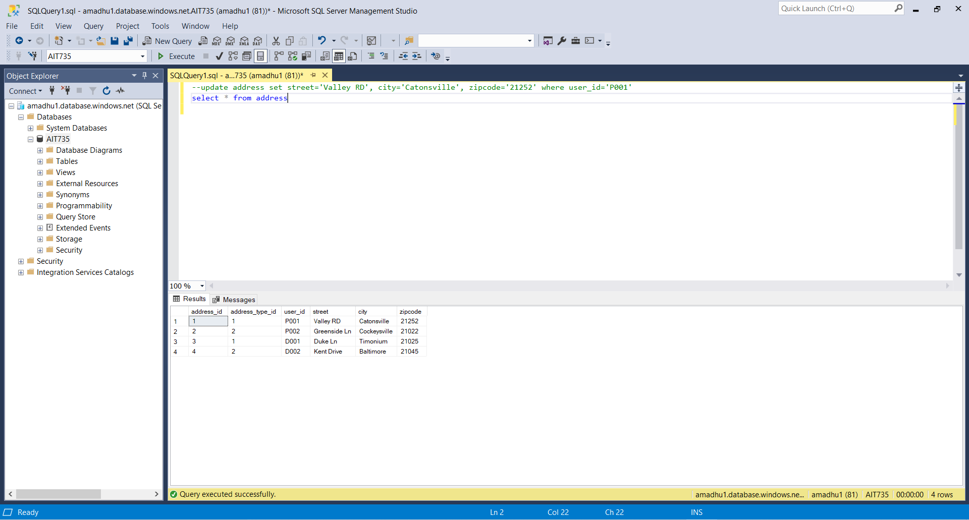

**Requirement 10:** The system will display appointment details that includes patient’s name, their doctor’s name, reason of visit information in the patient’s account.

**Code:** select appointment.appointment_id, patient.first_name as Patient_Name, doctor.name as Doctor_Name, appointment.reason_of_visit as Reason_Of_Visit, appointment.appointment_time from appointment inner join patient on appointment.patient_id=patient.patient_id inner join doctor on appointment.doctor_id=doctor.doctor_id;

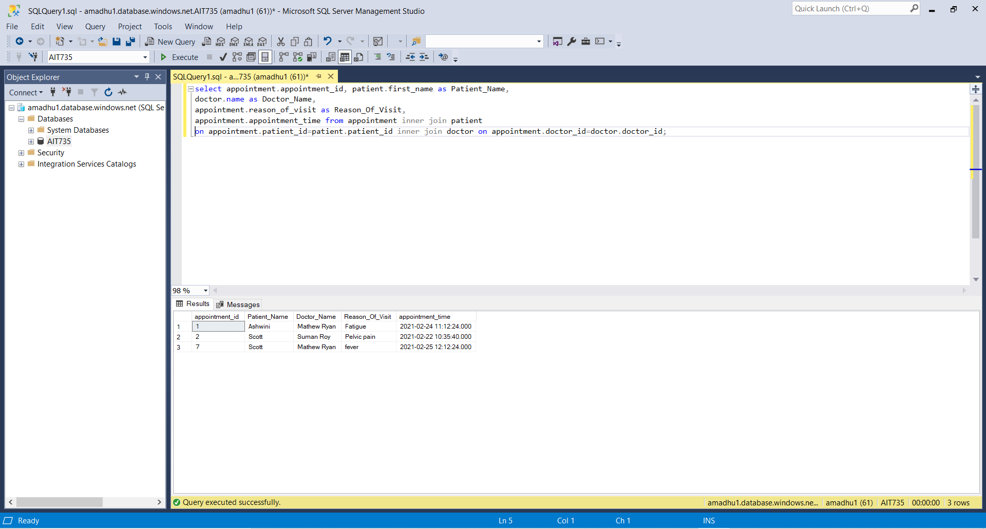

**Requirement 11:** The system will allow doctor to view the patient’s records

**Code:** select record.record_id, patient.first_name as Patient_Name, doctor.name as Doctor_Name, record.Date_of_visit as Date_Of_Visit, record.diagnosis as Diagnosis, record.amount_charged as Amount_Charged, medication.medication_name as Medication_Name from record inner join patient on record.patient_id=patient.patient_id inner join doctor on record.doctor_id=doctor.doctor_id inner join medication on record.medication_id= medication.medication_id;

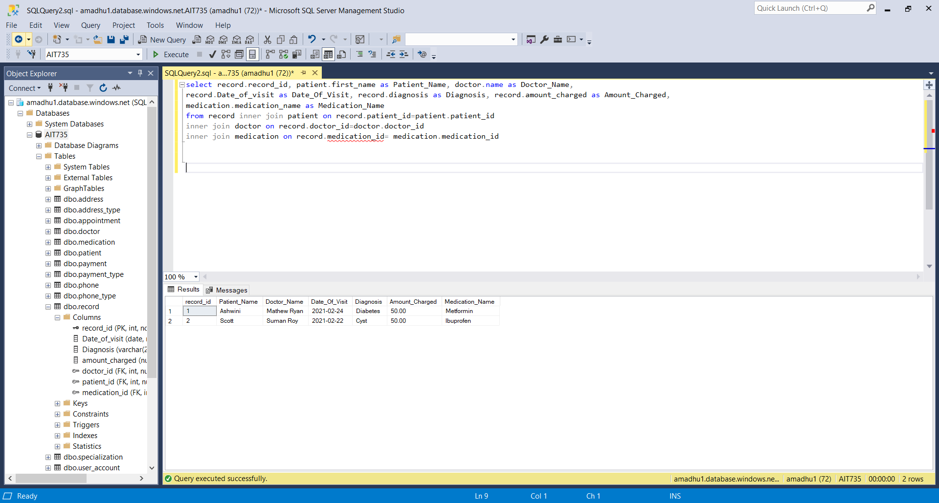

**Requirement 12:** The system will allow doctors to view the medications prescribed for the patients.

**Code:** Select medication.medication_id, patient.first_name as Patient_Name, doctor.name as Doctor_Name, medication.medication_name as Medication_Name, medication.dosage as Dosage from medication inner join patient on medication.patient_id=patient.patient_id inner join doctor on medication.doctor_id=doctor.doctor_id;

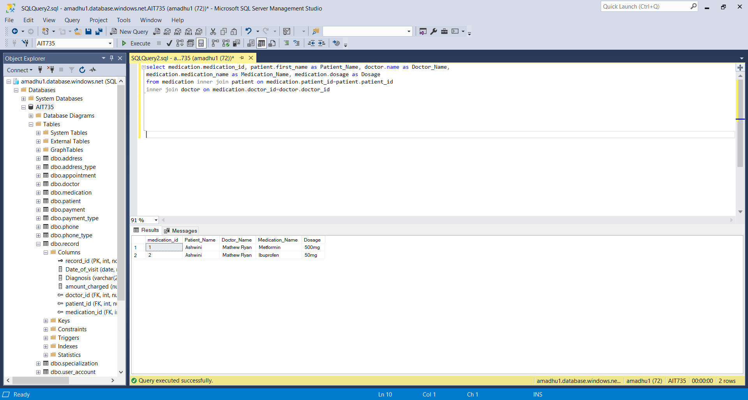

**Requirement 13:** The system will allow doctors to create a record for each visit with the following details (Date of visit, reason of visit, Diagnosis, amount_charged, doctor_id and patient_id)

**Code:** Insert into record values (‘2021-02-24’, ‘Diabetes’, 50.0,1,1);

Insert into record values (‘2021-02-22’, ‘Cyst’, 50.0, 2,2);



**Requirement 14:** The system will allocate unique system generated record id for each record.

**Code:** Select * from record;



**Requirement 15:** The system will save the patient payments with the following details (Amount, Payment type, Payment date, patient_id)

Code: insert into payment values (100, 1, 1, ‘2021-02-24 12:25:30’);

insert into payment values (200, 2, 2, ‘2021-02-23 08:55:35’);

Select * from payment;



**Requirement 16:** The system will display the payment information in the patient’s account

**Code:** select payment.payment_id as Payment_ID, patient.first_name as Patient_Name, payment.Amount as Amount_Paid, payment_type.Payment_description as Payment_Type, payment.payment_date as Payment_Date from payment inner join patient on payment. patient_id=patient.patient_id inner join payment_type on payment.payment_id=payment_type.payment_type_id;

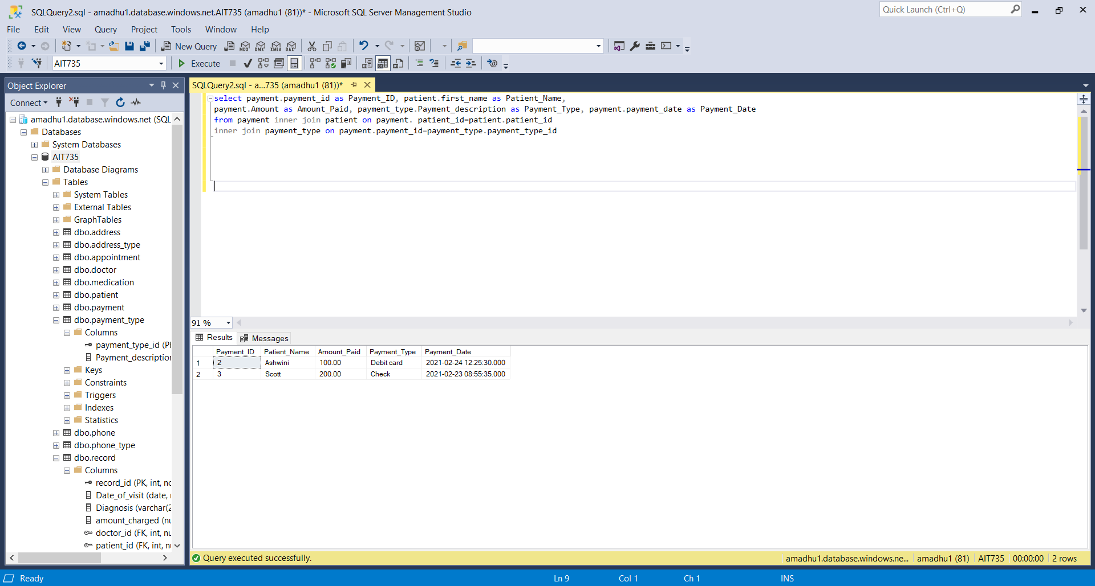

**Requirement 17:** The system will reduce the amount from the patient’s account balance every time the payment is made. (This requirement is implemented using a trigger)

**Code:** create or alter trigger update_balance

on payment

for insert

as

begin

--declaring two variables patient_id and amount to get the values from inserted row

declare @patient_id int, @amount numeric(5,2)

select @patient_id = (select patient_id from inserted)

select @amount = (select amount from inserted)

update patient

set account_balance = account_balance-@amount

where patient_id = @patient_id

if @@error<>0

begin

rollback transaction

return

end

end

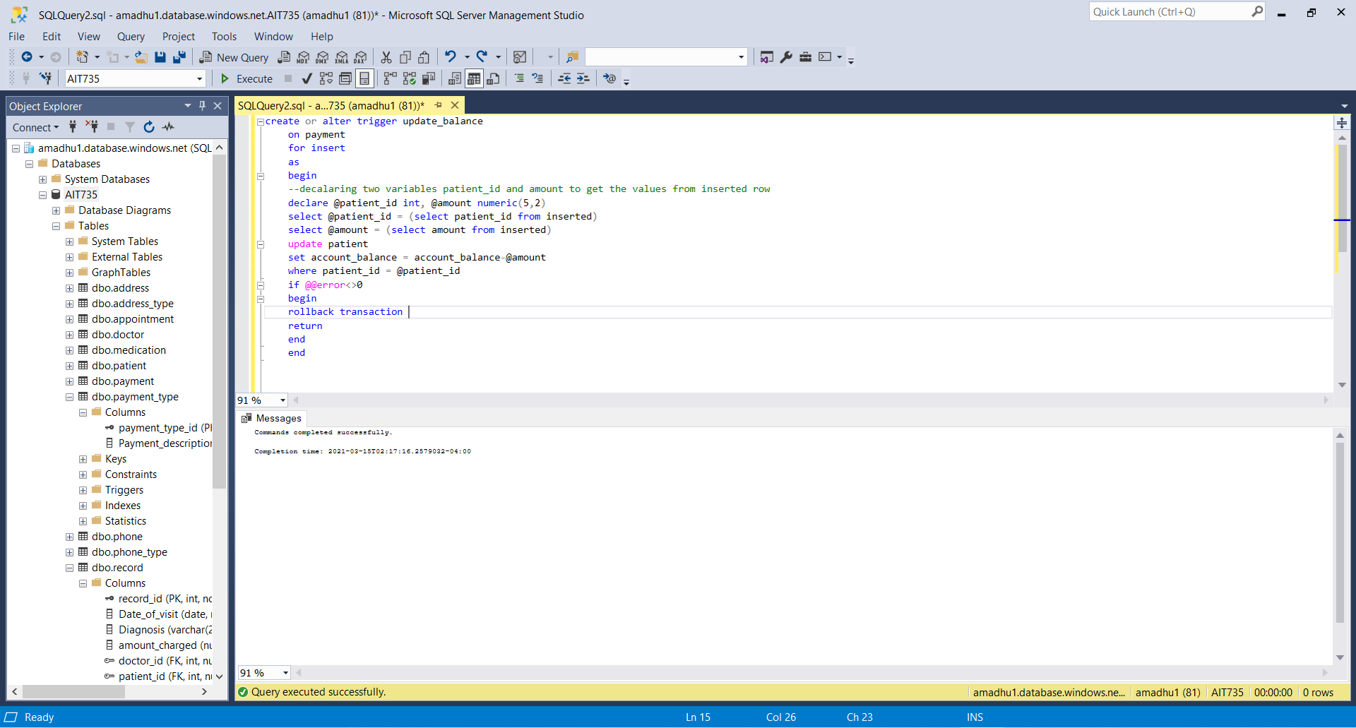

Account balance for the patient 1 is $800.85

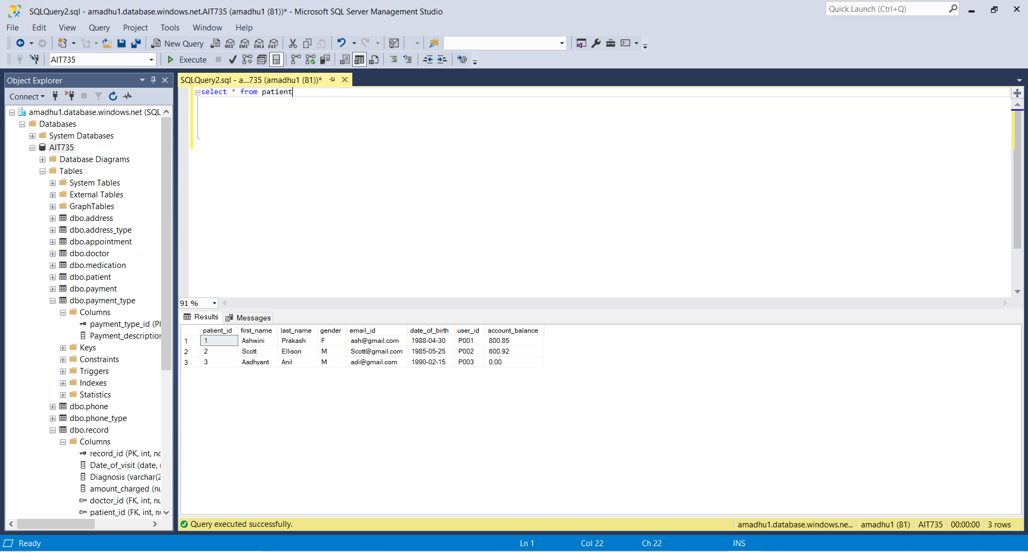

When the patient makes a payment of $100, the amount will be reduced from the account balance of the patient

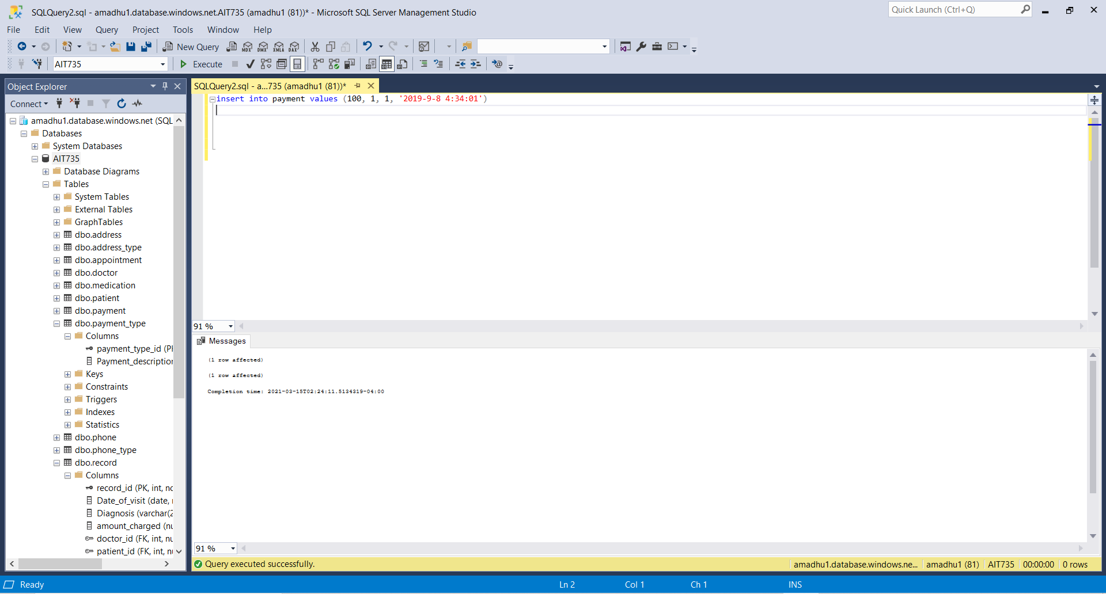

**Resulting patient table:** The account balance for the patient with the patient_id 1 has been reduced to $700.85

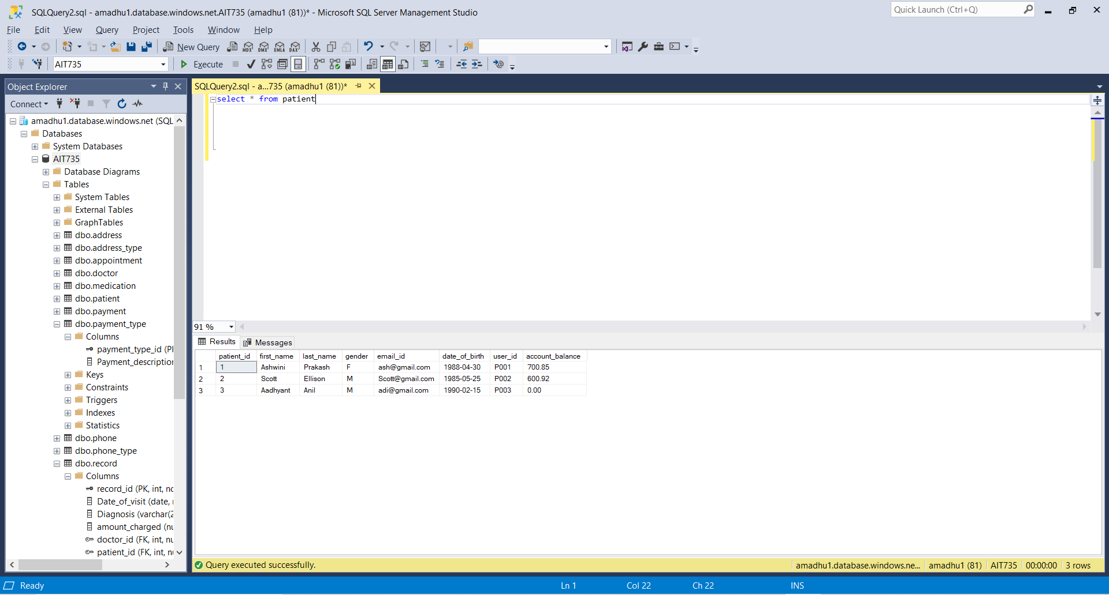

**Requirement 18:** The system will not allow the payments other than the valid payment types (Implemented using a stored procedure)

create or alter proc usp_record_payment

(@amount numeric(5,2),@payment_type_id int, @patient_id int, @payment_date datetime)

as

begin

/*verifying valid payment types from the payment_type table*/

if not exists (select 1 from payment_type where payment_type_id = @payment_type_id)

begin

print 'Invalid payment type'

end

else

begin

begin transaction

/* insert payment details */

insert into payment (amount,payment_type_id,patient_id, payment_date)

values (@amount, @payment_type_id,@patient_id, @payment_date)

if @@error<>0

begin

rollback transaction

return

end

else

begin

commit transaction

end

end

end

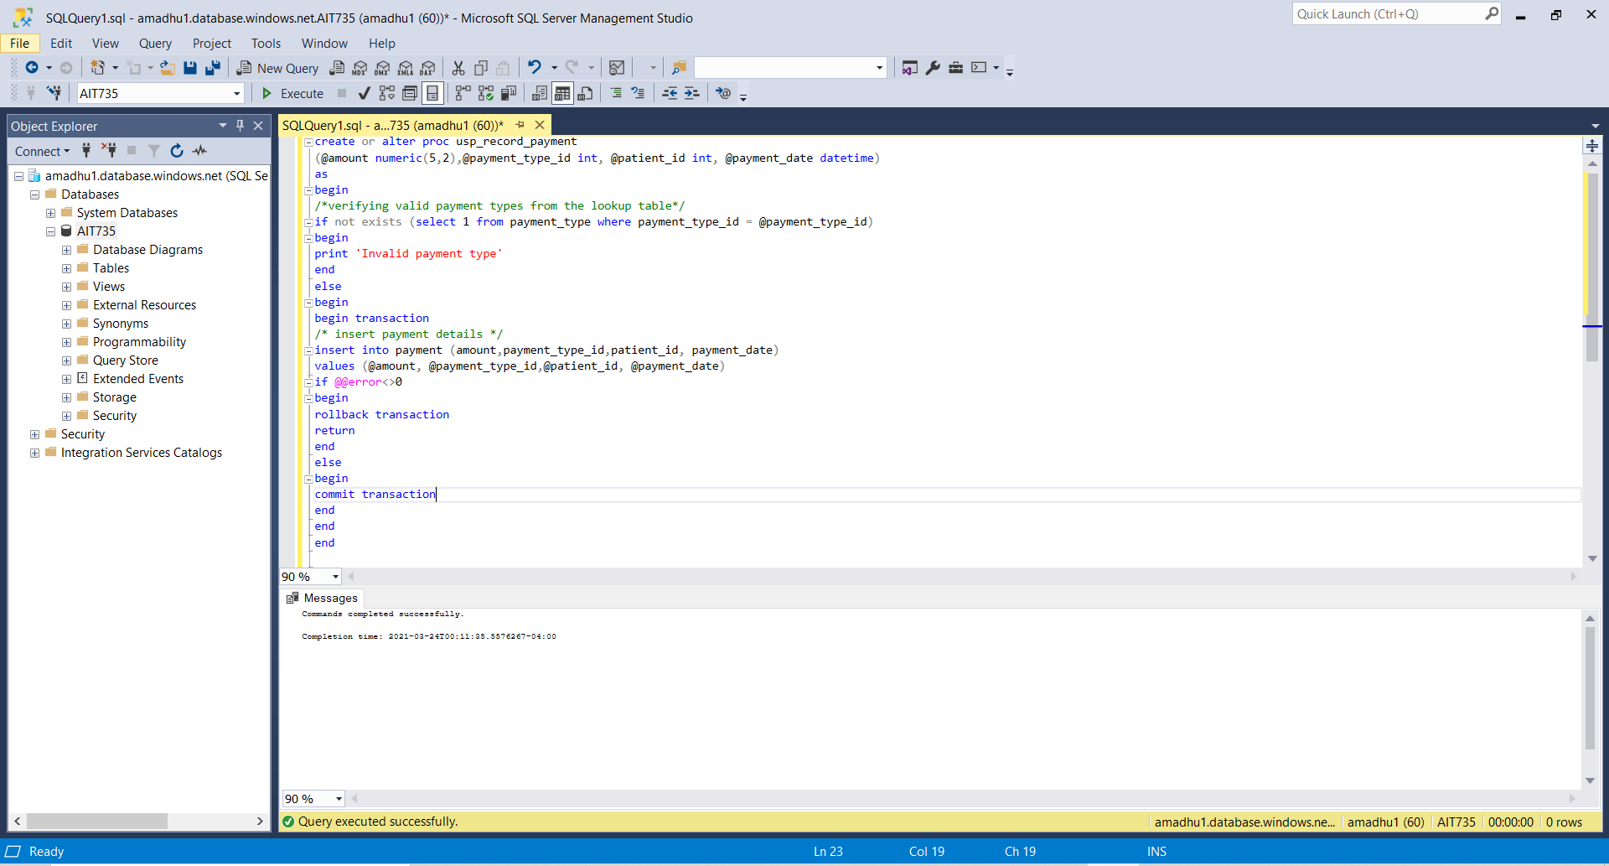

The below screenshot has the valid payment type ids

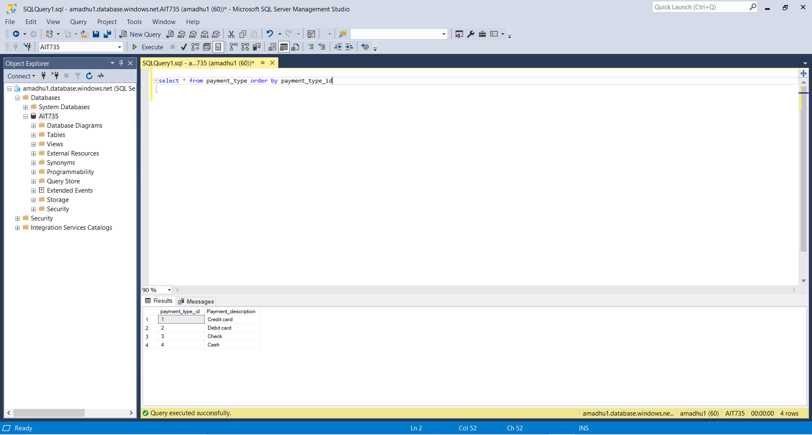

When the invalid payment id is entered the system displays an error message

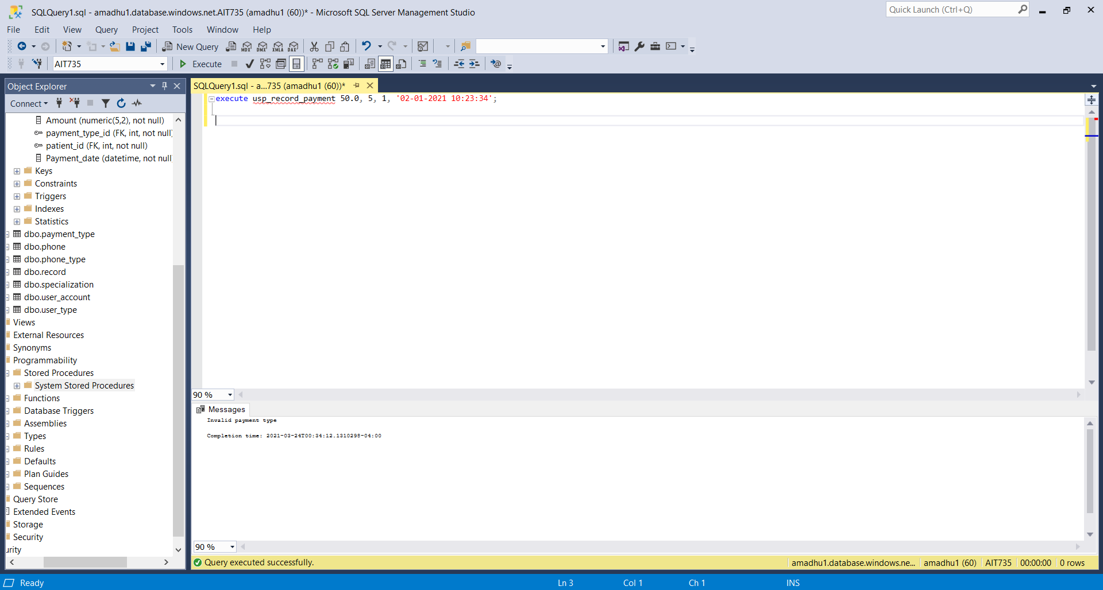

**Requirement 19:** The system will not allow to schedule two appointments at the same time with the same Doctor (Implemented using a stored procedure)

create or alter proc schedule_appointment

(@patient_id int, @doctor_id int, @reason_of_visit varchar(25), @appointment_time datetime)

as

begin

--checking for duplicates

if exists (select 1 from appointment where doctor_id=@doctor_id and appointment_time=@appointment_time)

begin

print 'Duplicate appointment'

end

else

begin

begin transaction

--Insert if there is no duplicate

insert into appointment (patient_id, doctor_id, reason_of_visit, appointment_time)

values(@patient_id, @doctor_id, @reason_of_visit, @appointment_time)

if @@error <>0

begin

print 'Insert Failed'

rollback transaction

return

end

else

begin

--Display success message if the action is successful

print 'appointment successfully scheduled'

commit transaction

end

end

end

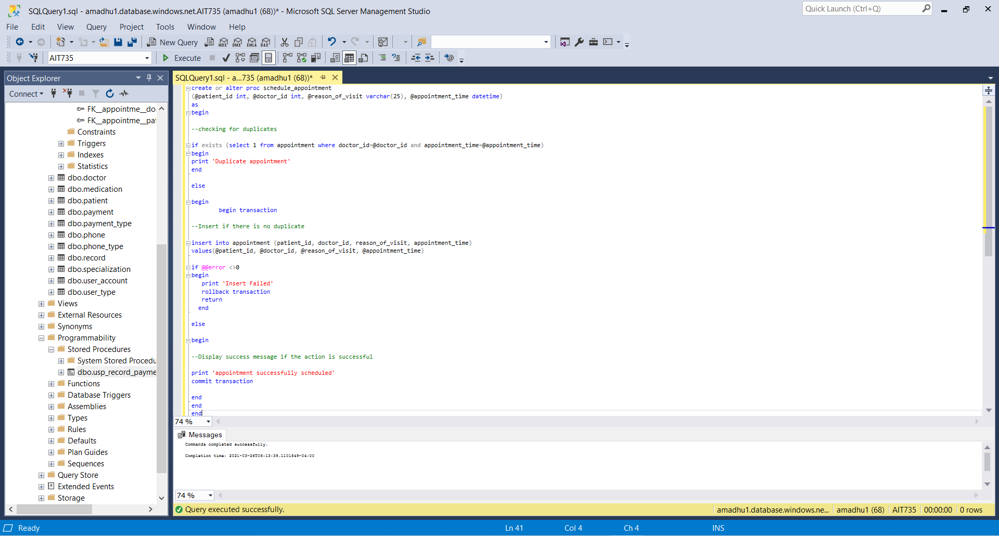

Existing data in the appointment table

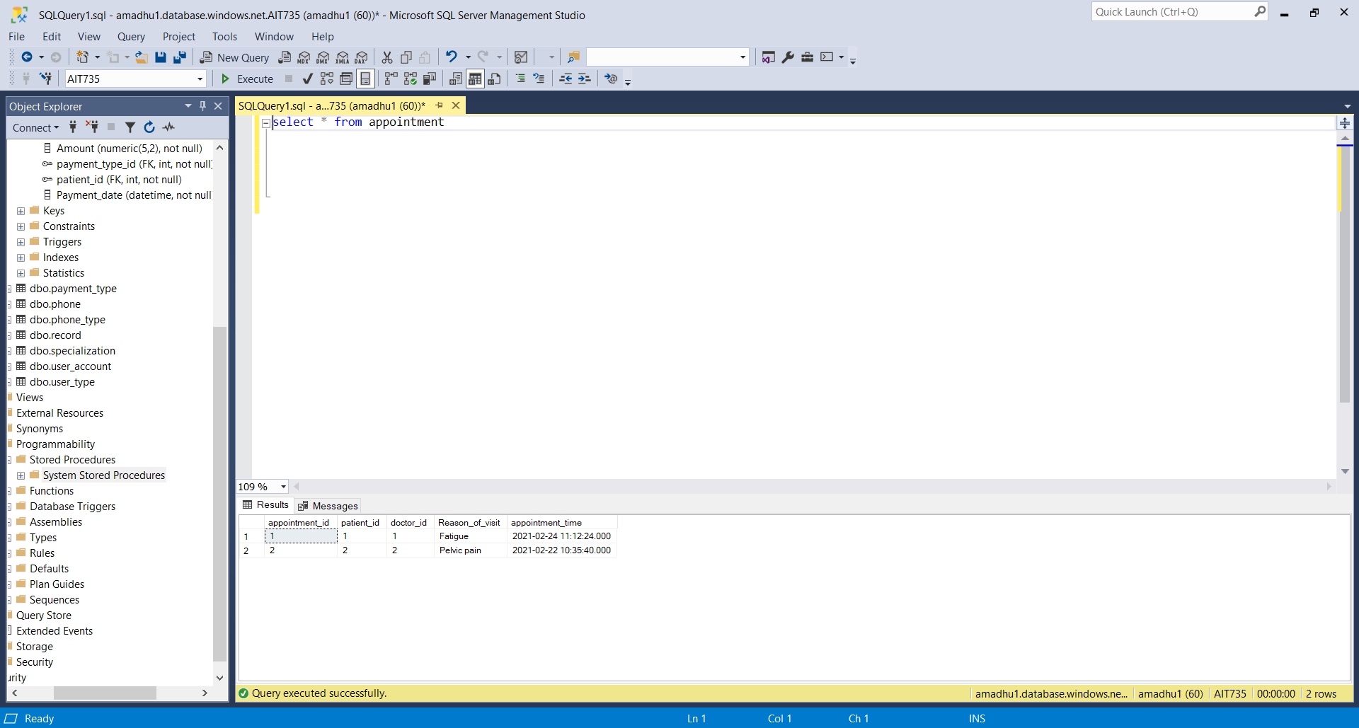

When tried to schedule an appointment with the same doctor at the same time the system displays a message “Duplicate appointment”

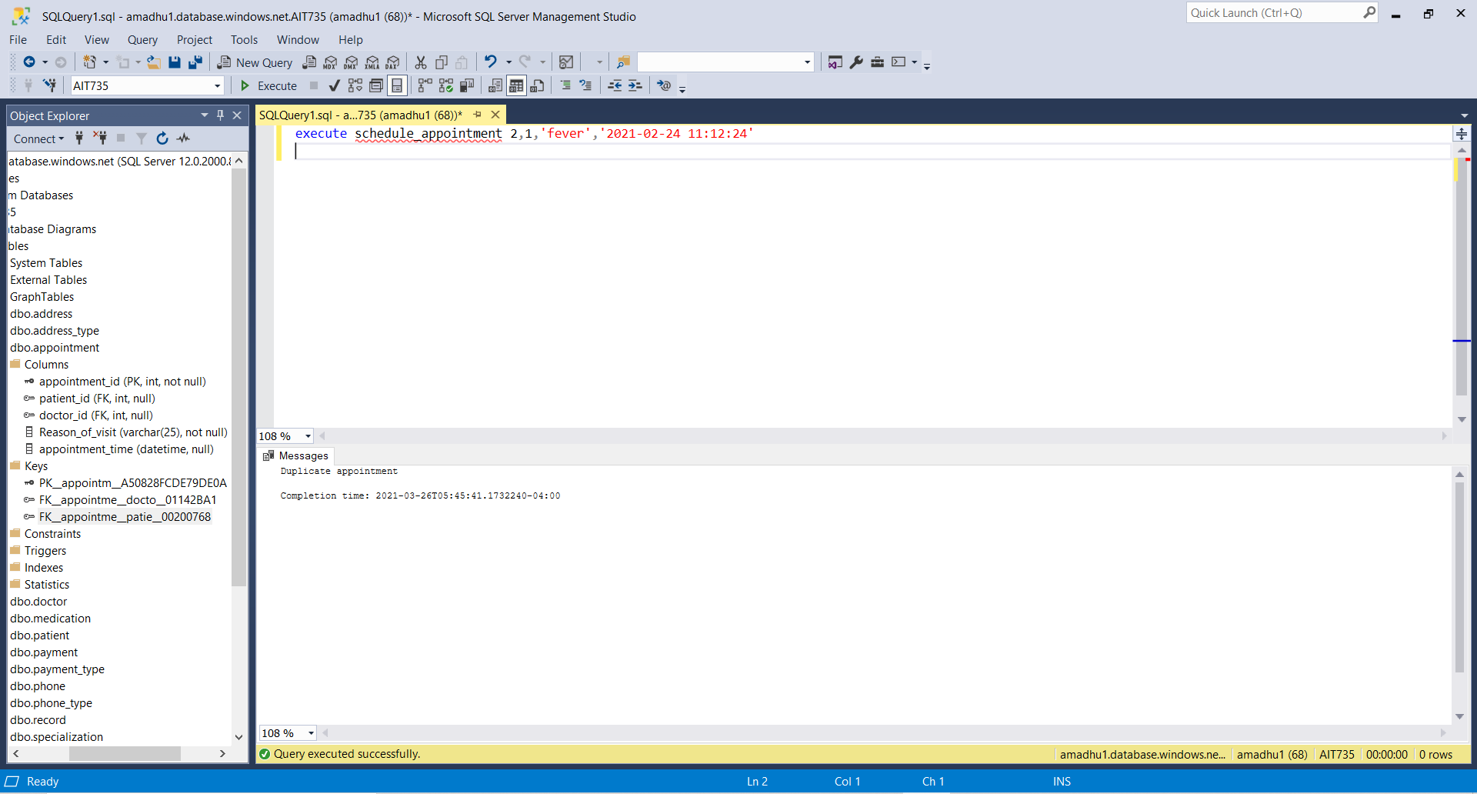

When tried to schedule an appointment at a different time the system displays a message “Appointment successfully scheduled”

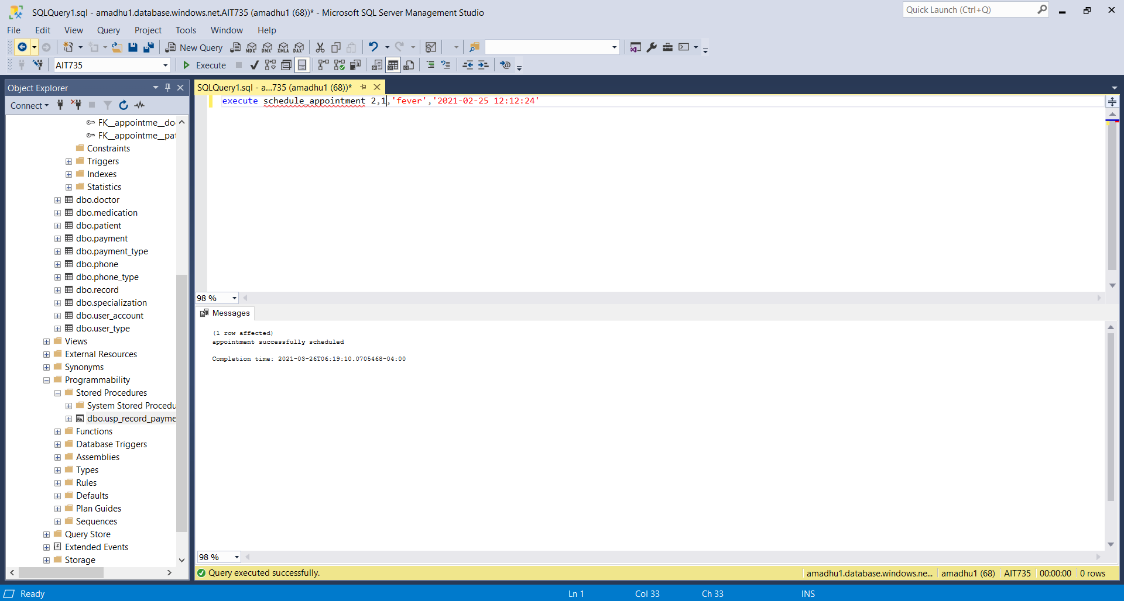

**Requirement 20:** The data is migrated from the on-premises database to the cloud database

The hospital database is moved from the on-premises database to the Microsoft Azure SQL cloud database making sure that there is no data loss or any changes to the data.

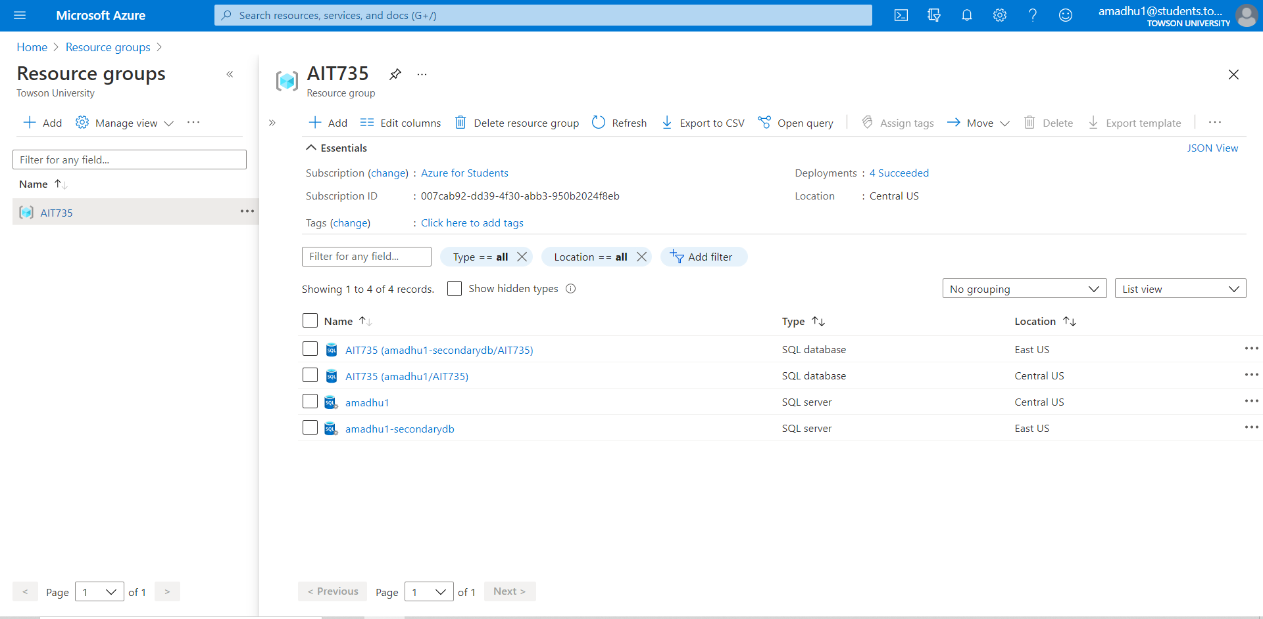

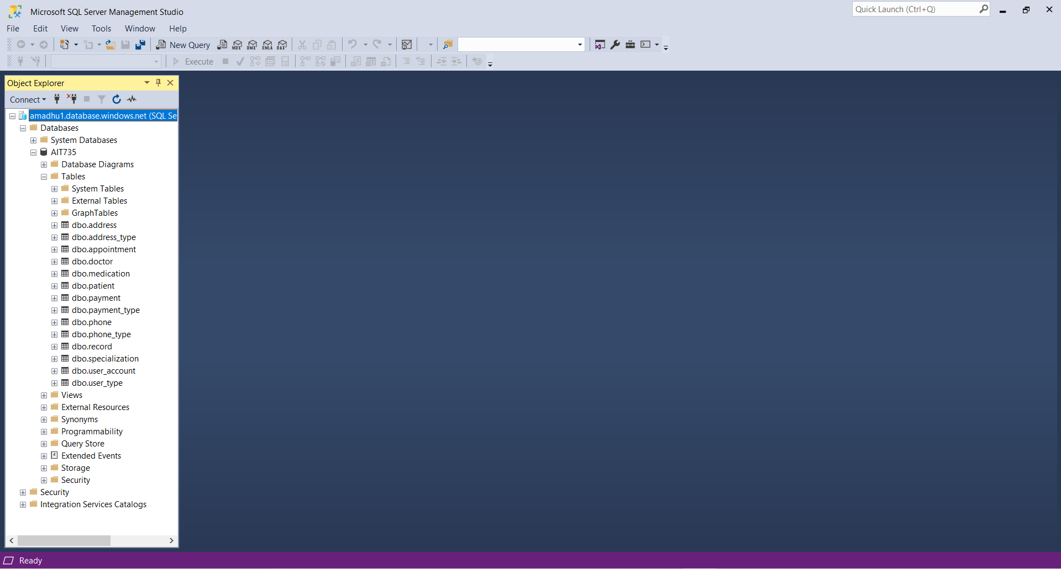

**Requirement 21:** The system will be able to scale in/out based on the need of service.

Microsoft Azure provides a great feature called “auto scaling” using which the capacity of the resources can be increases or decreased based on the requirements. Currently the database is configured with 1 GB storage. As the number of patients increases the storage can be increased. DTU directly affects the performance of the database. Currently the hospital is using 10 DTUs but as the performance requirement changes for the database, DTU can be configured based on database performance requirement.



**Requirement 22:** The cloud database will provide data back up on regular intervals

Microsoft Azure offers different back up plans based on the client’s requirement and subscription plans. Microsoft Azure displays the available backups and the backup plans configured for the cloud database. The back up plans can be changed according to the requirement.

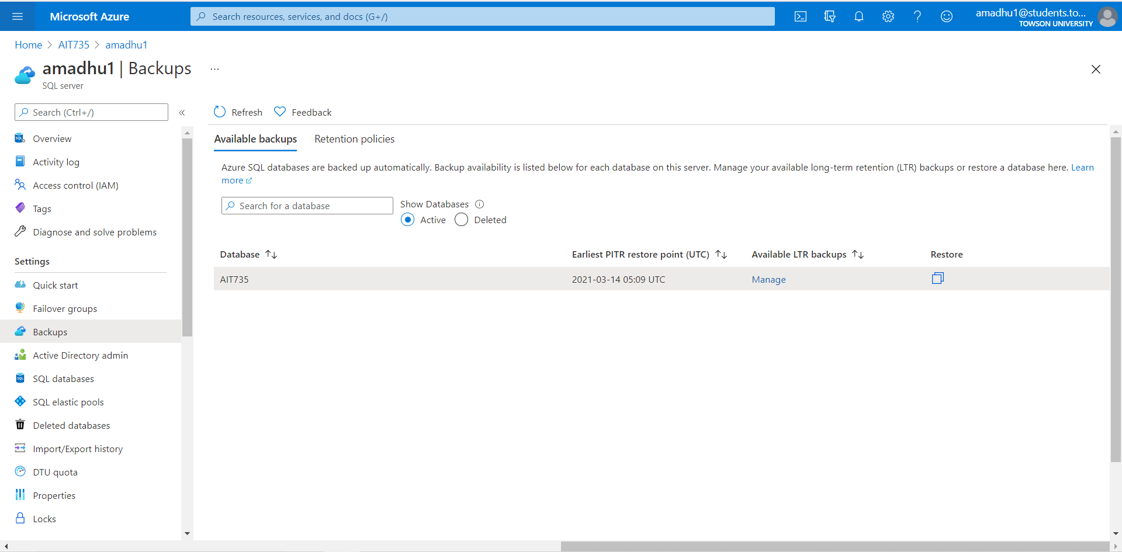



**Requirement 23:** The database will be geo replicated so that the data will be available in situations like natural disaster.

Using geo-replication feature of Microsoft Azure a readable secondary database is created in a different region. This helps the hospital database to continue functioning even in the instances like Natural disaster, Data center failure etc. The migrated hospital database has the primary database located in the Central US region and the secondary database of the hospital database is in the EAST US region. The reason for selecting these two regions is that their location is close and they meet the compliance requirement of the region.

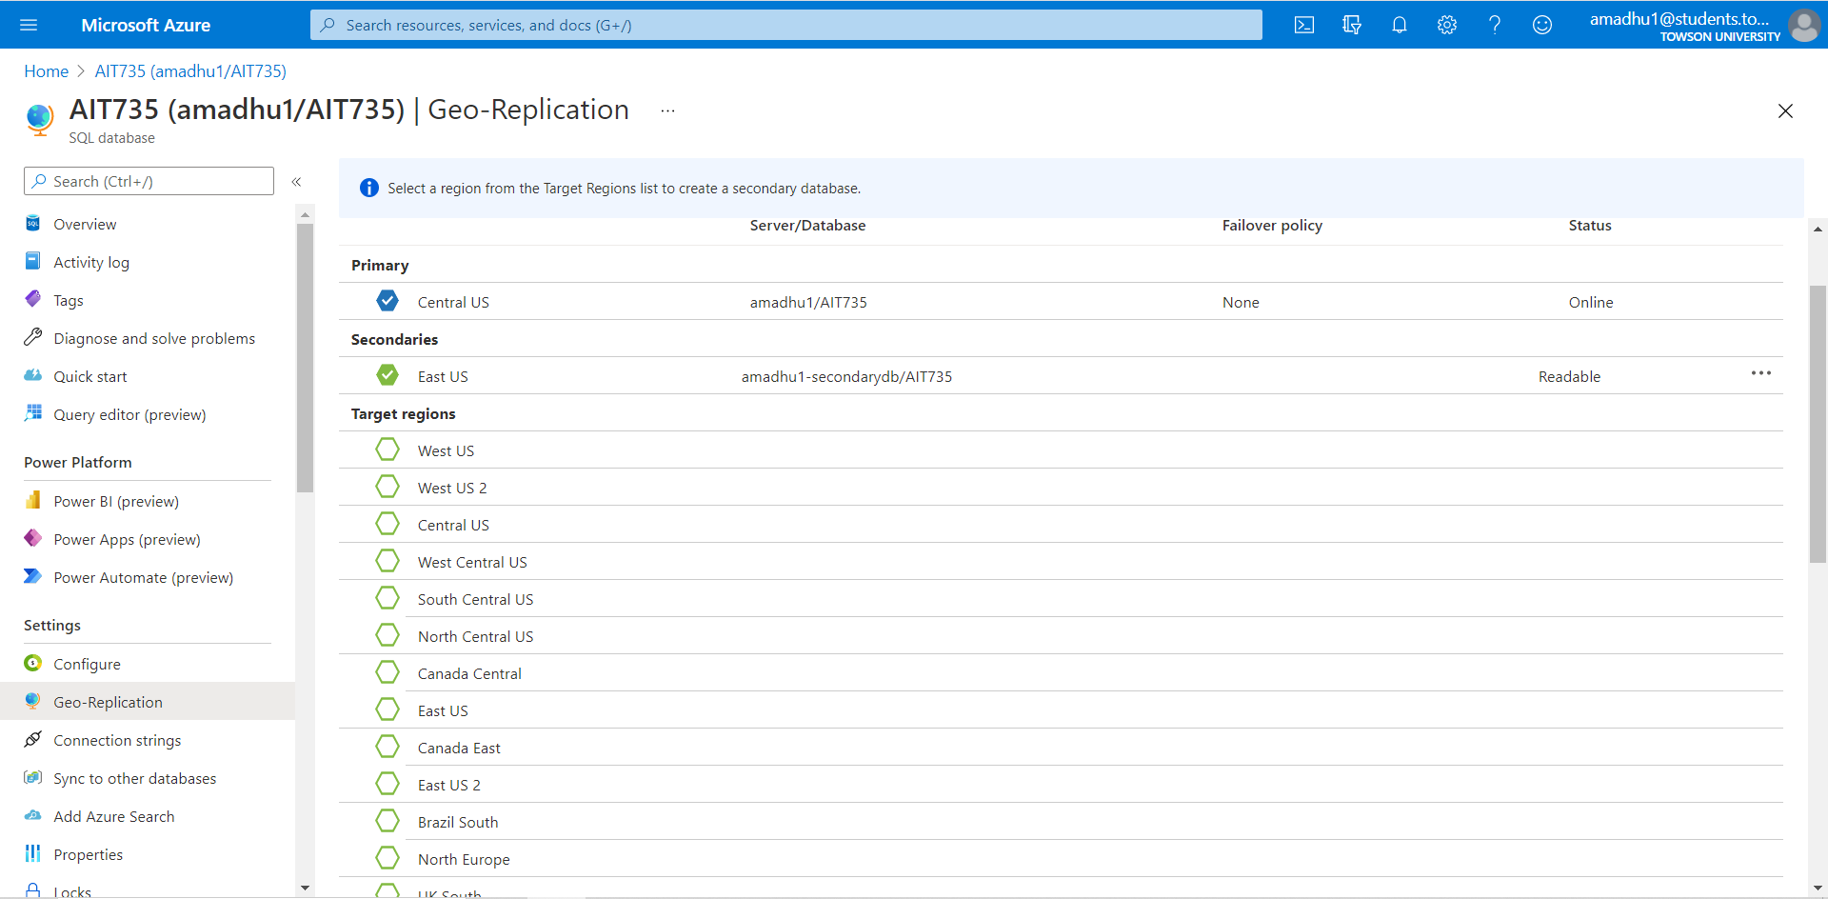

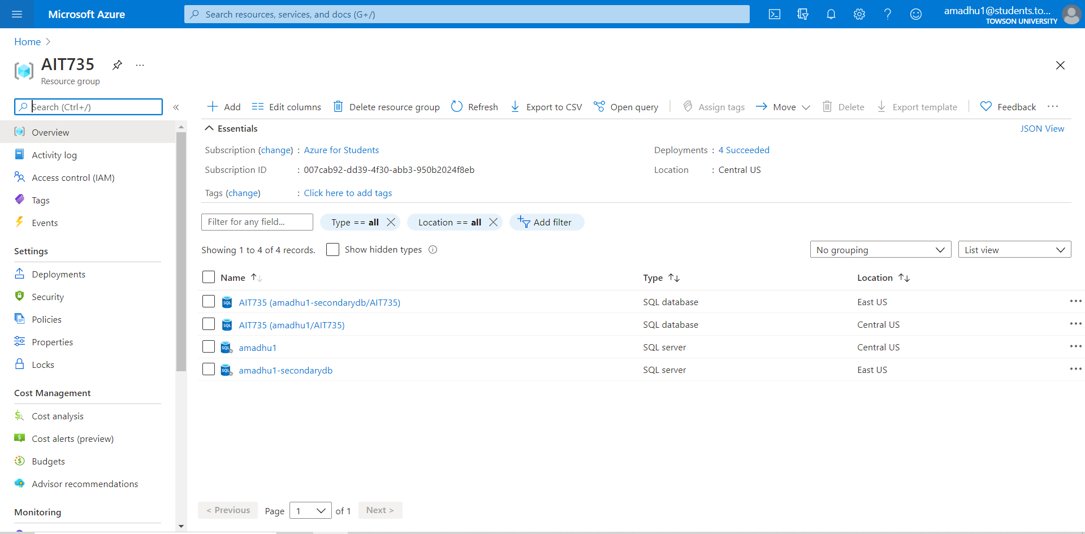

**Requirement 24:** The migrated database will be provided with cloud monitoring option for maintenance and proactive support

Microsoft Azure facilitates database monitoring using which it is possible to monitor the database based on different metrics like CPU percentage, Data space used percent, DTU percentage, successful connections etc.

To view the results, select the database, select the metric from the drop down.

In the screenshot below DTU percentage and CPU percentage are displayed.

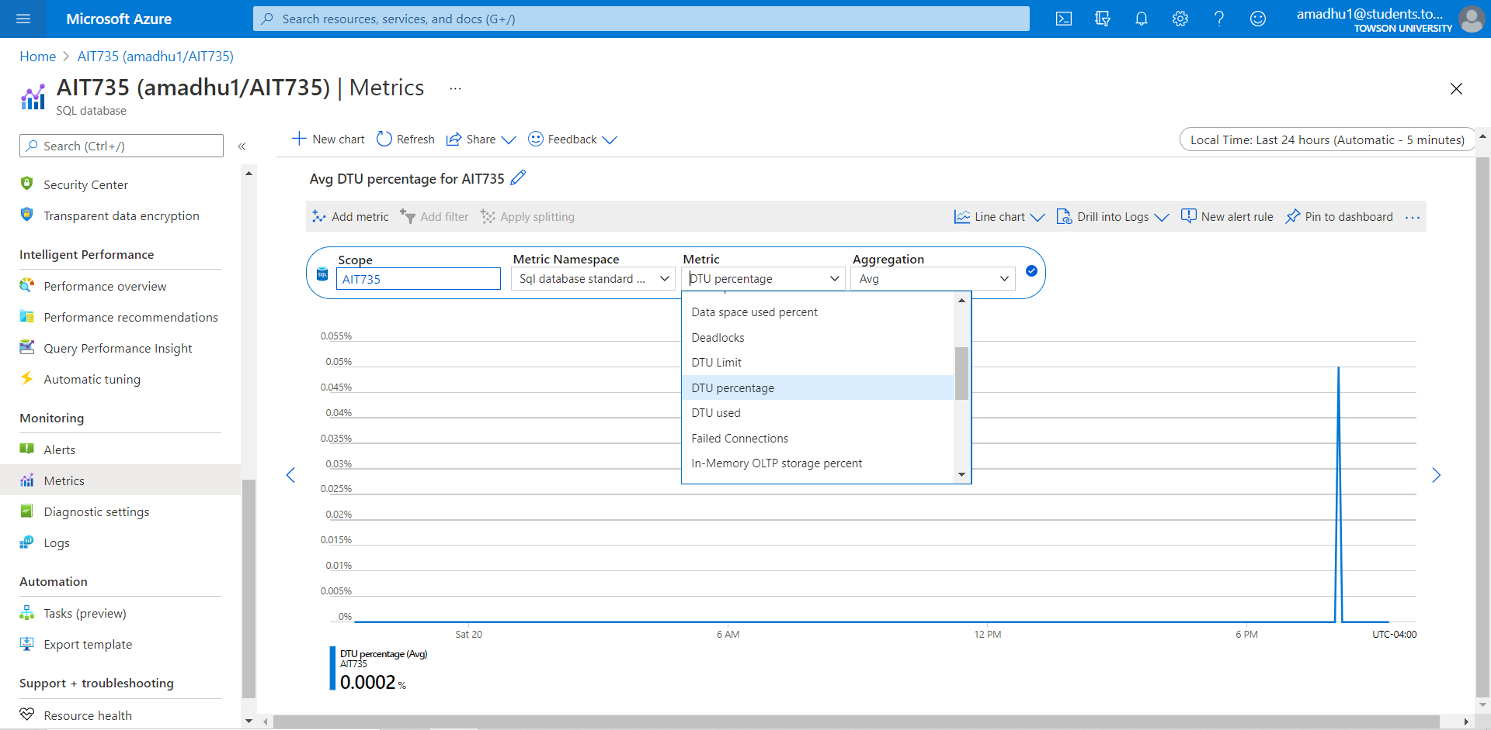

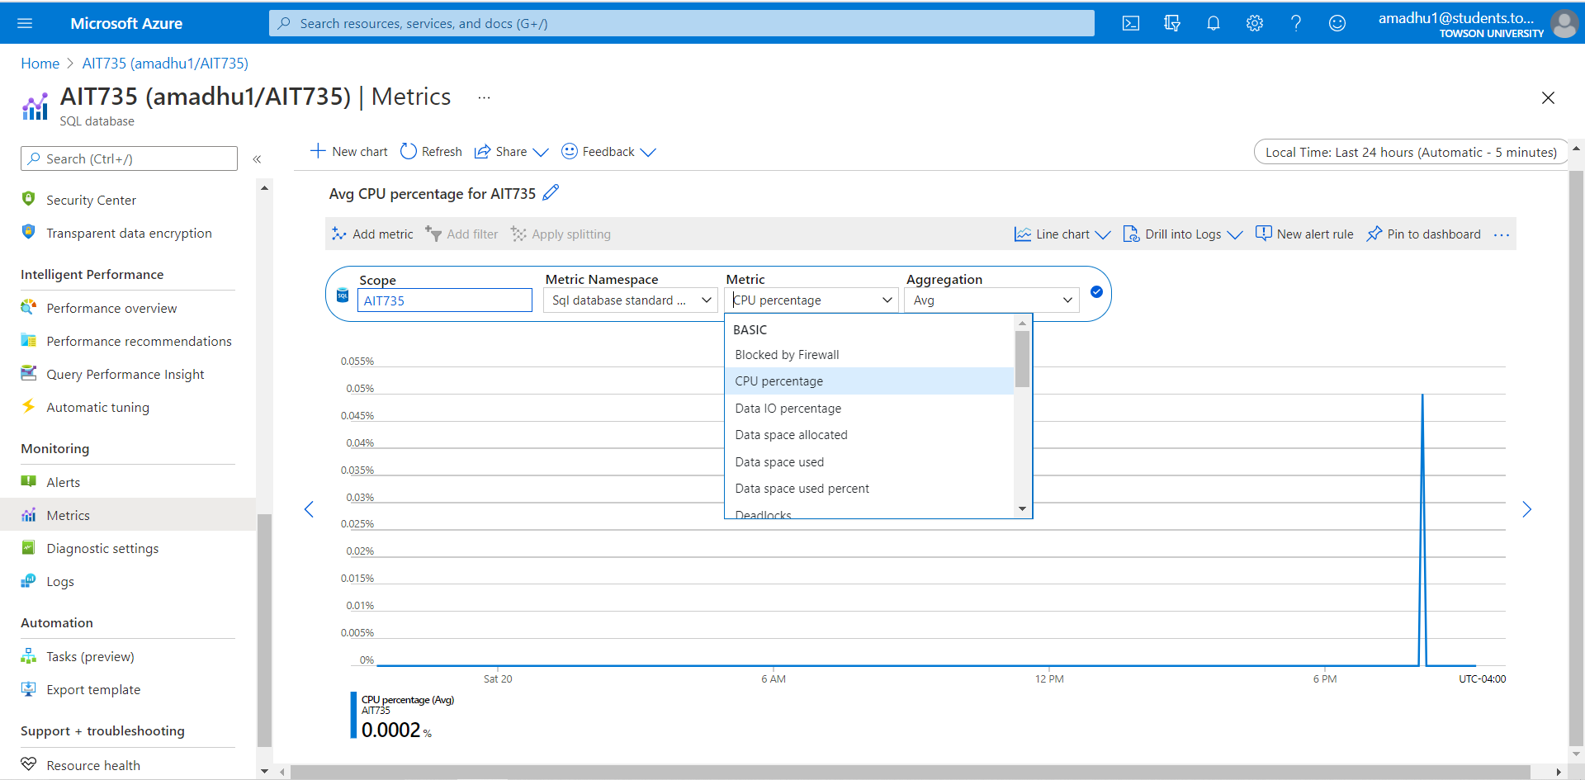

**Requirement 25:** The database after migration will be tested for data integrity.

After database migration Microsoft Azure takes the responsibility of the client’s data. Despite of this, Microsoft Azure provides options like alerts monitoring, back up integrity checks, Data integrity in rest and transit, to the client to verify the accuracy, completeness, and reliability of the data.



**Requirement 26:** The migrated database will be notified ahead of time in case of service-related issues

Microsoft Azure status reports on service problems that affect a broad set of Azure customers.

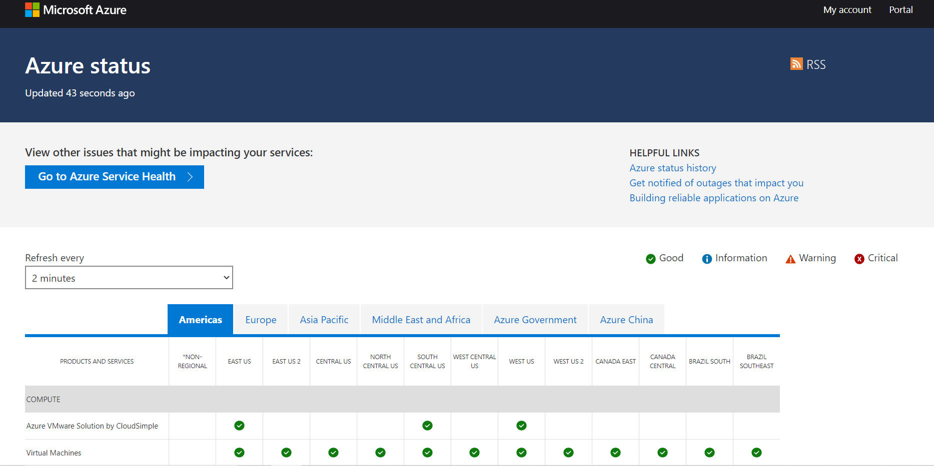

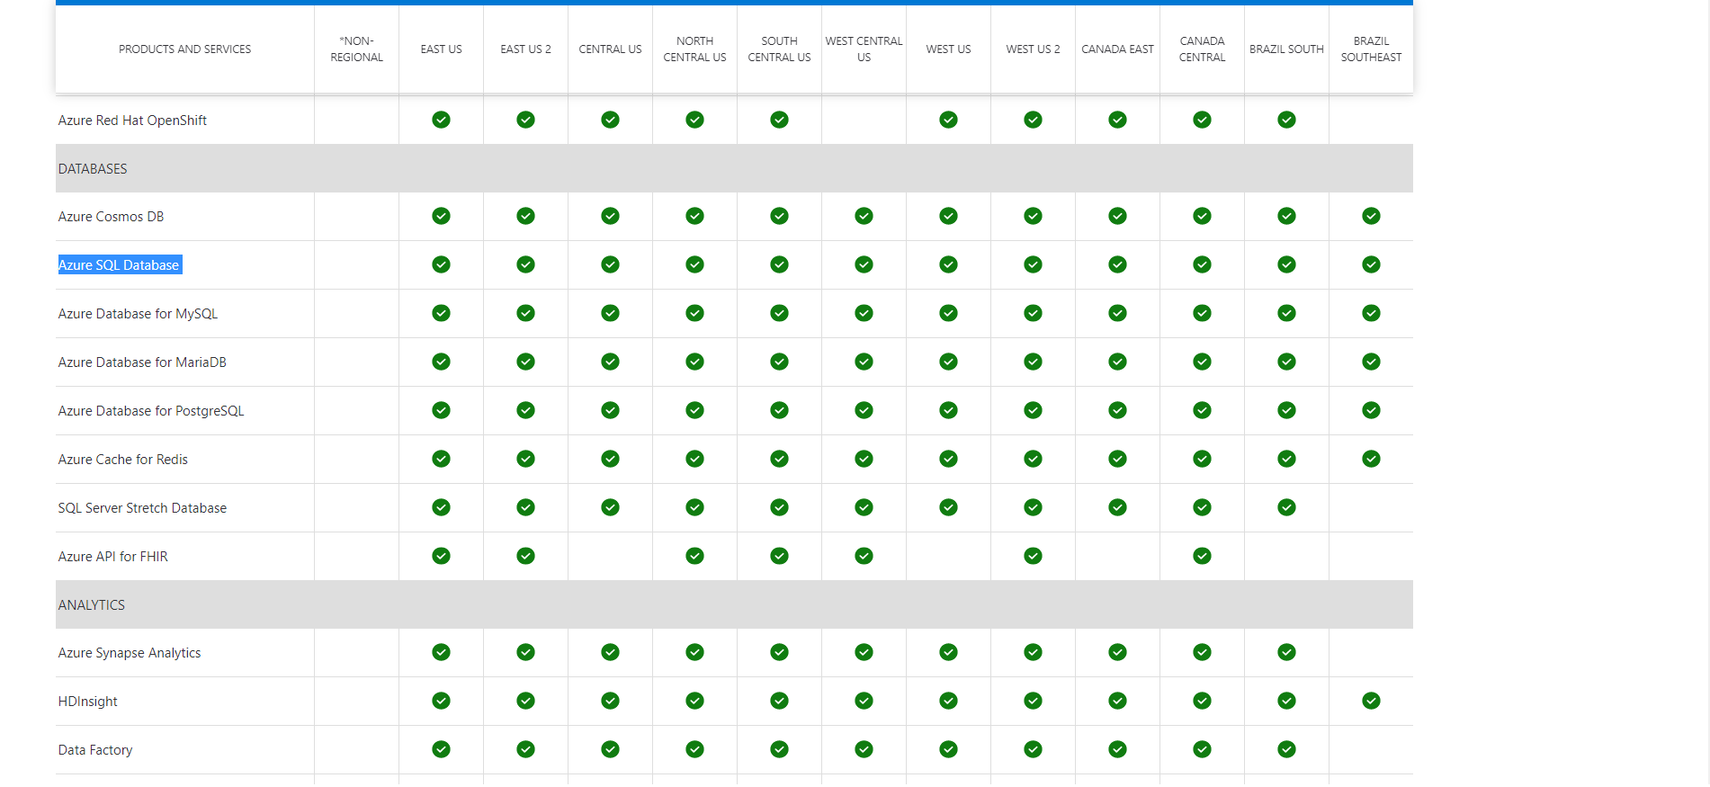

Microsoft Azure Resource health diagnoses and provides support options regarding the service-related issues that affect the provisioned azure resources.

A status of “Available” means that Resource Health has not detected login failures due to system errors on our SQL resource.

A status of “Degraded” means that Resource Health has detected most successful logins, but some failures as well.

A status of “Unavailable” means that Resource Health has detected consistent login failures to our SQL resource.

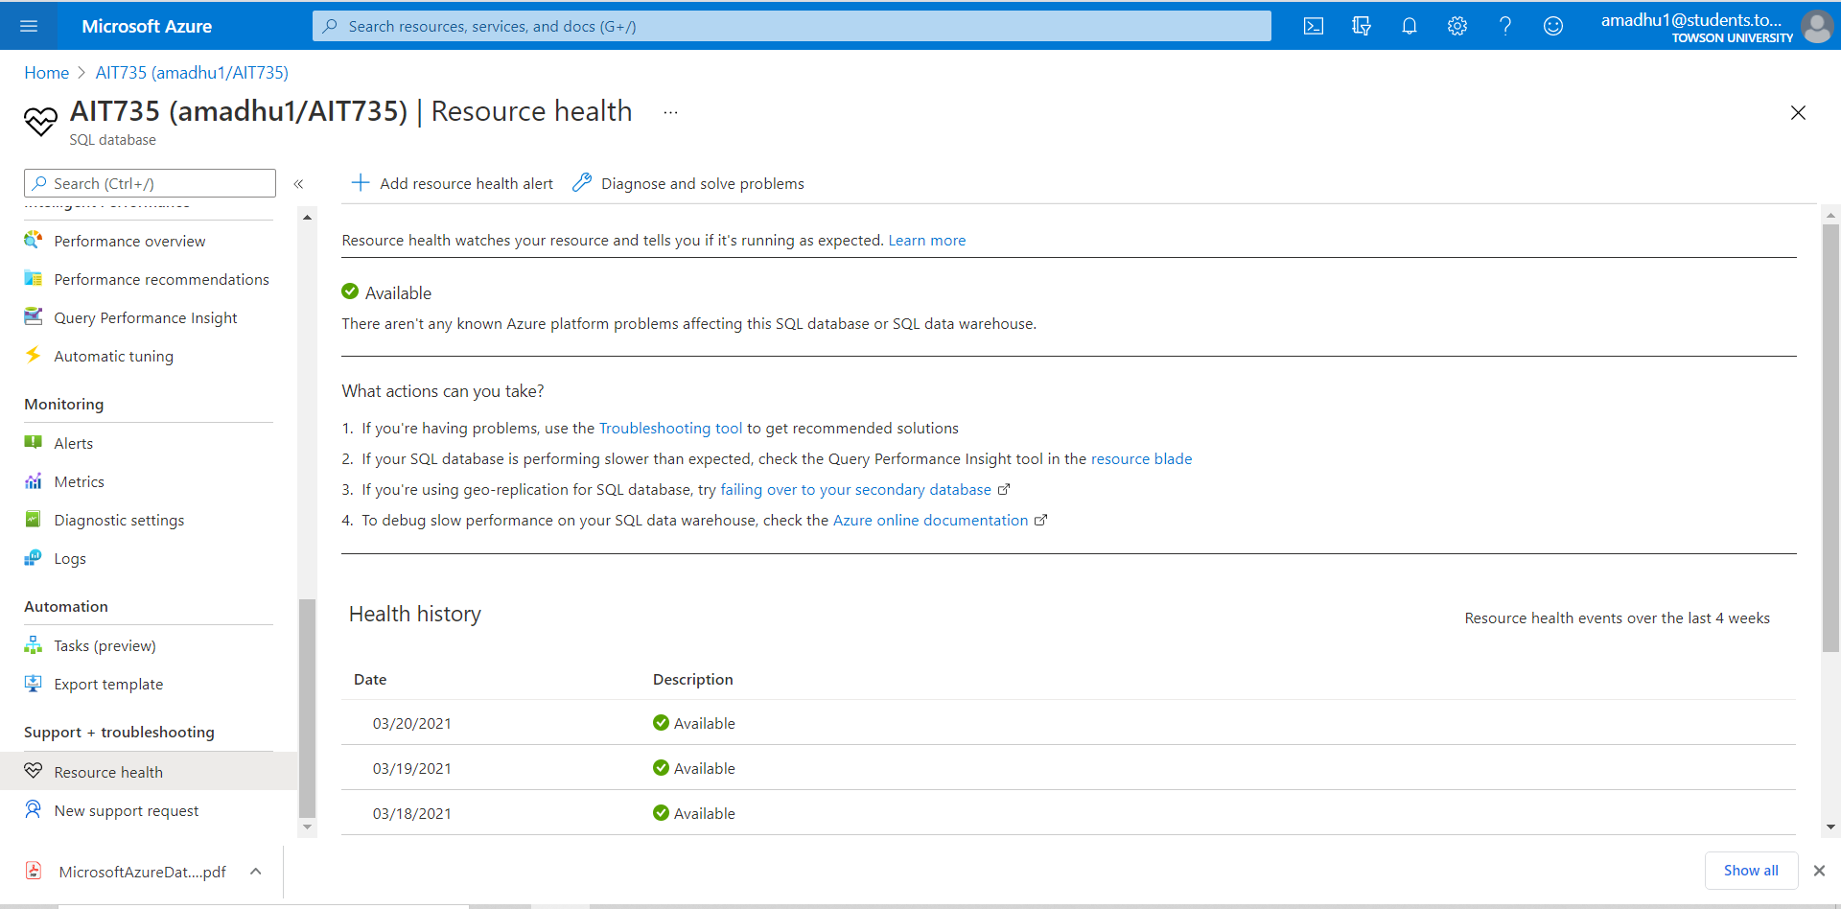

Azure Service Health notifies about Azure service incidents and planned maintenance so that we can take action to mitigate downtime. Microsoft Azure provides option to Configure customizable cloud alerts and use our personalized dashboard to analyze health issues and monitor the impact to our cloud resources.

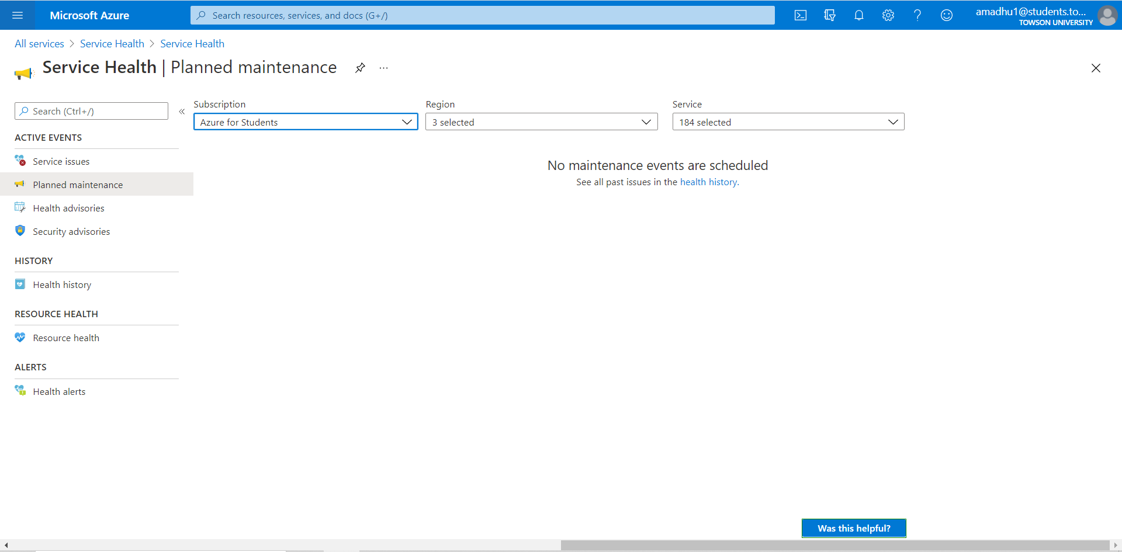

Customized Health alert created for “AIT735” resource group

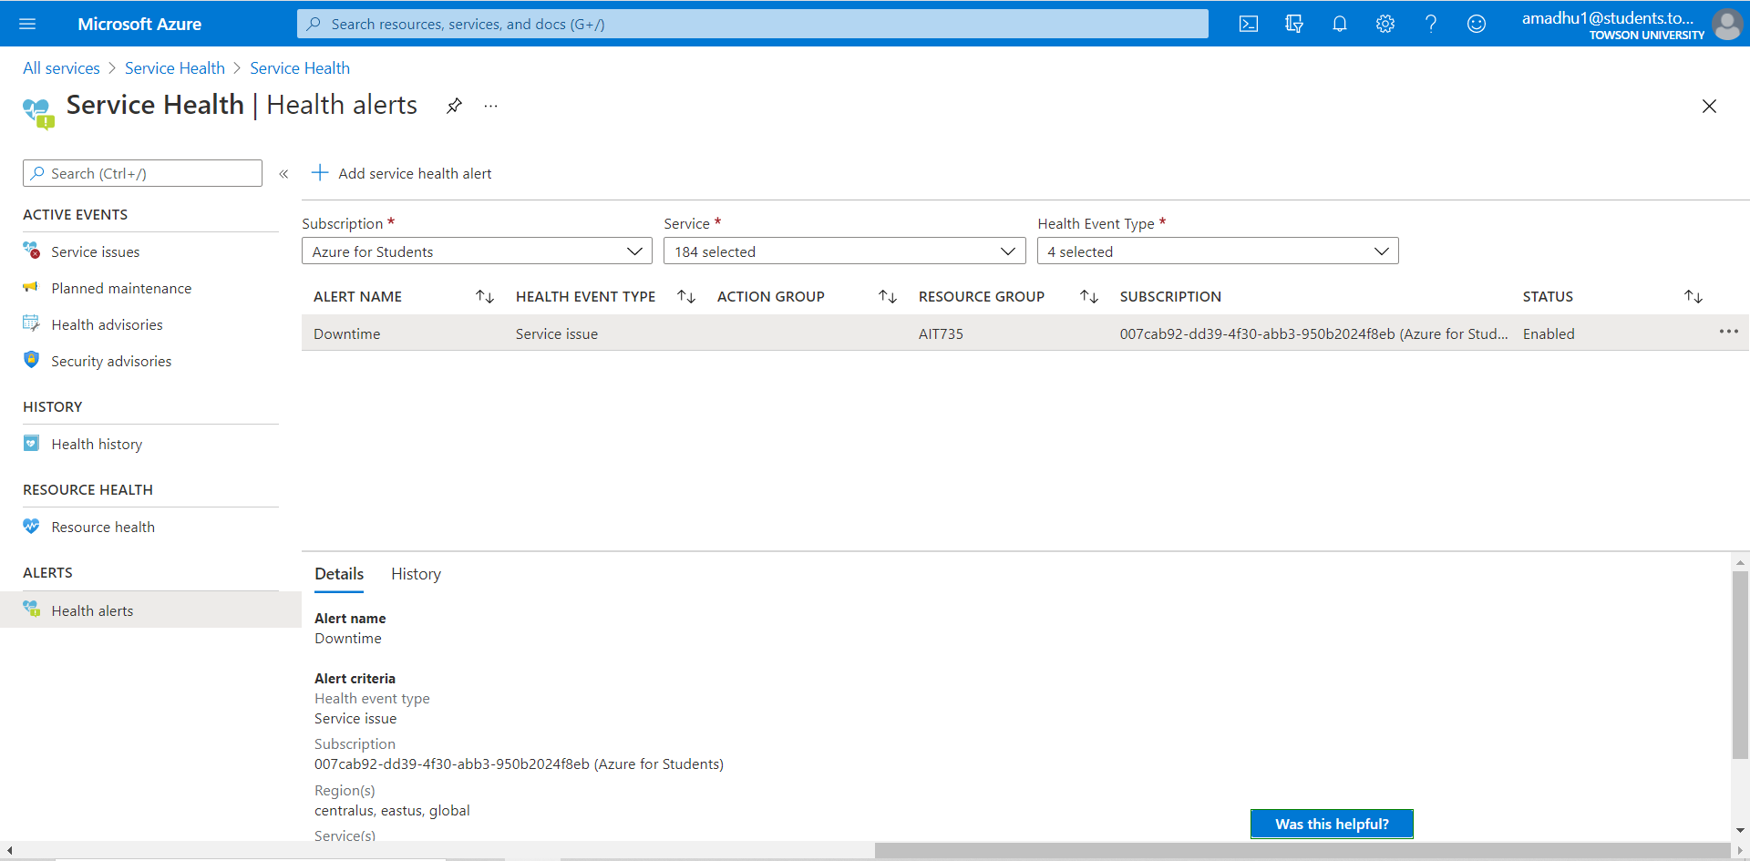

**Requirement 27**: The cloud database will be protected against malicious offline activity

Microsoft Azure SQL database provides transparent data encryption option that helps to protect the data against malicious offline activity by encrypting the data at rest. It performs real-time encryption and decryption of the database, associated backups, and transaction log files at rest without requiring changes to the application. TDE encrypts the storage of an entire database by using a symmetric key called the Database Encryption Key (DEK). On database startup, the encrypted DEK is decrypted and then used for decryption and re-encryption of the database files in the SQL Server database engine process. All this process will be completely managed and taken care by Microsoft developers.

The below screenshot shows that the Transparent data encryption (TDE) feature is enabled for the hospital database

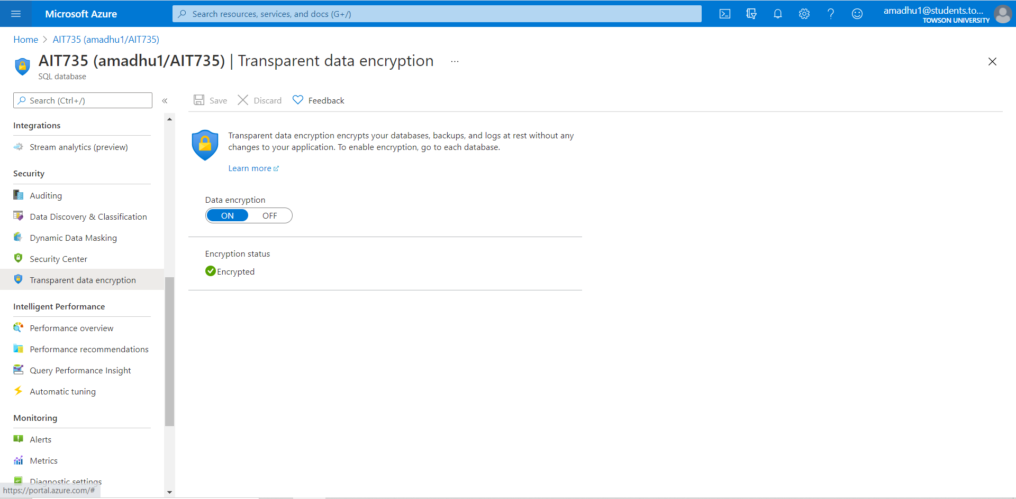

**Requirement 28**: The system will allow to monitor query performance to efficiently manage the resource consuming and long running queries

Microsoft Azure SQL database provides Query Performance Insight feature that performs intelligent query analysis for Azure database. It helps to identify the top resource consuming and long-running queries. This helps you find the queries to optimize to improve overall workload performance and efficiently use the resource that the hospital is paying for. Query Performance Insight helps to speed less time troubleshooting database performance

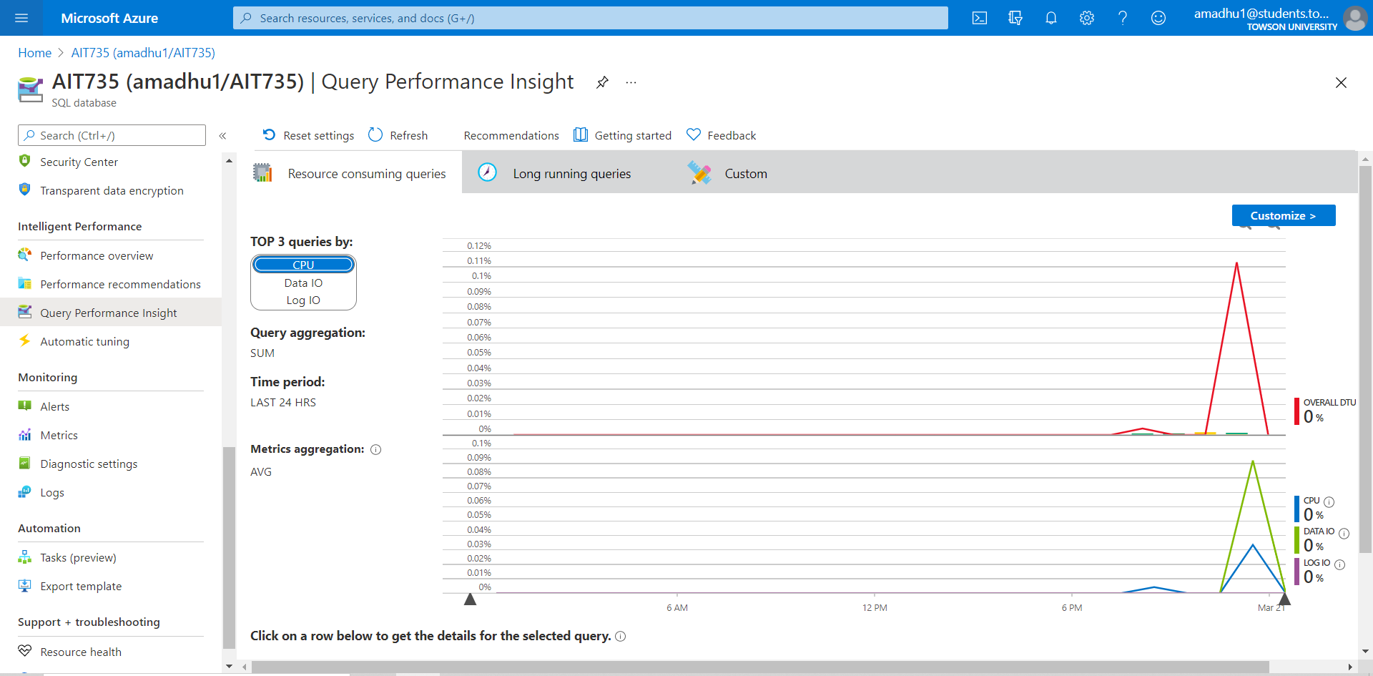

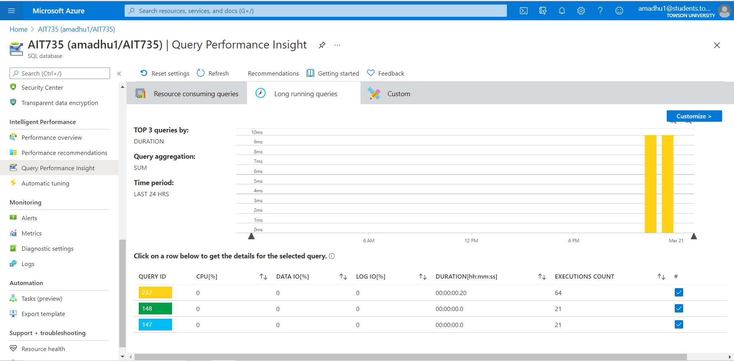

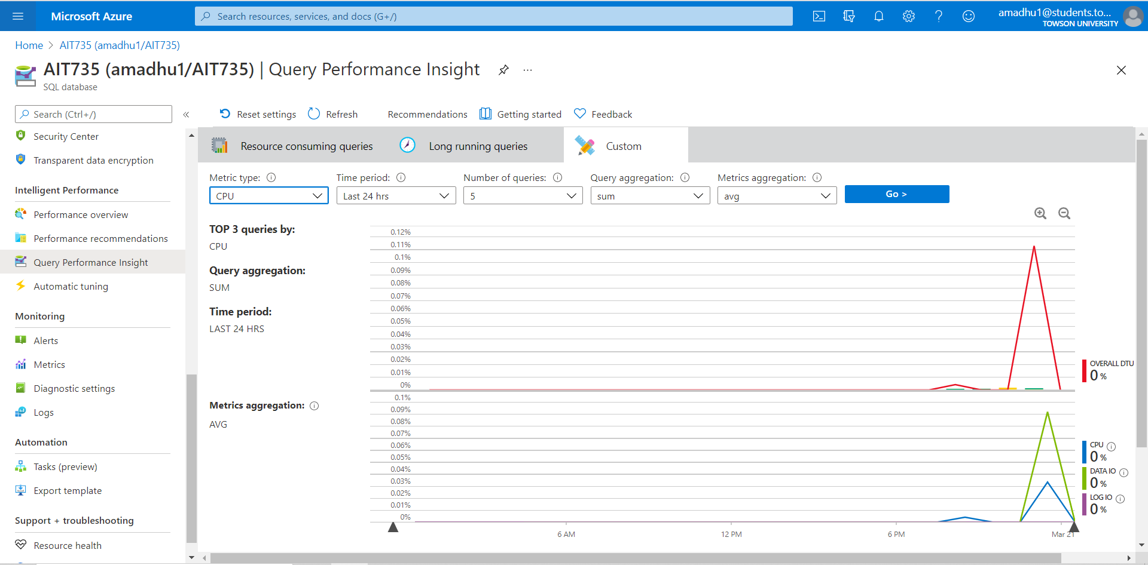

**Requirement 29:** The System will have 99% availability as per the cloud provider SLA.

Microsoft Azure SQL Database offers 99.99% availability SLA across all its service tiers but is now providing a higher 99.995% SLA for the business critical or premium tiers. 99.99% availability means that for any database, the downtime should not exceed 52.56 minutes per year. A minute of downtime is defined as the period during which all attempts to establish a connection failed. Microsoft Azure provides 10% service credits to the client if they fall beneath the SLA threshold. Azure SLA Credits are calculated on a per subscription basis as a percentage of the bill for that service in the billing month that the SLA was missed. The service credits are applied to the subsequent month’s bill. In the case study standard tier is being used and hence the SLA is 99.99%.



**Requirement 30:** The migrated database will be configured with advanced security features

Azure Defender for SQL is a package for advanced SQL security capabilities. Azure Defender is available for Azure SQL Database and Azure SQL Managed Instance. Microsoft Azure Defender discover and classify sensitive data, mitigates potential database vulnerabilities. It also helps to encounter anomalous activities that could be threat to the database. Microsoft Azure Defender includes Vulnerability Assessment and Advanced Threat Protection features

Vulnerability Assessment helps to remediate potential database vulnerabilities. It provides visibility into the database security state, and it also includes actionable steps to resolve security issues.

Advanced Threat Protection detects anomalous activities indicating unusual and potentially harmful attempts to access or exploit the database. It continuously monitors the database for suspicious activities, and it provides immediate security alerts on potential vulnerabilities, Azure SQL injection attacks, and anomalous database access patterns. Advanced Threat Protection alerts provide details of the suspicious activity and recommend action on how to investigate and mitigate the threat.

The below screenshots show the steps involved in enabling windows defender

Click on Database🡪security🡪Enable windows defender🡪successfully completes deployment

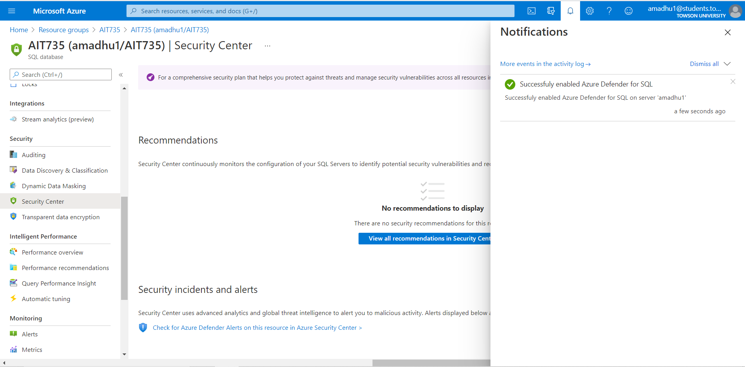

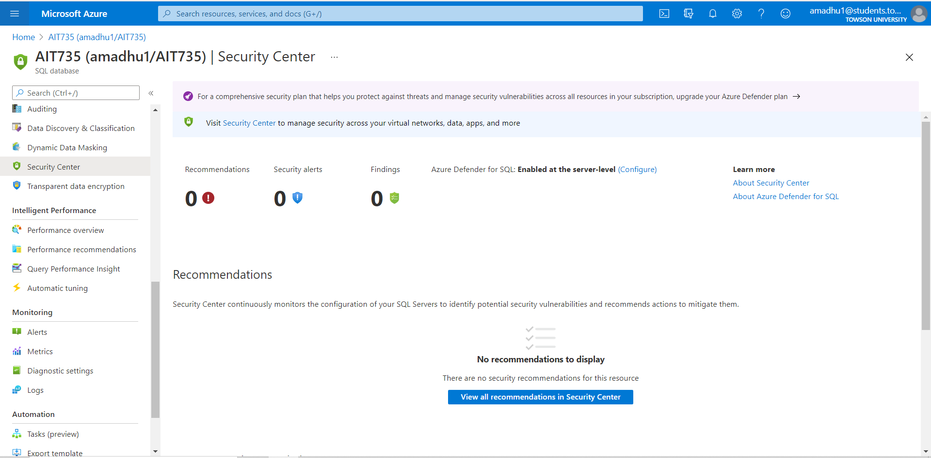

# 8. Conclusion

Hospital Database is an important part of operations because it includes patient identification, billing, payment, and other crucial information. Hence the importance of technology in healthcare cannot be underrated. Based on the observations in the case study, it can be concluded that for a healthcare system it is beneficial to migrate data to a more capable system. Cloud Computing can be considered as business innovation rather than technology solution. Cloud Computing is an evolving technology in the modern world and maximum benefits can be drawn if used effectively. Most of times lack of knowledge and interoperability will make it difficult for the organizations to derive value from the implementation of cloud technology.

The case study demonstrated a streamlined approach to migrate hospital database from on-premises database to the Microsoft Azure cloud database. The case study has identified a set of beneficial features like geo-replication, scalability, security, and data monitoring, that can be utilized during a hospital Database Migration. Along with this, additional services like resource health, service health, etc. offered by the Microsoft Azure were also discussed.

The case study explained the cost related advantages of migrating from on-premises database to the cloud database through detailed cost basis analysis. It is also shown that the database performance doesnot deteriorate when database is migrated from on-premises database to the Microsoft Azure cloud database and the performance can be increased through efficient scalability feature of the cloud service.

The case study particularly focused on Microsoft Azure cloud provider. There are few factors the healthcare industries may need to consider while selecting a cloud provider for migration. This has to do with legal and compliance standards offered by the cloud provider. The organization needs to verify if the cloud providers’ legal and compliance standards are in line with their organization’s requirement before proceeding with the entire process.

# 9. References

[1] Docs.microsoft.com. (2019). Microsoft Azure fundamentals and features. [online] Link: https://docs.microsoft.com/en-us/learn/certifications/azure-fundamentals/

[2] N. K. Sehgal and P. C. P. Bhatt, Cloud computing: Concepts and practices, 1st ed. Basel, Switzerland: Springer International Publishing, 2018.

[3] ccompy. (n.d.). Hybrid connections - Azure App Service. Retrieved April 11, 2021, from Microsoft.com website: https://docs.microsoft.com/en-us/azure/app-service/app-service-hybrid-connections

[4] P. De Tender, “SQL database migration using export/import of BacPac file,” in Introducing Azure SQL Database, Berkeley, CA: Apress, 2019.

[5] Usman, A. (2012). Cost-benefit analysis of cloud computing. LAP Lambert Academic Publishing.

[6] Mazumdar, P., Agarwal, S., & Banerjee, A. (2016). Business continuity and security with azure SQL database. In Pro SQL Server on Microsoft Azure (pp. 157–188). Berkeley, CA: Apress.

[7] Chakraborty, B., & Chowdhury, Y. (2020). On-premises to azure disaster recovery. In Introducing Disaster Recovery with Microsoft Azure (pp. 145–206). Berkeley, CA: Apress.

[8] Endo, P. T., Rodrigues, M., Gonçalves, G. E., Kelner, J., Sadok, D. H., & Curescu, C. (2016). High availability in clouds: systematic review and research challenges. Journal of Cloud Computing Advances Systems and Applications, 5(1). doi:10.1186/s13677-016-0066-8

[9] Agrawal, D., El Abbadi, A., Das, S., & Elmore, A. J. (2011). Database scalability, elasticity, and autonomy in the cloud. In Database Systems for Advanced Applications (pp. 2–15). Berlin, Heidelberg: Springer Berlin Heidelberg.

[10] P. Mazumdar, S. Agarwal, and A. Banerjee, “Azure SQL Database: Performance and Monitoring,” in Pro SQL Server on Microsoft Azure, Berkeley, CA: Apress, 2016, pp. 189–205.

[11] Carolyn E. Begg and Thomas Connolly, Database Systems: A Practical Approach to Design, Implementation, and management,6th ed USA, Pearson,1996.[3] David M. Kroenke and David J, Auer, Database Concepts, 7th ed USA, Pearson, 2015.

[12] P. Zhang, “Introduction to Database Migration,” Practical Guide to Large Database Migration, pp. 1–11, 2019.

[13] Thomas Erl, Ricardo Puttini, and Zaigham Mahmood. 2013. Cloud Computing: Concepts, Technology & Architecture (1st ed.) NJ, Prentice Hall Press, 2013.